Virginia Tiered Systems of Supports (VTSS)

VTSS Annual Report

January 2019
Maribel Saimre, EdS, Office of Student Services, Virginia Department of Education (VDOE)
Michael Gregory, MSW, LSW, Office of Student Services, VDOE
Martha Montgomery, EdS, Office of Student Services, VDOE
Sophia Farmer, MT, VTSS Research and Implementation Center (RIC) at the Center for School and Community Collaboration (CSCC)
Steve Tonelson, EdD, Old Dominion University
Corinne Wilson, PhD, Old Dominion University
Amanda Working, PhD, Old Dominion University
Michelle Schmitt, PhD, CSCC
Sharon deFur, EdD, VTSS-RIC
Melodie Fearnow-Kenney, PhD, VTSS-RIC
Regina Pierce, MEd, VTSS-RIC
Mary Tobin, MEd, VDOE Training and Technical Center at Virginia Commonwealth University (VCU)
Elisa Rosman, PhD, Formed Families Forward

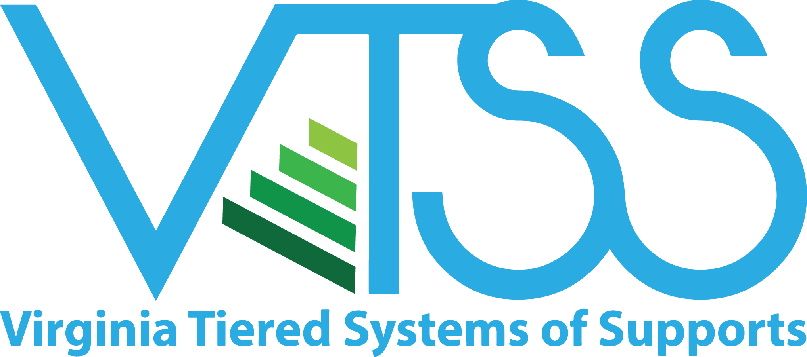
VTSS RIC Website

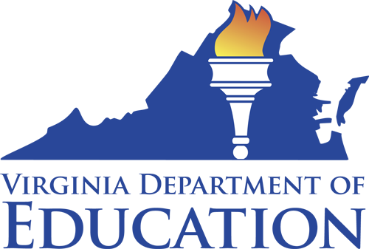

Virginia Tiered Systems of Supports (VTSS)
The Virginia Department of Education seeks to provide a high quality, effective learning environment for all students and has identified this as its first priority within the Virginia Board of Education’s Comprehensive Plan 2018-2023. Ongoing work focuses on supporting our teachers, school, and community leaders in providing appropriate supports to a diverse student body.
To accomplish this, the Virginia Tiered Systems of Supports (VTSS) establishes a decision-making framework in divisions and schools. This framework provides a system to integrate academics, behavior, and mental health supports. The VTSS approach allows divisions, schools, and communities to provide multiple levels of supports to students in a more effective and efficient, clearly defined process.
The mission of VTSS is to build capacity for a sustained tiered system of academic, behavioral, and social-emotional supports that are responsive to the needs of all students. To accomplish this mission, VTSS seeks to:
- Promote a culture of continuous growth through ongoing professional learning.
- Implement with fidelity, proactive and preventative evidence-based practices to support (improved) measurable academic and social behavioral outcomes.
- Use data informed problem solving, decision-making, screening, and progress monitoring to effectively meet instructional needs.
- Build an integrated framework that promotes shared leadership at the division, school, classroom, and community levels.

Division Leader Comments
Division leaders provided feedback on the impact of VTSS implementation during interviews for VTSS 1-2 and focus groups for VTSS 3. Comments included:
“In the first three years of implementing PBIS, [our] school was only partially accredited. We quickly became fully accredited based on state and federal requirements. Additionally, since joining VTSS, we have lowered all overall discipline for the entire school community from 35% of students having at least one office referral to 15%.”
“Student data is the focus. The VTSS tiered-support framework helps us identify those students who really need additional academic and/or behavioral supports.”
“If kids aren’t doing well, either academically or behaviorally, staff bring data to the school data team meeting where we problem-solve, trying to figure out if this an instruction issue, a mismatch, a fidelity issue, time,…”
“…at our elementary schools last year we saw significant gains in reading and math for students with disabilities…”

VTSS Implementation Milestones
2005 Effective School-wide Discipline (ESD) is initiated by VDOE to support schools in the implementation of positive behavior change through training and technical assistance.
2007 Response to Intervention (RtI) is initiated to provide a multi-tiered system of academic supports.
2008 ESD is rebranded as Positive Behavioral Interventions and Supports (PBIS) of Virginia.
2010 VDOE’s cascading model of support increases focus on building capacity at the division level to maximize and sustain student academic and social-behavior success.
2012 VTSS is established through the integration of PBIS and the RtI.
2013 VTSS Cohort 1 (3 divisions) receives training and technical assistance.
2014 VTSS expands to 11 additional school divisions (Cohort 2).
2015 VTSS-Research and Implementation Center is created to continue to build state capacity to support training and technical assistance efforts.
2015 VDOE receives a federal School Climate Transformation Grant (SCTG) to enhance and scale-up systems of support for implementing evidence based, multi-tiered behavioral frameworks for improving learning conditions and outcomes for all students.
2015 VTSS expands to 12 additional school divisions (Cohort 3).
2015 VDOE receives a Project AWARE grant introducing mental health supports within the VTSS framework that is piloted in 3 school divisions.
2017 VTSS expands to 13 additional school divisions (Cohort 4). A total of 40 school divisions now receive VTSS support in order to implement a comprehensive, aligned, academic, behavioral, and social-emotional framework.
2018 VDOE receives a federal School Climate Transformation Grant (SCTG) to enhance and scale-up systems of support for implementing evidence based multi-tiered behavioral frameworks for improving learning conditions and outcomes for all students. The 2018 SCTG includes targeted supports for mental wellness, trauma sensitive practices, cultural responsivity, and opioid use.
2018 VTSS expands to 14 additional school divisions (Cohort 5). A total of 54 school divisions now receive VTSS support in order to implement a comprehensive, aligned, academic, behavior, and social-emotional framework.

Virginia’s Vision
The vision of the Virginia Board of Education and Superintendent of Public Instruction, in cooperation with their partners, is to create an excellent statewide system of public education that derives strength from diversity and that ensures equity of opportunity for each student in a safe and healthy learning environment that prepares all students to be capable, responsible, and self-reliant citizens in the global society.

VTSS School Divisions
As of December 2018, there are 54 school divisions receiving support from and providing data to VTSS.

Cohorts 1-2
Charlottesville City
Essex County
Fauquier County
Frederick County
Greensville County
Northampton County
Orange County
Page County
Pittsylvania County
Powhatan County
Prince William County
Surry County
Westmoreland County

Cohort 3
Accomack County
Fairfax County (AWARE)
Hanover County
Madison County
Montgomery County (AWARE)
Northumberland County
Prince Edward County
Pulaski County (AWARE)
Virginia Beach City
Warren County
Waynesboro City
Williamsburg-James City County

Cohort 4
Amherst County
Brunswick County
Chesapeake City
Cumberland County
Danville City
Henrico County
Henry County
Lynchburg City
Martinsville City
Nelson County
Newport News City
Portsmouth City
Richmond City
Southampton County
Suffolk City

Cohort 5
Alleghany County
Caroline County
Chesterfield County
Falls Church City
Gloucester County
Grayson County
Loudoun County
Lunenburg County
Manassas City
Mecklenburg County
Petersburg City
Poquoson City
Salem City
York County

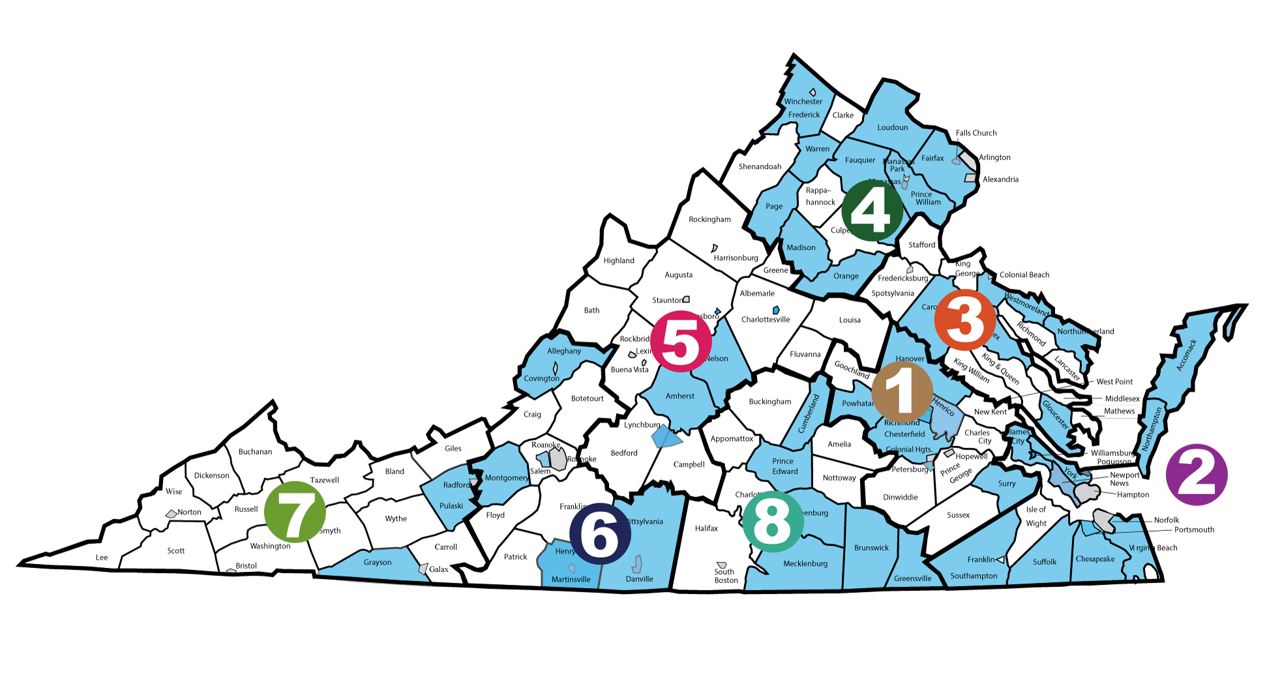

VTSS Professional Development
Evidence-based professional develop supports the establishment and sustainability of the Virginia Tiered System of Supports (VTSS) framework in school divisions across Virginia. VTSS offers regular state-wide and regional professional learning opportunities for divisions. Face-to-face and virtual opportunities to explore VTSS are provided. These events follow an established process to ensure the well-designed implementation of VTSS principles and practices. Over the past five years, division leadership teams have honed their skills in supporting and implementing VTSS in their school division. Many divisions now have VTSS coaches who have developed their skills through VTSS professional development. Participants in VTSS professional development overwhelmingly (more than 92%) report that they believe they are more skilled in implementing VTSS as a result of those learning experiences.
Between January 1, 2018 and December 31, 2018, VTSS:
- Held 28 state-wide professional learning events reaching more than 2,400 educators
- VTSS provided regional or division based professional development
- VTSS provided technical assistance and coaching to all participating VTSS school divisions
- VTSS collaborated with the VDOE and other organizations to provide the highly successful Virginia is for All Learners.
  - In 2016, 675 educators from 101 school divisions attended.
  - In 2017, 558 educators from 88 school divisions attended.
  - In 2018, 496 educators from 66 school divisions attended.
Coaching is central to VTSS professional development. Professional development research shows that coaching significantly improves the outcomes of professional development. The VTSS includes state Systems Coaches from the VDOE Training and Technical Assistance Centers and Research and Implementation Center. These coaches partner and collaboratively assist participating school divisions. Division leaders highly value the work of the coaches in helping them implement the VTSS framework.
VTSS professional development collects event evaluation data regarding the impact of the professional development on participants. These data contribute to the on-going improvement model that VTSS uses in creating and providing professional development.
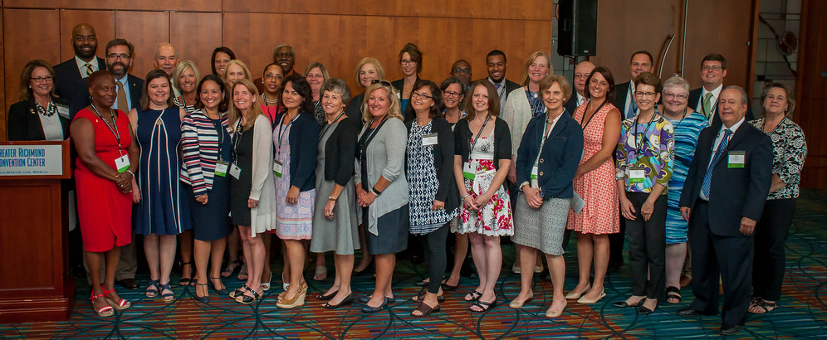

VTSS State-reported Schools
State-reported schools are schools within VTSS divisions that submit fidelity and outcome data to report to one of our funding agencies. Typically, these schools were identified as “pilot” or “demonstration” by the divisions and have received training/technical assistance from VDOE to implement VTSS. There are 38 state-reported schools within the 13 school divisions in Cohorts 1-2, 51 state-reported schools within the 12 divisions in Cohort 3, and 37 state-reported schools within the 14 divisions in Cohort 4. Data results in this report will focus on results from VTSS state-reported schools.

VTSS Cohorts 1-2 State-Reported Schools

Region 1 – Powhatan County
Pocahontas Elementary
Surry County
Luther P. Jackson Middle

Region 2 – Northampton County
Kiptopeke Elementary
Northampton High
Northampton Middle
Occohannock Elementary

Region 3 – Essex County
Essex High
Essex Intermediate
Tappahannock Elementary
Westmoreland County
Washington and Lee High

Region 4 – Fauquier County
C.M. Bradley Elementary
Cedar Lee Middle
James G. Brumfield Elementary
Liberty High
Marshall Middle
Frederick County
James Wood Middle
Millbrook High
Redbud Run Elementary
Robert E. Aylor Middle
Orange County
Orange County High
Orange Elementary
Prospect Heights Middle
Page County
Luray Elementary
Page County Middle
Stanley Elementary
Prince William County
Leesylvania Elementary

Region 5 – Charlottesville City
Buford Middle

Region 6 – Pittsylvania County
Chatham Middle
Dan River Middle
Dan River Senior High
Gretna Senior High
John L. Hurt Elementary
Kentuck Elementary
Stony Mill Elementary

Region 8 – Greensville County
Belfield Elementary
Edward W. Wyatt Middle
Greensville County High
Greensville Elementary

These 13 divisions have expanded from these 38 state-reported schools to 147 schools submitting fidelity and outcome data to the VTSS data collection system.

VTSS Cohort 3 State-Reported Schools

Region 1 – Hanover County
Gandy Elementary
Henry Clay Elementary
Liberty Middle
Patrick Henry High

Region 2 – Accomack County
Pungoteague Elementary
Metompkin Elementary
Virginia Beach City
Bayside Elementary
Bayside Middle – Campus 6
Bayside Middle – Campus 7/8
Brandon Middle
Frank W. Cox High
Green Run High
Independence Middle
Kempsville High
Plaza Middle
Point O’View Elementary
Renaissance Academy
Strawbridge Elementary
Williamsburg-James City
Berkeley Middle
D.J. Montague Elementary
Jamestown High
Lafayette High
Lois Hornsby Middle
Matthew Whaley Elementary

Region 3 – Northumberland County
Northumberland Elementary
Northumberland Middle
Northumberland High

Region 4 – Fairfax County
Centreville High
Fairfax High
Falls Church High
Southlakes High
West Potomac High
Madison County
Madison High
Madison Primary
Waverly Yowell
William Wetsel Middle
Warren County
Brighter Futures Learning Community
Ressie Jefferies Elementary
Skyline High
Warren High
Warren Middle

Region 5 – Waynesboro City
Kate Collins Middle
Waynesboro High

Region 6 – Montgomery County
Eastern Montgomery Elementary

Region 7 – Pulaski County
Critzer Elementary
Pulaski Elementary
Pulaski High
Pulaski Middle

Region 8 – Prince Edward County
Prince Edward Elementary
Prince Edward High
Prince Edward Middle

In three years, these 12 divisions have expanded from these 51 state-reported schools to 115 schools submitting fidelity and outcome data to the VTSS data collection system.

VTSS Cohort 4 State-Reported Schools

Region 1 – Richmond City
George Wythe High
Oak Grove/Bellemeade Elementary
Swansboro Elementary
Thomas C. Boushall Middle

Region 2 – Chesapeake City
Camelot Elementary
Truitt Intermediate
Newport News City
Horace H. Epes Elementary
Joseph H. Saunders Elementary
Kiln Creek Elementary
Portsmouth City
Churchland Middle
Cradock Middle
I.C. Norcom High
Southampton County
Southampton High
Southampton Middle
Suffolk City
Booker T. Washington Elementary
Elephant’s Fork Elementary
Hillpoint Elementary
Mack Benn Jr. Elementary
Nansemond Parkway Elementary

Region 5 – Amherst County
Amherst County High
Lynchburg City
E.C. Glass High
Linkhorne Middle
Nelson County
Nelson County High
Nelson Middle

Region 6 – Danville City
Woodberry Hills Elementary
Henry County
Laurel Park Middle
Martinsville City
Albert Harris Elementary

Region 8 – Brunswick County
Brunswick High
James S. Russell Middle
Meherrin Powellton Elementary
Red Oak-Sturgeon Elementary
Totaro Elementary
Cumberland County
Cumberland Elementary
Cumberland Middle

At the end of year one, these 14 divisions had a total of 183 schools submitting fidelity and outcome data to the VTSS data collection system of which 37 were state-reported.
As of December 2018, a total of 506 schools in 54 VTSS school divisions submit fidelity and outcome data to the VTSS data collection system.

Positive Behavioral Interventions and Supports (PBIS)
There are also divisions, not currently in a VTSS Cohort, that received training/technical assistance to implement PBIS. Some schools in these divisions continue to submit fidelity/outcome data to VTSS. As of December 2018, there were 77 registered PBIS schools in our data collection system.

PBIS Divisions

Region 2
Hampton City

Region 3
Caroline County
King George County
Lancaster County
Middlesex County
Spotsylvania County
Stafford County
West Point

Region 4
Arlington County
Culpeper County

Region 5
Bath County
Bedford County
Greene County
Staunton City

Region 6
Franklin County

Region 7
Buchanan County
Dickenson County
Russell County
Tazewell County

Region 8
Halifax County

VTSS Data
VTSS collects data during three data collection periods: New School Entry, Midyear, and End-of-Year. New School Entry establishes a school in the VTSS data collection system. Midyear collects school-level VTSS implementation fidelity using the Tiered Fidelity Inventory (TFI) and division-level capacity to implement VTSS using the Division Capacity Assessment (DCA). End-of-Year school-level data collection includes student enrollment and disciplinary outcome data including Office Discipline Referrals (ODRs), In-School Suspensions (ISSs), and Out-of-School Suspensions (OSSs) by gender, ethnicity/race, and disability type. End-of-Year division-level data collection included Value of Resources and Level of Satisfaction surveys. Data presented in the following sections is based on the 2017-18 data collection periods during which Cohort 1-4 schools were participating in VTSS.

Data Submissions
During the 2017-18 academic year:
- Midyear
  - 99.2% of VTSS state-reported schools
  - 100% of VTSS divisions
- End-of-Year
  - 99.2% of VTSS state-reported schools
  - 95-97.5% of VTSS divisions
During Midyear (MDY 2018), 125 of 126 state-reported VTSS schools submitted the TFI and 40 of the 40 VTSS divisions submitted the DCA. During End-of-Year (EOY 2018), 125 of 126 state-reported VTSS schools submitted the School Profile and Outcome Summary Data form, 38 of 40 VTSS divisions submitted the Level of Satisfaction, and 39 of 40 VTSS divisions submitted the Value of Resources.
Overall, 557 Virginia schools submitted MDY 208 data and 541 Virginia schools submitted EOY data to the VTSS data collection site.

Impact on School Discipline
From academic year 2016-17 to 2017-18, state-reported VTSS 1-2 schools had a
- 13% decrease in ODRs for special education students
This decrease is based on 37 VTSS 1-2 state-reported schools that submitted both EOY 2017 and EOY 2018 data without unknown values or inaccuracies.
From academic year 2016-17 to 2017-18, state-reported VTSS 3 schools had a
- 18% decrease in ODRs for general education students
This decrease is based on 51 VTSS 3 state-reported schools that submitted both EOY 2017 and EOY 2018 data without unknown values or inaccuracies.
State-reported VTSS 1-2 schools have submitted outcome summary data for four consecutive years. Figure 1 indicates the average number of office discipline referrals (ODRs) for students in general education (GE) and for students in special education (SE) for baseline (academic year 2014-15 and EOY 2018 (academic year 2017-18). Average ODRs for both groups of students decreased (29% GE, 5% SE) from baseline to EOY 2018.
Figure 1. Average Total Number of Office Discipline Referrals for General Education and Special Education Students in state-reported VTSS 1-2 Schools

*These averages are based on VTSS 1-2 state-reported schools that submitted data all four years without unknown values or inaccuracies.
Figure 2 indicates the average total number of out-of-school suspensions (OSSs) for students in general education (GE) and for students in special education (SE) VTSS 1-2 schools for baseline (academic year 2014-15 and EOY 2018 (academic year 2017-18). Average OSSs for both groups of students decreased (38% GE, 8% SE) from baseline to EOY 2018.
Figure 2. Average Total Number of Suspensions (Out-of-School Suspensions/In-School Suspensions) for General Education and Special Education Students in state-reported VTSS 1-2 Schools

*These averages are based on VTSS 1-2 state-reported schools that submitted data all four years without unknown values or inaccuracies.

Impact on Administrative and Instructional Time
A cost-benefit analysis using Virginia’s ODR data estimates that VTSS implementation saved on average (EOY 2015 – EOY 2018):
- 0.99 student instructional hours per week per school
- 2.89 administrative hours per week per school
These estimates are based on an average of 15 minutes of lost instructional time for students and 10 minutes per ODR and 45 minutes per suspension (OSSs/ISSs) of administrative time and are calculated using a school year consisting of 180 school days with 5-day weeks (average minutes per day × 5 / 60).

Tier Analysis
In a multi-tiered system of supports framework, student supports are tiered as follows:
- Tier I: Universal supports for ALL students.
- Tier II: Targeted group supports for SOME students.
- Tier III: Individual supports for a FEW students.
In Positive Behavioral Interventions and Supports (PBIS), a component of VTSS, a student with 0-1 ODRs receives Tier I supports, 2-5 ODRs Tier II supports, and 6 or more ODRs Tier III supports. Ideally, a school should have no more than 20% of the student body receiving Tier II supports and no more than 5% of students receiving additional Tier III supports. Figure 3 shows the standard student enrollment by tier (80% Tier I, 15% Tier II, and 5% Tier III) and the average tier enrollment for VTSS state-reported schools in 2017-18.
VTSS state-reported schools have less than the standard percent of students in Tiers II and III.
Thus, fewer students require higher intensity supports!
Figure 3. Student Enrollment by Tier
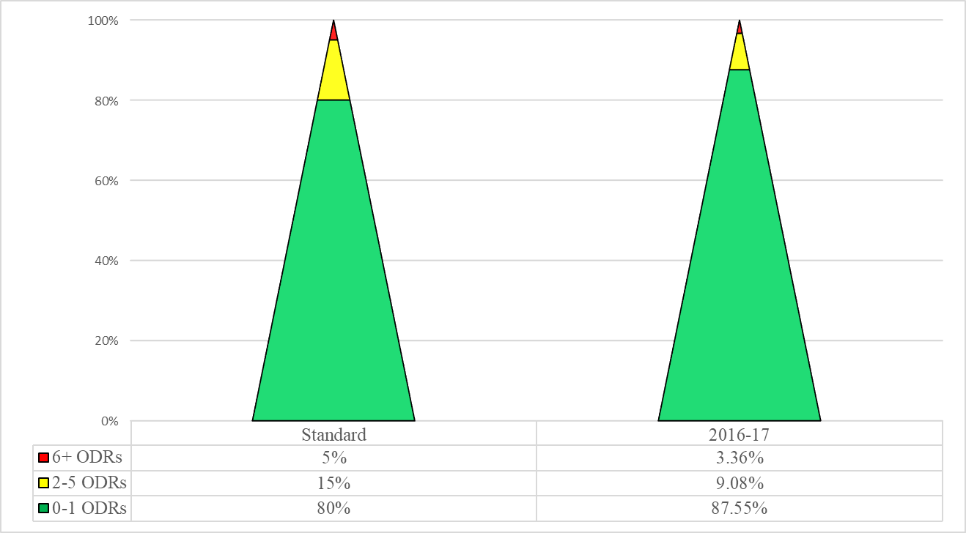

State Accreditation
State accreditation standards are designed to ensure that effective educational programs are established and maintained in Virginia's public schools. According to the Virginia 2018-2019 School Accreditation Report:
- 84% state-reported VTSS 1-3 schools are accredited for the 2018-19 academic year compared to 72% in 2017-18
- 12 of the 25 VTSS 1-3 school divisions had 100% of school accreditation compared to 8 in 2017-18

Standards of Learning (SOL)
A school’s accreditation is determined in part by the performance on Virginia’s SOL assessments. The SOLs establish minimum expectations for what students should know and be able to do at the end of each grade or course.

Division English SOL Pass Rates:
- 88% remained consistent or improved for all students from initial year of implementation to 2017-18
- 88% remained consistent or improved for African American students from initial year of implementation to 2017-18
- 76% remained consistent or improved for students with disabilities from initial year of implementation to 2017-18

Division Mathematics SOL Pass Rates:
- 72% remained consistent or improved for all students from initial year of implementation to 2017-18
- 52% remained consistent or improved for African American students from initial year of implementation to 2017-18
- 72% remained consistent or improved for students with disabilities from initial year of implementation to 2017-18
The initial year of implementation for VTSS 1-2 divisions was 2013-14 and the initial year of implementation for VTSS 3 divisions was 2014-15.
Similar to division pass rates, 79%, 69%, and 69% of state-reported VTSS 1-3 schools remained consistent or improved English SOL pass rates from initial year of implementation to 2017-18 for all students, African American students, and students with disabilities, respectively. Sixty-two percent (62%), 53% and 50% of state-reported VTSS 3 schools remained consistent or improved Mathematics SOL pass rates from initial year of implementation to 2017-18 for all students, African American students, and students with disabilities, respectively.

Graduation Rates
Graduation rates are an academic measure indicating student learning and the accreditation of high schools in Virginia. Figures 3 and 4 show the average division graduation rate for VTSS 1-2 and VTSS 3 along with the graduation rate for the state of Virginia for the last 5 years for all students and African American students, respectively. Both VTSS 1-2 and VTSS 3 division average graduation rates started below the state graduation rate but are now above the state average.
Figure 3. Average division graduation rates for VTSS 1-2, VTSS 3, and the state of Virginia for the last 5 years

Division graduation rates of African American students have increased in both VTSS 1-2 and VTSS 3 divisions remaining above the state graduation rate.
Figure 4. Average division graduation rates for African American students in VTSS 1-2, VTSS 3, and the state of Virginia for the last 5 years

Similar to division graduation rates, school graduation rates for African American students have increased in state-reported VTSS 1-2 and state-reported VTSS 3 schools remaining above the state graduation rate.
Table 1. Average graduation rates for African American in state-reported VTSS 1-2 schools and state-reported VTSS 3 schools for the last 5 years
 | 2013-14 | 2014-15 | 2015-16 | 2016-17 | 2017-18
VTSS 1-2 | 87.6 | 89.5 | 89.7 | 90.2 | 91.4
VTSS 3 | 86.8 | 87.0 | 89.4 | 91.1 | 92.3
State | 85.4 | 86.3 | 88.4 | 88.4 | 89.6

Mental Wellness
The integration of mental wellness into the VTSS framework is a priority of VDOE and is supported, in part, by a Project AWARE grant from the Substance Abuse and Mental Health Services Administration (SAMHSA). This work began in 2015 with three pilot LEAs developing a multi-tiered model that integrates a comprehensive and efficient systems approach for addressing the mental health needs of school-aged (K-12) youth.
One component of this work is to implement and expand the availability and delivery of Youth Mental Health First Aid (YMHFA/Adult) throughout the Commonwealth to increase early identification and intervention in cases of mental health distress in Virginia's youth and reduce the mental health stigma in the schools and wider communities. Since 2015, more than 4,499 adults have been trained in YMHFA as first-aiders, and 9,313 students have received referrals to mental health resources and/or services.
The LEAs established data systems that allow them to track student outcomes and make data-based decisions. Some major findings from the first 4 years of this work include:
- Over 2,851 students were served by school-based mental health professionals during the 2017-18 academic year; an increase of 71% from baseline.
- During 2017-18, 77.5% of students who were referred to community-based mental health services in two pilot divisions received services; an increase of 12% from baseline.
- The number of evidence-based programs being implemented in Project AWARE schools increased from 20 in 2015-16 to 106 in 2017-18. These programs are expected to impact mental health related risk and protective factors. The most commonly identified evidence-based programs are Positive Behavioral Interventions and Supports (PBIS) and Student Assistance Programs (SAP).
- Office Discipline Referral rates for students with disabilities decreased an average of 37% from 2015-16 to 2017-18. In-School Suspensions and Out-of-School Suspensions have decreased in the Project AWARE schools, in most cases for both general education students and students with IEP/504 plans.
- School Safety/School Climate improvements are evidenced by 3-year reductions in number of disorderly/disruptive behavior offenses (–58%) and other offenses against persons (–71.4%). In addition, there was a 58% increase in the percentage of students reporting that they have adults at school to talk with about a problem.
- Past 30-day alcohol and marijuana use declined among Project AWARE divisions from 2014 to 2018 by 45% and 21%, respectively.

Early Childhood
VTSS is expanding into Early Childhood with the purpose of investigating and identifying essential features for divisions applying the VTSS Framework to schools with early childhood programs and classrooms. This expansion includes the selection of three pilot sites who, through exploration and installation activities, will inform development activities of the work. Exploration steps include identifying a process for selecting pilot divisions; outlining the necessary requirements for participation as a pilot site; designing a training and technical assistance plan to recruit, coach, train, and support demonstration sites; and developing resources including early childhood enhancements for the Tiered Fidelity Inventory.

Family Engagement
VTSS partners with Formed Families Forward (FFF), a community parent resource center, to increase meaningful family engagement in implementation of tiered supports. School and division teams during the Summer 2018 Tier 1 Forums received research-based family engagement content and strategies. Family engagement was the focus of one strand of the division leadership trainings throughout the academic year. In addition, VTSS is capturing data about community engagement efforts. For example, Division Leadership Teams will receive a Family Engagement Survey allowing VTSS to carefully target our efforts moving forward.
In the past year, trauma has been a focus of family engagement efforts. Recognizing that many students and their families are faced with the realities of trauma and its impacts, over this past year, FFF and VTSS have created a series of three trauma-related videos on understanding trauma, responding to trauma, and trauma-sensitive schools. These videos are used during trainings and are available on YouTube. From August to November 2018, the videos were downloaded over 850 times. Based on data collected during Summer 2018, 92% training participants rated the videos as excellent or good. This focus on trauma aligns family engagement efforts with the integration of mental wellness into the VTSS framework.

Research and Implementation Center
Supported by the Virginia Department of Education, the Research and Implementation Center at the Virginia Commonwealth University Center for School-Community Collaboration (VTSS-RIC) strives to build state and local capacity for a sustained tiered system of academic, behavioral, and social-emotional supports that are responsive to the needs of all students.

Partners
- Virginia Department of Education
- VTSS Research and Implementation Center at the Virginia Commonwealth University Center for School Community Collaboration
- Old Dominion University
- Formed Families Forward
- Virginia Department of Education’s Training and Technical Assistance Centers at:
  - College of William and Mary
  - George Mason University
  - James Madison University
  - Old Dominion University
  - Radford University
  - Virginia Commonwealth University
  - Virginia Tech

Sponsors
- Virginia State Personnel Development Grant, Office of Special Education Programs, U.S. Department of Education, Award #H323A120026 and Award #H323A170018
- Virginia School Climate Transformation Grant, Office of Safe and Healthy Students, U.S. Department of Education, Award #S184F140020
- Virginia Project AWARE, Substance Abuse and Mental Health Services Administration, Department of Health and Human Services, Award #H79SM061987
- Virginia General Assembly Funds
TO REQUEST ASSISTANCE CONTACT:
Research and Implementation Center
3600 West Broad Street, Suite 117
Box 980626
Richmond, Virginia 23298-2020
(804) 828-1482
Email: vtssric@vcu.edu

