Virginia Tiered Systems of Supports (VTSS)
VTSS Annual Report
December 2019
Maribel Saimre, EdS, Office of Student Services, Virginia Department of Education (VDOE)
Michael Gregory, MSW, LSW, Office of Student Services, VDOE
Martha Montgomery, EdS, Office of Student Services, VDOE
Sophia Farmer, MT, VTSS Research and Implementation Center (RIC) at Virginia Commonwealth University
Steve Tonelson, EdD, Center for Implementation and Evaluation of Education Systems (CIEES) at Old Dominion University
Corinne Wilson, PhD, CIEES at Old Dominion University
Amanda Working, PhD, CIEES at Old Dominion University
Regina Pierce, MEd, VTSS-RIC at Virginia Commonwealth University
Whitney Miller, EdS, VDOE Training and Technical Center (TTAC) at Virginia Tech
Mary Tobin, MEd, VDOE TTAC at Virginia Commonwealth University
Elisa Rosman, PhD, Formed Families Forward

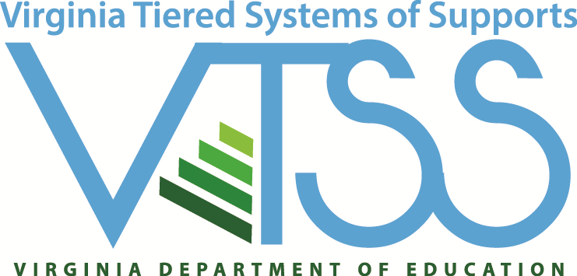

VTSS RIC Website

Virginia Tiered Systems of Supports (VTSS)
The Virginia Department of Education seeks to provide a high quality, effective learning environment for all students and has identified this as its first priority within the Virginia Board of Education’s Comprehensive Plan 2018-2023. Ongoing work focuses on supporting our teachers, school, and community leaders in providing appropriate supports to a diverse student body.
To accomplish this, the Virginia Tiered Systems of Supports (VTSS) establishes a decision-making framework in divisions and schools. This framework provides a system to integrate academic, behavioral, and mental wellness supports. The VTSS approach facilitates the ability of divisions, schools, and communities to provide multiple levels of supports to students in a more effective and efficient, clearly defined process.
The vision of VTSS is to build capacity for a sustained tiered system of academic, behavioral, and social-emotional supports that are responsive to the needs of all students. Our mission is to:
- Promote a culture of continuous growth through ongoing professional learning.
- Implement with fidelity, proactive and preventative evidence-based practices to support (improved) measurable academic and social behavioral outcomes.
- Use data informed problem solving, decision-making, screening, and progress monitoring to effectively meet instructional needs.
- Build an integrated framework that promotes shared leadership at the division, school, classroom, and community levels.

Division Leader Comments
Division leaders provided feedback on the impact of VTSS implementation during interviews and focus groups. Comments included:
“In the first three years of implementing PBIS, [our] school was only partially accredited. We quickly became fully accredited based on state and federal requirements. Additionally, since joining VTSS, we have lowered all overall discipline for the entire school community from 35% of students having at least one office referral to 15%.”
“Student data is the focus. The VTSS tiered-support framework helps us identify those students who really need additional academic and/or behavioral supports.”
“If kids aren’t doing well, either academically or behaviorally, staff bring data to the school data team meeting where we problem-solve, trying to figure out if this an instruction issue, a mismatch, a fidelity issue, time, [etc.]…”

VTSS Implementation Milestones
2005 Effective School-wide Discipline (ESD) is initiated by VDOE to support schools in the implementation of positive behavior change through training and technical assistance.
2007 Response to Intervention (RtI) is initiated to provide a multi-tiered system of academic supports.
2008 ESD is rebranded as Positive Behavioral Interventions and Supports (PBIS) of Virginia.
2010 VDOE’s cascading model of support increases focus on building capacity at the division level to maximize and sustain student academic and social-behavior success.
2012 VTSS is established through the integration of PBIS and the RtI.
2013 VTSS Cohort 1 (3 divisions) receives training and technical assistance.
2014 VTSS expands to 11 additional school divisions (Cohort 2).
2015 VTSS-Research and Implementation Center is created to continue to build state capacity to support training and technical assistance efforts.
2015 VDOE receives a federal School Climate Transformation Grant (SCTG) to enhance and scale-up systems of support for implementing evidence based, multi-tiered behavioral frameworks for improving learning conditions and outcomes for all students.
2015 VTSS expands to 12 additional school divisions (Cohort 3).
2015 VDOE receives a Project AWARE grant introducing mental health supports within the VTSS framework that is piloted in 3 school divisions.
2017 VTSS expands to 15 additional school divisions (Cohort 4).
2018 VDOE receives a second federal SCTG to enhance and scale-up systems of support for implementing evidence-based multi-tiered behavioral frameworks for improving learning conditions and outcomes for all students. The 2018 SCTG includes targeted supports for mental wellness, trauma sensitive practices, cultural responsivity, and opioid use.
2018 VTSS expands to 14 additional school divisions (Cohort 5).
2019 VTSS expands to 2 additional school divisions (Cohort 6) with a focus on opioid and other substance use reduction. A total of 54 school divisions now receive VTSS support in order to implement a comprehensive, aligned, academic, behavior, and social-emotional framework.

Virginia’s Vision
The vision of the Virginia Department of Education, in collaboration with the governor, secretary of education, General Assembly, Virginia Board of Education, local school boards, education stakeholders, and parents, is to create an excellent system of public education that prepares every Virginia student for success.

VTSS Professional Development
Evidence-based professional development supports the establishment and sustainability of the Virginia Tiered Systems of Supports (VTSS) framework in school divisions across Virginia. VTSS offers regular state-wide and regional professional learning opportunities for divisions. Face-to-face and virtual opportunities to explore VTSS are provided. These events follow an established process to ensure the well-designed implementation of VTSS principles and practices. Over the past six years, division leadership teams have honed their skills in supporting and implementing VTSS in their school division. Many divisions now have VTSS coaches who have developed their skills through VTSS professional development.
VTSS professional development collects event evaluation data regarding the impact of the professional development on participants. These data contribute to the on-going improvement model that VTSS uses in creating and providing professional development. An average of 94% of participants in VTSS professional development report that they believe they are more skilled in implementing VTSS as a result of those learning experiences.
Between January 1, 2019 and December 31, 2019, VTSS:
- Held 48 state-wide professional learning events reaching more than 3,000 educators
- Provided regional or division based professional development
- Provided technical assistance and coaching to all participating VTSS school divisions
- Collaborated with the VDOE and other organizations to provide the highly successful Virginia is for All Learners Equity Conference with over 2,000 attendees from 2016 to 2019.
Coaching is central to VTSS professional development. Research shows that coaching significantly improves the outcomes of professional development. The VTSS includes state Systems Coaches from the VDOE Training and Technical Assistance Centers and Research and Implementation Center. These coaches partner and collaboratively assist participating school divisions. Division leaders highly value the work of the coaches in helping them implement the VTSS framework as evidenced by level of satisfaction and value of resource survey results.
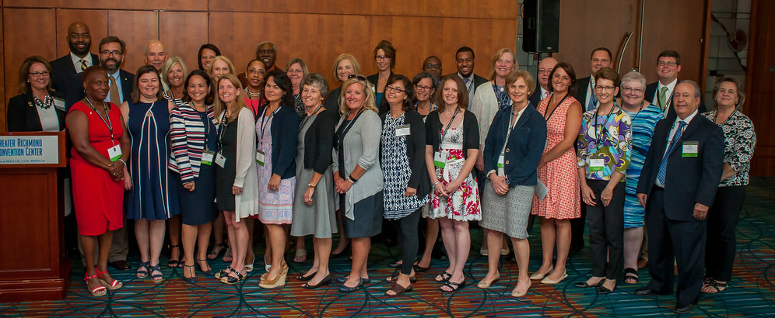

VTSS School Divisions
As of December 2019, there are 54 school divisions receiving support from and providing data to VTSS.

Cohorts 1-2
Charlottesville City
Essex County
Fauquier County
Frederick County
Greensville County
Northampton County
Orange County
Page County
Pittsylvania County
Powhatan County
Prince William County
Surry County
Westmoreland County

Cohort 3
Fairfax County
Hanover County
Madison County
Montgomery County
Northumberland County
Prince Edward County
Pulaski County
Virginia Beach City
Warren County
Waynesboro City
Williamsburg-James City County

Cohort 4
Amherst County
Brunswick County
Chesapeake City
Cumberland County
Danville City
Henrico County
Henry County
Lynchburg City
Martinsville City
Nelson County
Newport News City
Portsmouth City
Richmond City
Southampton County
Suffolk City

Cohort 5
Alleghany County
Caroline County
Chesterfield County
Falls Church City
Gloucester County
Grayson County
Loudoun County
Lunenburg County
Mecklenburg County
Petersburg City
Poquoson City
Salem City
York County

Cohort 6
Buchanan County
Norfolk City

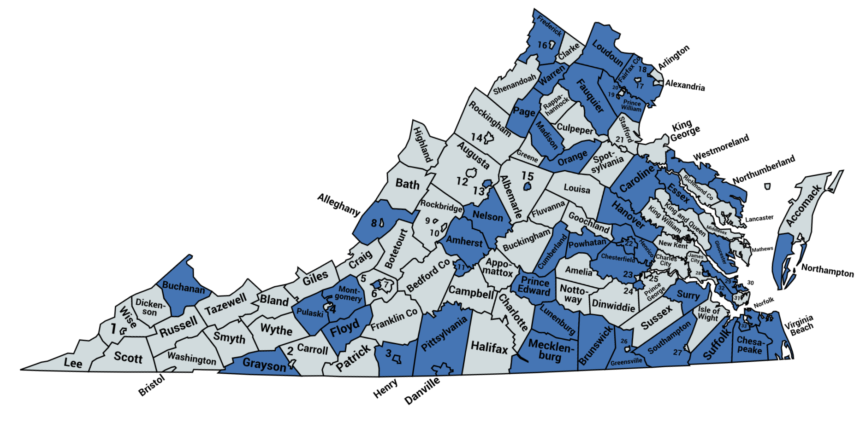

VTSS State-reported Schools
State-reported schools are identified as “pilot” or “demonstration” sites by the divisions and have received training/technical assistance from the VDOE to implement VTSS. There are 38 state-reported schools within the 13 school divisions in Cohorts 1-2, 49 state-reported schools within the 11 divisions in Cohort 3, 28 state-reported schools within the 15 divisions in Cohort 4, and 36 state-reported schools within the 13 divisions in Cohort 5. See Appendix A on pages 16-18 for a list of VTSS state-reported schools by division.
The 13 VTSS 1-2 divisions began implementation in 2012-13/2013-14 and have expanded from 38 state-reported schools to 143 schools submitting fidelity and outcome data to the VTSS data collection system. The 11 VTSS 3 divisions began implementation in 2015 and have expanded from 49 state-reported schools to 138 schools submitting fidelity and outcome data to the VTSS. The 15 VTSS 4 divisions began implementation in 2017 and have a total of 182 schools submitting fidelity and outcome data to the VTSS of which 28 were state-reported. VTSS 5 divisions began implementation in 2018. At the end of year one, these 13 divisions had a total of 83 schools submitting fidelity and outcome data to the VTSS of which 36 were state-reported. VTSS Cohort 6 divisions began implementation in 2019 and will identify state-reported schools by April 2020.
As of December 1, 2019, a total of 550 schools in the 54 VTSS school divisions submit fidelity and outcome data to the VTSS data collection system.

Positive Behavioral Interventions and Supports (PBIS)
There are also divisions, not currently in a VTSS Cohort, that previously received training/technical assistance to implement PBIS and have at least one school that continues to submit fidelity/outcome data to VTSS. As of December 2019, there were 49 registered PBIS schools in 14 divisions that submit fidelity and outcome data to the VTSS data collection system.

PBIS Divisions

Region 3
King George County
Lancaster County
Middlesex County
Spotsylvania County
West Point

Region 4
Culpeper County

Region 5
Bath County
Bedford County
Greene County

Region 6
Franklin County

Region 7
Dickenson County
Russell County
Tazewell County

Region 8
Halifax County

VTSS Data
VTSS collects data during three data collection periods: New School Entry, Midyear, and End-of-Year. New School Entry establishes a school in the VTSS data collection system. Midyear collects school-level VTSS implementation fidelity using the Tiered Fidelity Inventory (TFI) and division-level capacity to implement VTSS using the Division Capacity Assessment (DCA). End-of-Year school-level data collection includes student enrollment and disciplinary outcome data including Office Discipline Referrals (ODRs), In-School Suspensions (ISSs), and Out-of-School Suspensions (OSSs) by gender, ethnicity/race, and disability type. End-of-Year division-level data collection included Value of Resources, Level of Satisfaction, and Family Engagement surveys. Data presented in the following sections is based on the 2018-19 data collection periods during which Cohort 1-5 schools were participating in VTSS.

Data Submissions
Data submission rates for the 2018-19 academic year:
- Midyear
  - 100% of VTSS state-reported schools
  - 100% of VTSS divisions
- End-of-Year
  - 99.3% of VTSS state-reported schools
  - 96% of VTSS divisions
During Midyear 2019, 151 of 151 state-reported VTSS schools submitted the TFI and 52 of the 52 VTSS divisions submitted the DCA. During End-of-Year 2019, 150 of 151 state-reported VTSS schools submitted the School Profile and Outcome Summary Data form, 50 of 52 VTSS divisions submitted the Value of Resources, Level of Satisfaction, and Family Engagement surveys.
Overall, 589 Virginia schools submitted Midyear 2019 data and 588 Virginia schools submitted End-of-Year 2019 data to the VTSS data collection site.

Impact on School Discipline
From academic year 2017-18 to 2018-19, state-reported VTSS 1-3 schools had a
- Office Discipline Referrals (ODRs)
  - 9% decrease in ODRs for general education students.
  - 2% decrease in ODRs for students with disabilities.
- Out-of-School Suspensions (OSSs)
  - 4% decrease for general education students.
  - 8% decrease for students with disabilities.
These decreases are based on 87 VTSS 1-3 state-reported schools that submitted both End-of-Year 2018 and End-of-Year 2019 data without unknown values or inaccuracies.
State-reported VTSS 1-2 schools have submitted outcome summary data for five consecutive years. Figure 1 indicates the average number of office discipline referrals (ODRs) for students in general education (GE) and Figure 2 for students with disabilities (SWD) from initial year of implementation (academic year 2014-15) to academic year 2018-19. Average ODRs for both groups of students decreased (38% GE, 15% SWD) from initial year of implementation to academic year 2018-19.
Figures 1-2. Average Total Number of Office Discipline Referrals for General Education and Students with Disabilities in state-reported VTSS 1-2 Schools

*These averages are based on VTSS 1-2 state-reported schools that submitted data all four years without unknown values or inaccuracies.
Figure 3 indicates the average total number of suspensions (in-school and out-of-school) for students in general education and Figure 4 for students with disabilities in VTSS 1-2 schools from initial year of implementation (academic year 2014-15) to academic year 2018-19. Average OSSs for both groups of students decreased (39% GE, 20% SWD) from initial year of implementation to academic year 2018-19.
Figures 3-4. Average Total Number of Suspensions (Out-of-School Suspensions/In-School Suspensions) for General Education and Students with Disabilities in state-reported VTSS 1-2 Schools

*These averages are based on VTSS 1-2 state-reported schools that submitted data all four years without unknown values or inaccuracies.

Impact on Administrative and Instructional Time
VTSS implementation saved on average from academic year 2014-15 to 2018-19:
- 1.77 student instructional hours per week per school
- 3.09 administrative hours per week per school
These estimates are based on an average of 20 minutes of lost instructional time for students per referral and 10 minutes per ODR and 45 minutes per suspension (OSSs/ISSs) of administrative time. Estimates are calculated using a school year consisting of 180 school days with 5-day weeks (average minutes per day × 5 / 60).

Tier Analysis
In a multi-tiered system of supports framework, student supports are tiered as follows:
- Tier 1: Universal supports for ALL students.
- Tier 2: Targeted group supports for SOME students.
- Tier 3: Individual supports for a FEW students.
Behaviorally, a student with 0-1 ODRs is considered successful with Tier 1 supports, a student with 2-5 ODRs is provided with Tier 2 supports, and a student with 6 or more ODRs is provided with Tier 3 supports. Ideally, a school should have no more than 20% of the student body receiving Tier 2 supports and no more than 5% of students receiving additional Tier 3 supports. Figure 5 shows the standard student enrollment by tier (80% Tier 1, 15% Tier 2, and 5% Tier 3) and the average tier enrollment for VTSS state-reported schools in 2018-19.
VTSS state-reported schools have less than the standard percent of students in Tiers 2 and 3.
Thus, fewer students require higher intensity supports!
Figure 5. Student Enrollment by Number of Office Discipline Referrals (ODRs)
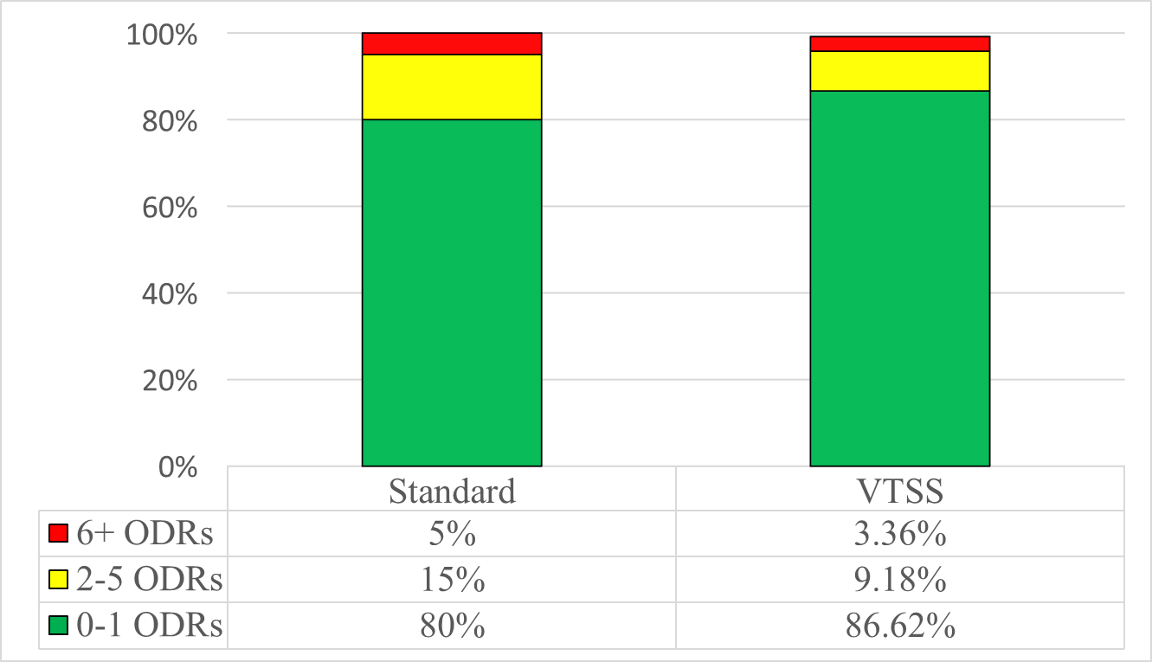

State Accreditation
State accreditation standards are designed to ensure that effective educational programs are established and maintained in Virginia's public schools. According to the Virginia 2019-20 School Accreditation Report:
- 92% of VTSS 1-3 schools are accredited for the 2019-20 academic year
- 12 VTSS 1-3 school divisions had 100% of schools accredited

Standards of Learning (SOL)
A school’s accreditation is determined in part by student performance on Virginia’s SOL assessments. The SOLs establish minimum expectations for what students should know and be able to do at the end of each grade or course.

VTSS 1-3 Division English SOL Pass Rates:
- 67% remained consistent or improved for all students from initial year of implementation to 2018-19
- 67% remained consistent or improved for African American students from initial year of implementation to 2018-19
- 58% remained consistent or improved for students with disabilities from initial year of implementation to 2018-19

VTSS 1-3 Division Mathematics SOL Pass Rates:
- 92% remained consistent or improved for all students from initial year of implementation to 2018-19
- 83% remained consistent or improved for African American students from initial year of implementation to 2018-19
- 96% remained consistent or improved for students with disabilities from initial year of implementation to 2018-19
The initial year of implementation used for VTSS 1-2 divisions was academic year 2013-14, and the initial year of implementation for VTSS 3 divisions was academic year 2015-16.
Seventy-four percent (74%), 66%, and 68% of state-reported VTSS 1-2 schools remained consistent or improved English Reading SOL pass rates from 2013-14 to 2018-19 for all students, African American students, and students with disabilities, respectively. Eighty-seven (87%), 87%, and 79% of state-reported VTSS 1-2 schools remained consistent or improved Mathematics SOL pass rates from 2013-14 to 2018-19 for all students, African American students, and students with disabilities, respectively.

Graduation Rates
Graduation rates are an academic measure indicating student learning and a component of accreditation for high schools in Virginia. Figure 6 illustrates the state graduation rate for students across all divisions compared with the average graduation rate for students in VTSS 1-2 divisions. VTSS 1-2 divisions started below the state in 2013-14 (initial year of implementation) and are now, on average, performing above the state rate.
Figure 6. State graduation rate and average VTSS 1-2 division graduation rates

Figure 7 illustrates trends in the state graduation rate of African American students across all divisions compared with the average graduation rate for African American students in VTSS 3 divisions. On average, African American students in VTSS divisions are graduating at a higher rate than the state as a whole. This gap has increased since 2015-16 (initial year of implementation).
Figure 7. State graduation rate and average VTSS 3 division graduation rates for African American Students

Mental Wellness
The integration of mental wellness into the VTSS framework is a priority of VDOE and was supported, in part, by a Project AWARE grant from the Substance Abuse and Mental Health Services Administration (SAMHSA). This work began in 2015 and ended in 2019 with three pilot divisions (Fairfax, Montgomery, and Pulaski) developing a multi-tiered model that integrates a comprehensive and efficient systems approach for addressing the mental health needs of school-aged (K-12) youth.
One component of this work was to implement and expand the availability and delivery of Youth Mental Health First Aid (YMHFA/Adult) throughout the Commonwealth to increase early identification and intervention in cases of mental health distress in Virginia's youth and reduce the mental health stigma in schools and the wider communities. From 2015 to 2019, a project total of 5,323 adults have been trained in YMHFA as first-aiders, and 9,926 students have received referrals to mental health resources and/or services.
The divisions established data systems that allow them to track student outcomes and make data-based decisions. Some major findings from this work include:
- During the 2018-19 academic year, 4,936 students were served by school-based mental health professionals; an increase of 195% from 2014-15.
- During 2018-19, 458 of 790 students referred to community-based mental health services received services.
- The number of evidence-based programs being implemented in Project AWARE schools increased from 20 in 2015-16 to 139 in 2018-19. These programs are expected to impact mental health related risk and protective factors. The most commonly identified evidence-based programs are Positive Behavioral Interventions and Supports (PBIS) and Student Assistance Programs (SAP).
- Office Discipline Referral and Out-of-School Suspension rates for students with disabilities decreased an average of 32% and 29%, respectively, from 2015-16 to 2018-19.
- School Safety/School Climate improvements are evidenced by 4-year reductions; 59% decrease in number of disorderly/disruptive behavior offenses, and 69% decrease in other offenses against persons. During 2018-19, 76.8% to 82.75% of students in Project AWARE divisions report that they have adults to talk with about a personal problem, an increase for each division from the initial year of data collection.
- Past 30-day alcohol and marijuana use declined among VTSS High schools in Project AWARE divisions from 2014 to 2018 by 45% and 21%, respectively.

Strategic Instruction Model (SIM) and Fusion Reading
Academic year 2019-20 was the second year that in collaboration with VTSS the VDOE Training and Technical Assistance Center (T/TAC) at Virginia Tech offered training on the Strategic Instruction Model (SIM) and Fusion Reading to VTSS schools. SIM includes two types of evidence-based instructional tools, known as Content Enhancement Routines and Learning Strategies for teachers and students. Content Enhancement Routines are sets of inclusive teaching practices that help teachers organize and present critical information in such a way that students identify, organize, comprehend, and recall it. Some students require more intensive, systematic, explicit instruction of content, strategies, and skills. SIM Learning Strategies are designed to provide the skills and strategies students need to learn the content. Learning Strategies encompass strategies for acquiring information from the printed word and for expressing information in writing. There are currently seven VTSS schools implementing SIM Content Enhancement Routines and/or Learning Strategies in the 2019-20 academic year.
Fusion Reading (FRP) is a one to two-year, based on implementation, evidence-based supplemental reading course designed to significantly improve the reading performance of students in sixth through 12th grade who have fallen two or more grade levels behind in reading. FRP is an intervention that can be utilized for students at-risk and with disabilities receiving Tier 2 or Tier 3 instruction. Fusion Reading is a comprehensive reading intervention that incorporates decoding, advanced phonics, sight word recognition, vocabulary, fluency, and comprehension. Students learn strategies to become better readers, both in their reading class, as well as transferring learning into other academic classes. A major goal of the program is to increase student motivation by linking reading with personal goal attainment and relying on highly engaging reading materials to help them become college and career ready. Several studies (e.g., random assignment, quasi-experimental comparison, and single group pre/post-test designs) for Fusion Reading have found moderate to large effect sizes.¹ There are currently three VTSS schools implementing Fusion Reading in the 2019-20 academic year.
Reading SOL scores for students with disabilities will be used to assess the impact SIM/Fusion Reading implementation once the 2019-20 academic year is complete.
¹Hock, M. F., Brasseur-Hock, I. F., Hock, A. J., & Duval, B. (2015). The Effects of a comprehensive reading program on reading outcomes for middle school students with disabilities. Journal of Learning Disabilities, 50(2), 195-212.

Early Childhood
VTSS continues expansion into Early Childhood with the purpose of investigating and identifying essential features for divisions applying the VTSS Framework to schools with early childhood programs and classrooms. Currently, three VTSS divisions are participating in the early childhood pilot and will inform development activities of the work. Preliminary information gathered from exploration activities in the first pilot site has provided valuable information to guide the design of the technical assistance plan that will be used to support other divisions. These essential activities include mapping the early childhood experience in the division to inform the organization of teaming structures and identifying early childhood division leadership who can promote alignment of early childhood systems and processes vertically and horizontally across the division framework.
VTSS continues to engage in activities that support capacity building within participating divisions by engaging Systems Coaches in discussions to improve the scope of services and supports for early care and education throughout the state. Additional activities include continuing to develop resources such as the early childhood enhancements for the Tiered Fidelity Inventory (TFI Companion Guide: Early Childhood Planning Tool). Pilot divisions are field testing Tier 1 of this new resource.

Family Engagement
VTSS partners with Formed Families Forward (FFF), a community parent resource center, to increase meaningful family engagement in implementation of tiered supports. During the Summer 2019 Tier 1 Forums, school and division teams received research-based family engagement content and strategies. Family engagement was the focus of one strand of the division leadership trainings throughout the academic year.
For the first time in spring 2019, VTSS began collecting data addressing family engagement efforts. The Family Engagement Survey, a 10-item survey, was administered at End-of-Year (EOY) 2019 to division coordinators in all VTSS/PBIS divisions. Ninety-six percent (96%) of VTSS divisions completed the Family Engagement Survey. Additionally, schools were asked to submit End-of-Year data regarding their family engagement efforts. In this collection effort, 90% of VTSS schools submitted data. Division and school data will be used as baseline to measure changes in family engagement efforts within VTSS.
To support divisions, schools, and families in increasing efforts to engage families in VTSS, Formed Families Forward produced three brief videos highlighting six key elements: positive relationships, empowering families, collaborative problem-solving, data-based goals and outcomes, leadership, and a multi-dimensional, multi-tiered approach. Screened during the Summer 2019 Tier 1 Forums in Harrisonburg and Richmond, 87% of screening attendees were very satisfied or satisfied with the content of the videos, 84% were very likely or likely to share the videos, and 77% were very likely or likely to share the videos. These results were very positive across the board.

Virginia Department of Education
Virginia Department of Education through the VTSS initiative strives to build state and local capacity for a sustained tiered system of academic, behavioral, and social-emotional supports that are responsive to the needs of all students.

Partners
- VTSS Research and Implementation Center at the Virginia Commonwealth University
- Center for Implementation of Evaluation Education Systems at Old Dominion University
- Formed Families Forward
- Virginia Department of Education’s Training and Technical Assistance Centers at:
  - College of William and Mary
  - George Mason University
  - James Madison University
  - Old Dominion University
  - Radford University
  - Virginia Commonwealth University
  - Virginia Tech

Funding
- Virginia State Personnel Development Grant, Office of Special Education Programs, U.S. Department of Education, Award #H323A170018
- Virginia School Climate Transformation Grant, Office of Safe and Healthy Students, U.S. Department of Education, Award #S184F140020
- Virginia School Climate Transformation Grant, Office of Safe and Healthy Students, U.S. Department of Education, Award #S184F180014
- Virginia Project AWARE, Substance Abuse and Mental Health Services Administration, Department of Health and Human Services, Award #H79SM061987 (ended September 2019)
- Virginia General Assembly Funds
TO REQUEST ASSISTANCE CONTACT:
Research and Implementation Center
3600 West Broad Street, Suite 117
Box 980626
Richmond, Virginia 23298-2020
(804) 828-1482
Email: vtssric@vcu.edu

Appendix – List of VTSS State-reported Schools
State-reported schools are identified as “pilot” or “demonstration” sites by the divisions and have received training/technical assistance from VDOE to implement VTSS. There are 38 state-reported schools within the 13 school divisions in Cohorts 1-2, 49 state-reported schools within the 11 divisions in Cohort 3, 28 state-reported schools within the 15 divisions in Cohort 4, and 36 state-reported schools within the 13 divisions in Cohort 5 (see page 6 for a list of divisions in each cohort). This appendix contains a list of state-reported schools by region and division.

Section listing State-reported Schools

Alleghany County
Clifton Middle
Mountain View Elementary

Amherst County
Amherst County High

Brunswick County
None

Buchanan County
None

Caroline County
Bowling Green Elementary
Caroline Middle

Charlottesville City
Buford Middle

Chesapeake City
Camelot Elementary
Truitt Intermediate

Chesterfield County
Manchester High
Providence Elementary
Providence Middle

Cumberland County
Cumberland Elementary
Cumberland Middle

Danville City
Woodberry Hills Elementary

Essex County
Essex High
Essex Intermediate
Tappahannock Elementary

Fairfax County
Centreville High
Fairfax High
Falls Church High
South Lakes High
West Potomac High

Falls Church City
Thomas Jefferson Elementary

Fauquier County
C.M. Bradley Elementary
Cedar Lee Middle
James G. Brumfield Elementary
Liberty High
Marshall Middle

Frederick County
James Wood Middle
Millbrook High
Redbud Run Elementary
Robert E. Aylor Middle

Gloucester County
Abingdon Elementary
Gloucester High
Page Middle
Peasley Middle

Grayson County
Grayson Highlands

Greensville County
Belfield Elementary
Edward W. Wyatt Middle
Greensville County High
Greensville Elementary

Hanover County
Henry Clay Elementary
John M. Gandy Elementary
Liberty Middle
Patrick Henry High

Henrico County
Arthur Ashe Jr. Elementary
Highland Springs Elementary
Hungary Creek Middle

Henry County
Laurel Park Middle

Loudoun County
Ball’s Bluff Elementary
Harper Park Middle
John W. Tolbert Jr. Elementary

Lunenburg County
Central High
Kenbridge Elementary
Lunenburg Middle
Victoria Elementary

Lynchburg City
E.C. Glass High
Linkhorne Middle

Madison County
Madison County High
Madison Primary
Waverly Yowell Elementary
William H. Wetsel Middle

Martinsville City
Albert Harris Elementary

Mecklenburg County
LaCrosse Elementary
South Hill Elementary

Montgomery County
Eastern Montgomery Elementary

Nelson County
Nelson County High
Nelson Middle

Newport News City
Horace H. Epes Elementary
Joseph H. Saunders Elementary
Kiln Creek Elementary

Norfolk City
None

Northampton County
Kiptopeke Elementary
Northampton High
Northampton Middle
Occohannock Elementary

Northumberland County
Northumberland Elementary
Northumberland High
Northumberland Middle

Orange County
Orange County High
Orange Elementary
Prospect Heights Middle

Page County
Luray Elementary
Page County Middle
Stanley Elementary

Petersburg City
Vernon Johns Middle

Pittsylvania County
Chatham Middle
Dan River Middle
Dan River Senior High
Gretna Senior High
John L. Hurt Elementary
Kentuck Elementary
Stony Mill Elementary

Poquoson City
Poquoson Elementary
Poquoson Primary

Portsmouth City
Churchland Middle
Cradock Middle
I.C. Norcom High

Powhatan County
Pocahontas Elementary

Prince Edward County
Prince Edward County High
Prince Edward Elementary
Prince Edward Middle

Prince William County
Leesylvania Elementary

Pulaski County
Critzer Elementary
Pulaski County Senior High
Pulaski Elementary
Pulaski Middle

Richmond City
None

Salem City
Andrew Lewis Middle
East Salem Elementary
G.W. Carver Elementary
South Salem Elementary
West Salem Elementary

Southampton County
Southampton High
Southampton Middle

Suffolk City
Booker T. Washington Elementary
Elephant’s Fork Elementary
Hillpoint Elementary
Mack Benn Jr. Elementary
Nansemond Parkway Elementary

Surry County
Luther P. Jackson Middle

Virginia Beach City
Bayside Elementary
Bayside Middle – Campus 6
Bayside Middle – Campus 7/8
Brandon Middle
Frank W. Cox High
Green Run High
Independence Middle
Kempsville High
Plaza Middle
Point O’View Elementary
Renaissance Academy
Strawbridge Elementary

Warren County
Bright Futures Learning Community
Ressie Jefferies Elementary
Skyline High
Skyline Middle
Warren County High

Waynesboro City
Kate Collins Middle
Waynesboro High

Westmoreland County
Washington and Lee High

Williamsburg-James City County
Berkeley Middle
D.J. Montague Elementary
Jamestown High
Lafayette High
Lois Hornsby Middle
Matthew Whaley Elementary

York County
Grafton Middle
Queens Lake Middle
Tabb High
Waller Mill Elementary
York High
Yorktown Elementary

