

Creating Capacity for Change Collaborative: Updates on Multi-Tiered Systems of Supports (MTSS) in Virginia for 2023-2024

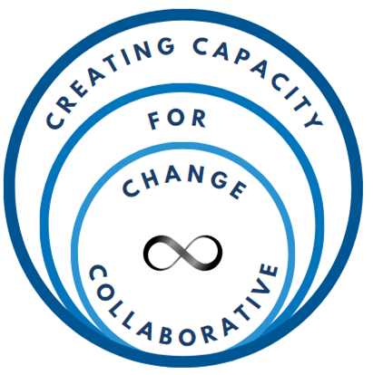

# Introduction

The Virginia Department of Education (VDOE) is committed to ensuring that every learner achieves their fullest potential and meets rigorous academic standards. This goal stands as the Virginia Board of Education's top priority in the VDOE’s Comprehensive Plan for 2024-2029, underscoring the state's dedication to educational excellence for all children. Ongoing Board priorities include supporting teachers, school, and community leaders in providing effective support to a diverse student body.

As a part of this effort, the VDOE established the Creating Capacity for Change Collaborative (CCCC) to support staff and student outcomes through the implementation of multi-tiered systems of support (MTSS). The CCCC, led by the VDOE in partnership with the Virginia Tiered Systems of Supports, is comprised of state leaders, division leaders, school leaders, and community constituents.

## Report Structure

This report is organized by implementation effort. For the Virginia Tiered Systems of Supports (VTSS), implementation efforts are reported by the domains of reach, process, capacity, and outcomes along with the VTSS focus of family engagement.

* Timeline of Support for Tiered Services Initiatives in Virginia
* Virginia Tiered Systems of Supports
  + *Reach*
  + *Process:* Training
  + *Process:* Technical Assistance and Coaching
  + *Capacity*
  + *Outcomes:* Academics
  + *Outcomes:* Behavior
  + **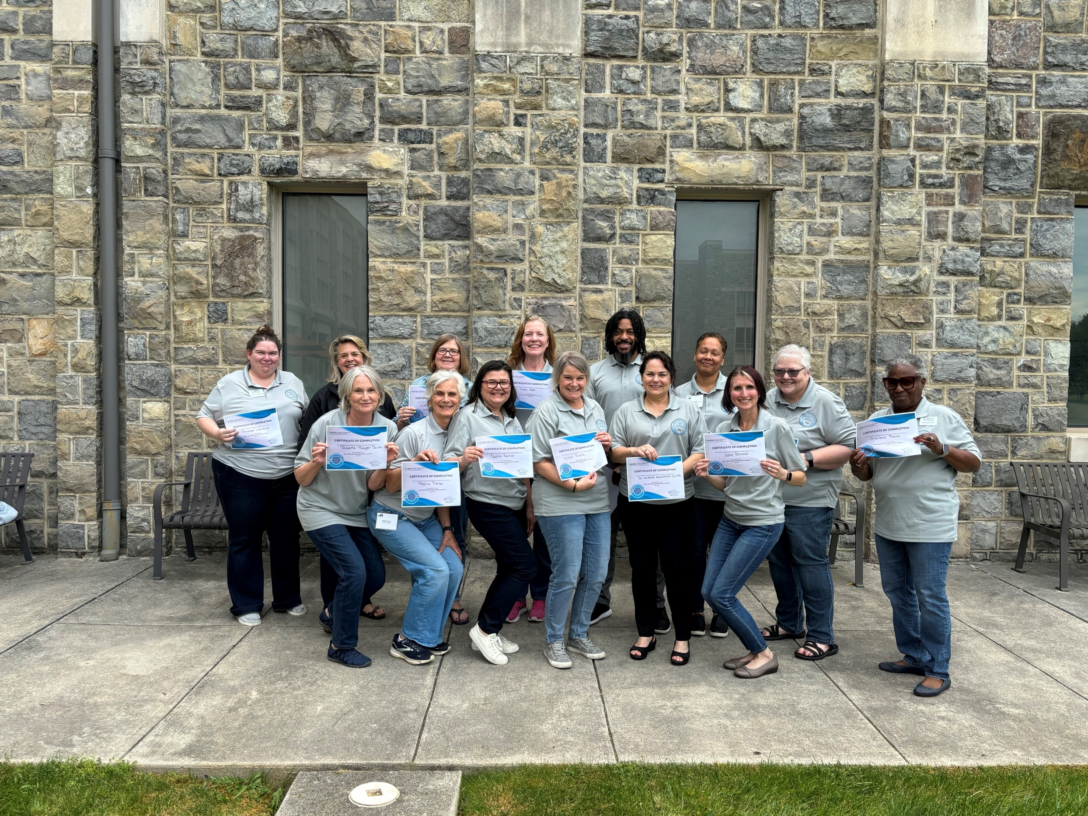***Outcomes:* Chronic Absenteeism
* Family Engagement
* Virginia’s Approach to Retention of Special Education Teachers
* Virginia’s Comprehensive Approach to Recruitment and Retention of School Mental Health Providers
* State Personnel Development Grant
* Implementation Science Academy
* Collaborators

# Timeline of Support for Tiered Services Initiatives in Virginia

Since 2007, the VDOE has received eight federal grants focused on providing tiered supports to students in schools. These grants have included four State Professional Development Grants (SPDGs), two federal School Climate Transformation Grants (SCTGs), a Project Aware Grant, a Personnel Development Grant (PDG), and a School Based Mental Health Grant (SBMH).

This image shows a timeline of VDOE grants supporting tiered service initiatives in VA. 
In 2007, the Virginia Department of Education received the first State Professional Development Grant focused on supporting tiered supports to students in schools.
In 2012, the Virginia Department of Education received the second State Professional Development Grant.
In 2015, the Virginia Department of Education received the first School Climate Transformation Grant and a Project AWARE grant.
In 2017, the Virginia Department of Education received the third State Professional Development Grant.
In 2018, the Virginia Department of Education received the second School Climate Transformation Grant.
In 2021, the Virginia Department of Education received a Professional Development Grant.
In 2023, the Virginia Department of Education received the fourth State Professional Development Grant and a School-based Mental Health Grant.
The focus of all these grants includes tiered supports to students. 

These grants have funded the evolution of tiered systems of support initiatives in Virginia. Implementation milestones include:

* **2005:** Effective School-wide Discipline (ESD) was established to support positive behavior change through tiered supports.
* **2007:** Response to Intervention (RtI) was initiated to a provide multitiered system of academic supports.
* **2008:** ESD was rebranded Positive Behavioral Interventions and Supports (PBIS) of Virginia.
* **2012:** The VTSS was established through the integration of PBIS and RtI supports within a MTSS framework.
* **2015:** The VDOE focused on enhancing and scaling up tiered systems of support along with introducing mental health into the tiered systems. Additionally, the VTSS-Research and Implementation Center (VTSS-RIC) was created to build state capacity to support training and technical assistance.
* **2021:** The VDOE expanded efforts toward retaining Special Education Teachers through a MTSS framework.
* **2023:** The VDOE expanded efforts toward recruiting and retaining school-based mental health providers through a MTSS framework.

# Virginia Tiered Systems of Supports (VTSS)

The Virginia Department of Education (VDOE) established the VTSS and the VTSS-Research and Implementation Center (VTSS-RIC) at Virginia Commonwealth University to support implementation of multi-tiered systems of support (MTSS). The VTSS, led by the VDOE, collaborates with state universities to provide coaching, technical assistance, and professional learning to school division teams to establish and sustain implementation of their MTSS. The vision of the VTSS is to build sustainable MTSS through collaboration with divisions, schools, families, communities, and students resulting in improved academic, behavioral, and social emotional outcomes for all students.

Through this network of technical assistance, VTSS State Systems Coaches work with school division teams to establish a decision-making framework. This framework provides a system to integrate academic, behavioral, and social-emotional wellness supports. The VTSS approach facilitates the ability of divisions, schools, and communities to provide multiple layers of support to students in an effective, clearly defined process.

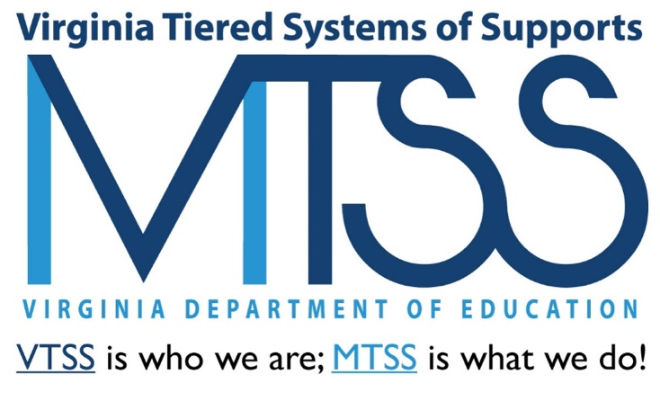

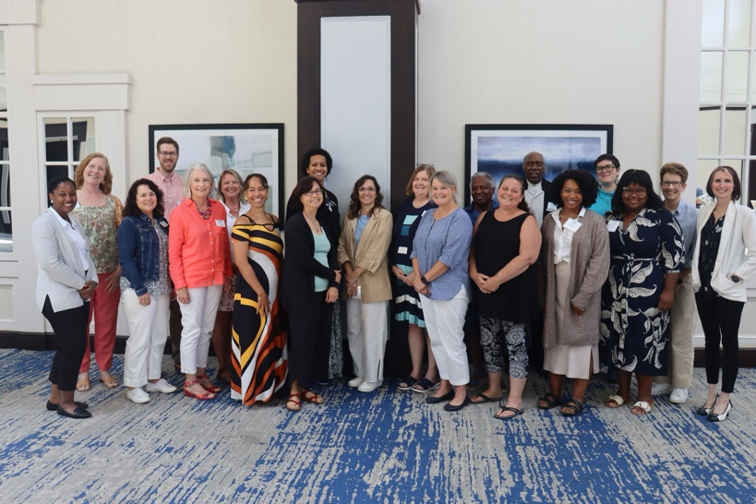

# VTSS R**each**

**The VTSS provides coaching, technical assistance, and professional learning opportunities to nearly 50% of Virginia’s school divisions.**

**60**

Divisions

**690**

Schools

**653,000**

Students

A map of virginia with divisions highlighted if they are in VTSS. Divisions highlighted are: 
Amelia County Public Schools
Amherst County Public Schools
Brunswick County Public Schools
Buckingham County Public Schools
Caroline County Public Schools
Charlottesville City Public Schools
Chesapeake City Public Schools
Chesterfield County Public Schools
Colonial Beach Public Schools
Cumberland County Public Schools
Danville City Public Schools
Falls Church City Public Schools
Fauquier County Public Schools
Floyd County Public Schools
Frederick County Public Schools
Gloucester County Public Schools
Grayson County Public Schools
Greensville County Public Schools
Hanover County Public Schools
Henrico County Public Schools
Henry County Public Schools
Loudoun County Public Schools
Lunenburg County Public Schools
Lynchburg City Public Schools
Madison County Public Schools
Martinsville City Public Schools
Mecklenburg County Public Schools
Nelson County Public Schools
Newport News City Public Schools
Norfolk City Public Schools
Northumberland County Public Schools
Nottoway County Public Schools
Orange County Public Schools
Page County Public Schools
Petersburg City Public Schools
Pittsylvania County Public Schools
Poquoson City Public Schools
Portsmouth City Public Schools
Powhatan County Public Schools
Prince Edward County Public Schools
Prince George County Public Schools
Prince William County Public Schools
Pulaski County Public Schools
Salem City Public Schools
Southampton County Public Schools
Suffolk City Public Schools
Virginia Beach City Public Schools
Virginia School for the Deaf and the Blind Public Schools
Williamsburg-James City County Public Schools
York County Public Schools
Rappahannock County Public Schools
Charles City Public Schools
Craig County Public Schools
New Kent County Public Schools
King and Queen County Public Schools
Harrisonburg City Public Schools
Stafford County Public Schools
Alleghany Highands
Northampton County Public Schools
Franklin City Public Schools


## Professional Learning Events

In 2023-2024, the VTSS staff hosted professional learning events for **581** participants.

## Website Visitors

In 2023-2024, the VTSS had **19,947** individual website visits of which **8,547** were new users.

## Professional Learning Participants

* Central Office Personnel
* Community Mental Health Providers
* Division/School Coaches
* Early Childhood Personnel
* General Education Teachers
* Parents/Family Members
* Related Service Providers
* School Administrators
* Special Education Teachers
* Student Services Personnel

# VTSS Process: Training

**During the 2023-2024 academic year:**

**28** Training Events with 581 total participants across the training events

**7** Professional Learning Community (PLCs) and networking events

**97%** of participants agreed or strongly agreed that the **training events aligned with their division’s standards and goals.**

**98%** of participants agreed or strongly agreed that the **training events emphasized the impact of the content on student outcomes.**

**97%** of participants agreed or strongly agreed that the **training events improved their knowledge of MTSS**

The image outlines five core components and their features for the Virginia Tiered Systems of Supports.

1. Aligned Organizational Structures; Features: Leadership & Teaming, Professional Learning, Operating Routines & Procedures, Coaching Systems.

2. Problem Solving Process; Features: Data Collection & Management Systems, Data-Informed Decision Making, Iterative Improvement.

3. Tiered Systems of Supports; Features: Selection & De-Selection Process, Integration of Evidence-Based Practices, High-Quality Instruction, Process for Access.

4. Systematic Implementation; Features: Capacity Building, Progress Monitoring, Phased Approach.

5. Evaluation; Features: Fidelity of Systems & Practices, Process for Assessment & Evaluation, Plan for Dissemination, Identified Valued Outcomes.

At the bottom, the tagline reads: "Building sustainable multi-tiered systems of supports through collaboration with divisions, schools, families, communities, and students."

# Process: Technical Assistance and Coaching

VTSS has a cadre of trained and skilled State Systems Coaches to provide technical assistance (TA) and coaching at the regional and local levels.

*“The systems coaches have an incredible range of knowledge. Truly, they are some of the most intelligent, innovative, and insightful people I’ve ever had the pleasure to work with.” ~Division survey response*

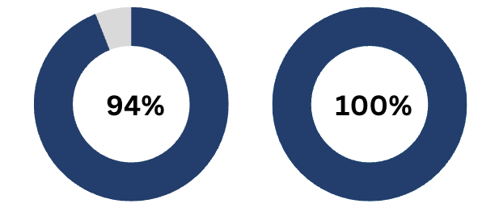**100%** agreed or strongly agreed that the **collaborative work between their division leadership team and VTSS is valuable** **to implementing tiered systems of support** in their division.

**94%** agreed or strongly agreed that **VTSS Systems Coaches have helped their division team develop a framework to implement tiered systems of support with fidelity**.

During the 2023-2024 academic year, there were **more than 2,000 TA & coaching events**.

VTSS State Systems Coaches develop annual coaching plans in collaboration with the divisions they support. They select focus areas for coaching supports to improve division implementation of MTSS with coaching and data & decision-making practices as the most common focus areas.

# C**apacity**

|  |  |
| --- | --- |
| Acquisition and fluency are identified by scores on the Division Capacity Assessment.  **26 Divisions**  Twenty-six divisions have **acquired** the capacity to support building-level implementation of MTSS.  **13 Divisions**  Thirteen are **fluent** in the capacity to support building-level implementation of MTSS. | **43 Divisions**  Forty-three divisions have at least one **internal coach** to support schools in their implementation of MTSS. |

## VTSS State Systems Coaches

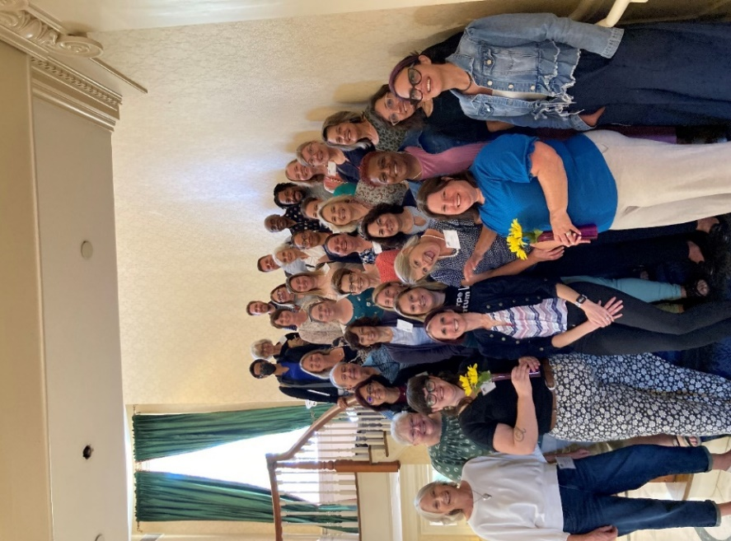VTSS State Systems Coaches assist division and school-level teams to build organizational capacity to sustain MTSS implementation.

*“The most beneficial aspect of VTSS support is the wealth of knowledge the state coaches possess, resources, collaboration, and being a sounding board when needed.”*

*“[VTSS Systems] Coaches are invaluable as thought partners, consistently offering insightful perspectives and fostering collaborative dialogue. Beyond their role as mentors, they also equip individuals with essential resources.”*

*~Division survey responses*

## Exploration Phase

During 2023-2024, VTSS supported 10 divisions as they worked through Exploration. In Exploration, VTSS Systems Coaches facilitate the installation of structures/systems needed to support MTSS. The goal is for teams to examine the current system using exploration activities and generate actions to move toward a more efficient and effective service delivery model.

# Outcomes: Academics

During the 2023-2024 academic year, ***208 division and 70 school TA & coaching events*** focused on ***improving academic outcomes***.

***28*** *VTSS participating schools earned the 2024-2025 Board of Education Highest Achievement Award*

***17*** *VTSS participating schools earned the 2024-2025 Board of Education Continuous Improvement Award*

VTSS has defined **High Implementing Schools** as schools that have been implementing MTSS with fidelity for the past 3 years (2021-2022, 2022-2023, and 2023-2024). There were **312 High Implementing Schools** as of 2023-2024.

On average, **VTSS High Implementing Schools** performed better on Reading SOLs than **non-VTSS Schools** for the following subgroups.

On average, **VTSS High Implementing Schools** performed better on Math SOLs than **non-VTSS Schools** for the following subgroups.

* **English-Reading Pass Rates** higher than the state
  + - **60%** of *High Implementing Schools* for Black students
    - **65%** of *High Implementing Schools* for students who are economically disadvantaged
  + **Mathematics Pass Rates** higher than the state
    - **57%** of *High Implementing Schools* for Black students
    - **65%** of *High Implementing Schools* for students who are economically disadvantaged

**Kim McGrath, Director of Academic Support, Chesapeake,** “Chesapeake City Public Schools is advancing a streamlined, collaborative approach to MTSS by bringing key decision-makers from human resources, strategic planning, and school leadership into the process. This effort includes aligning initiatives for cohesive implementation across schools. Through this work, schools struggling to meet benchmarks made significant gains, showcasing the success of targeted intervention and teacher capacity-building. Initiatives include supporting teacher retention and a coaching conference to effectively align and maximize coaching resources across the division.”

On average, **VTSS High Implementing Schools** had higher graduation rates than **non-VTSS Schools** for the following subgroups.

* + **Graduation Rates** higher than the state
    - **78%** of *High Implementing Schools* for all students
    - **81%** of *High Implementing Schools* for female students
    - **81%** of *High Implementing Schools* for male students
    - **74%** of *High Implementing Schools* for students who are economically disadvantaged
    - **60%** of *High Implementing Schools* for students with disabilities
    - **96%** of *High Implementing Schools* for Hispanic students

**Outcomes: Behavior**

During the 2023-2024 academic year, ***585 division and 289 school TA & coaching events*** focused on ***improving behavior outcomes*** including attendance.

***874 TA & Coaching events on improving behavior outcomes***

On average, ***High Implementing Schools*** lowered their disciplinary actions from 2022-2023 to 2023-2024 for **all students** and for **students with disabilities**.

On average, **High Implementing Schools** have lower dropout rates than **non-VTSS Schools** for the following subgroups.

# Outcomes: Chronic Absenteeism

On average, ***VTSS High Implementing Schools*** have lower chronic absenteeism compared to the **State** rate for the following subgroups.

**Cumberland County Public Schools** is transforming education with a data-driven, student-centered approach across elementary, middle, and high schools. By **strategically aligning resources and implementing targeted interventions**, they are addressing key challenges like **chronic absenteeism, teacher alignment, and student achievement**.

Thanks to their dedicated staff, Cumberland County has achieved significant progress:

* **Chronic absenteeism** **dropped** **by 11%** compared to last year.
* **Major discipline referrals decreased by 31%.**
* **Gains were made across all content areas**.

**Independence Elementary, Grayson County,** “Our school is performing at or above the state standard with ***89%*** of our almost 300 students **missing less than 10% of the school year**. This is due, in part, to our VTSS team working with our Community School Coordinator to find ways to recognize and encourage school attendance. With almost 300 students in our building, there were few behaviors that required in-school or out of school suspensions. **Students who had behavioral issues in the past were identified by our VTSS team and given mentors** **to check in and out with daily, helping to motivate better choices and giving them an adult they felt safe talking to and depending on.** For some students, our IES staff are a safe place for them. **We truly are a family and VTSS guides our family to keep striving for success!**”

**York County Public Schools** has a strong commitment to **reducing chronic absenteeism through a multi-tiered approach that emphasizes early intervention and community involvement**.

* The division introduced Student Connection Coaches (SCCs) in both secondary and elementary schools to support students with attendance challenges. These coaches provide **timely interventions**, such as the Check and Connect program and offering rides for students who miss the bus.
* York County also partners with local services like Juvenile and Youth Services to provide mentoring and wraparound support for students with repeated absences, aiming to prevent truancy-related interactions with the juvenile justice system.
* **Through re-messaging efforts, incentives for attendance, and family engagement activities, York County is fostering a culture that values consistent school attendance.**

Their data-driven approach allows for continuous monitoring and adjustment of strategies, ultimately strengthening connections between students, families, and schools to promote lasting improvements in attendance.

York County reduced chronic absenteeism in schools from **2022-2023** to **2023-2024**.

**Family Engagement**

## Components of Family Engagement

Positive Relationships

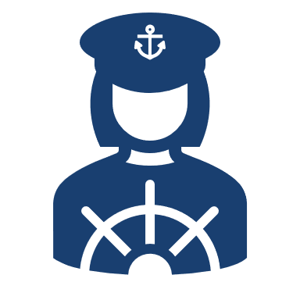Family Empowerment

Strong and Shared Leadership

Data-based Goals and Outcomes

Multidimensional Communications

Multi-tiered Approaches

Collaborative Problem Solving

## VTSS Division-Level Data

**69%** of divisions provide schools with technical assistance (e.g. coaching, training, etc.) on how to engage families in the school MTSS activities.

**76%** of divisions include at least one staff person responsible for family engagement, and an additional 6% plan to.

**71%** of divisions address Family Engagement in their division goals.

## Resources

Formed Families Forward and VTSS continue to partner to create videos and resources for divisions, schools, and families.

* [Family Engagement Video Modules](https://formedfamiliesforward.org/vtss/)
* [Family Engagement in MTSS](https://vtss-resources.vcu.edu/media/resources-vtss-ric/implementation-resources/student-family-community/FamilyEngagementinMTSS,WhatResearchSays11_2024.pdf)

## Division Examples

**Crystal Martin, family member on the Division Level Team, Buckingham County,** “Families know their students both at their best and at their worst; **having family members feeling heard and empowered in key discussions is pivotal to a healthy student-centered relationship** **with schools**. Through my engagement with our school division and the divisional leadership team, I know my opinion is not only respected but also a valuable part of the decision-making process.”

**Susan Gayle, Family Engagement Coordinator, Madison Elementary, Caroline County,** “**Building positive relationships between families and school staff is critical to our work.** When we invest in building connections, families feel comfortable sharing their fears, frustration, as well as what’s working in their schools. These relationships are powerful; we resolve conflicts and also encourage families to participate on various committees and volunteer for activities.”

**Alexis Miller, Family Resource Center Coordinator, Henrico County,** “… Our school-level **Impact Committees bring together parents, caregivers, school staff, community partners, and students to drive positive change**… these committees focus on **improving attendance, fulfilling school wide needs, and strengthening school culture**, making a meaningful difference in our communities.”

# Virginia’s Approach to Retention of Special Education Teachers

The Virginia Personnel Development Grant (PDG), Creating Capacity for Change and Continued Professional Growth, falls under the VDOE VTSS initiative, which focuses on the implementation of innovations and practices through MTSS. The PDG extends the core components of MTSS to retention of special education (SPED) teachers. Chesapeake City Schools (CPS) partners with VTSS to participate in the Virginia PDG with over 500 SPED teachers.

## Project Goals

1. Improve quality of teacher candidates and in-service teacher preparation.
2. Division and school leaders make data-informed decisions about retaining SPED teachers.
3. Improve SPED teacher retention rates in pilot sites and participating divisions.

## 2023-2024 Implementation Milestones

* Chesapeake held a 2-day academy for administrators including middle and elementary school assistant principals, special education administrators, and special education department chairs.
* Cohort 2 teachers participated in a special education teacher academy where they received Tier 1 curriculum including:
  + Personal wellness, resilience, and time management
  + Individual Education Plans (IEP) process and role in instruction
  + Eligibility determination and Specially Designed Instruction
  + Prior Written Notice
  + Behavioral strategies and the de-escalation cycle
  + Understand how special education fits within MTSS
  + Available division resources

**95% of Cohort 1 teachers retained by CPS for 2023-202489% of Cohort 1 teachers are still in CPS 1-year after academy participation for 2024-202587% of Cohort 2 teachers retained in CPS for 2024-2025**

# Virginia’s Comprehensive Approach to Recruitment and Retention of SMHPs

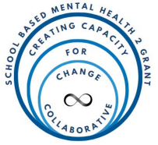The 2022 School Based Mental Health Grant (SBMH 2) S184F220101 is the second iteration of the SBMH Grant out of the United States Department of Education. The 2022 iteration of this grant is funded through the Appropriations Act and the Bipartisan Safer Communities Act, with the goal of increasing the number of credentialed school-based mental health service providers in local educational agencies with demonstrated need (USED 87 FR 60137, 2022). This grant was initially funded in response to student mental health concerns that arose after changes in educational service models for students across the United States in the wake of COVID-19.

The Virginia SBMH 2, Virginia’s Comprehensive Approach to Recruitment and Retention of School Mental Health Professionals, aligns with the VDOE VTSS initiative extending the core components of MTSS to recruitment and retention of school mental health providers (SMHPs). SBMH 2 partners with ***8 Virginia divisions with approximately 50,000 students across the divisions.***

## Project Activities

1. Supporting division-level recruitment and retention planning for SMHPs to define short- and long-term needs and division action steps.
2. Providing targeted professional learning to build recruitment and retention leadership capacity, SMHP specific skills, and implementation skills.

## Proposed Outcomes

* Each participating division will increase the number of SMHPs by two positions in year two which will be partially subsidized by project funds. Additional SMHP positions will be added during years three through five using internal resource allocation.
* Students will receive increased access to mental health services from SHMPs in the divisions.

## Implementation Milestones

The 8 divisions participated in an Implementation Science Academy and additional microteaching sessions for the 2023-2024 academic year.

**24 SMHPs Hired**

**221 SMHPs Retained**

**46,038**

**students received school-based mental health services**

**SBMH 2 Division Testimonials**

**Amelia County**

Amelia County Public Schools fosters a supportive, adaptable environment focused on student needs, staff retention, and long-term program success through an integrated MTSS framework addressing behavior, academics, and mental health. Notable progress has been achieved in improving attendance through practices like enhanced communication, personalized plans, student engagement strategies, and school-wide incentives.

To attract and retain quality staff, Amelia offers competitive bonuses and emphasizes mental health support with additional counselors and social workers. The division integrates SEL into daily instruction, equipping students with essential skills like emotional regulation and conflict resolution. Ongoing professional development for counselors, psychologists, and social workers ensures staff are well-prepared to support a resilient, diverse student community.

**Fredericksburg City** 

Fredericksburg City Public Schools prioritizes mental health and family engagement through innovative partnerships, including a collaboration with the Cook Center for Human Connection. This partnership provides resources like family engagement webinars to strengthen community ties and support student well-being. By engaging stakeholders and fostering collaboration, Fredericksburg creates an inclusive, supportive environment centered on mental health and student success.

**New Kent County**

New Kent County Public Schools has strengthened student mental health support with initiatives like hiring Student Support Specialists for elementary and secondary schools, offering retention bonuses, expanding professional development, and covering therapeutic day treatment for underinsured students. A division-wide mental health resource map helps identify service gaps and drive improvements. Strong partnerships with Henrico Mental Health, faith-based groups, and public health organizations foster a connected, supportive environment focused on student well-being. ​​

**Portsmouth City** 

Portsmouth City Public Schools has enhanced mental health services by offering stipends, supervision hours, tuition support, and bonuses to recruit and retain a diverse, fully staffed mental health team. Initiatives like the Stay Survey help understand and support employee retention, while programs such as the Second Step Curriculum, external partnerships, and universal screening improve student belonging, relationships, and self-efficacy. Comprehensive mental health support spans all tiers, including summer school and crisis teams, fostering a nurturing environment for student success.

**Prince George County** 

Prince George County Public Schools prioritizes student mental health with initiatives like hiring additional counselors for elementary schools, implementing a threat assessment program, and the Signs of Suicide Program for middle and high schools. 'Calm Cafes' provide peaceful spaces in elementary and alternative schools, with plans to expand to secondary schools. Peer mediation programs for grades 5-12 and enhanced professional development, including Mental Health First Aid training for social workers, foster a proactive, supportive environment for student well-being across all grade levels.

**Roanoke City** 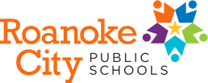

Roanoke City Public Schools is enhancing student well-being by developing school-based mental health teams and expanding services through an MTSS-based model. Professional development, feedback-driven training, and orientation programs ensure sustainable, high-quality service delivery. Recruitment efforts, professional learning stipends, and stay data analysis demonstrate a commitment to staff stability and well-being. Data-driven practices, supported by the SBMH 2 grant, drive continuous improvement to meet student and staff needs.

**Salem City** 

Salem City Public Schools supports community mental health through resources like ParentGuidance.org, virtual workshops, and parent coaching. Staff receive professional development, including motivational interviewing training, and benefit from two in-school clinical counselors. Students engage in mental health awareness initiatives such as cognitive training, music therapy, and tools like Calm Strips and relaxation techniques. Events like Mental Health Awareness Day and Mental Health Month underscore the division's commitment to fostering a supportive environment.

**Scott County** 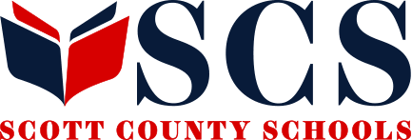

Scott County Schools has enhanced student mental health by assigning a dedicated counselor to every school and implementing an SEL curriculum for elementary students. The division supports social worker certification, provides clinical supervision, and offers Mental Health First Aid training and retention bonuses. Collaboration with Communities in Schools of Appalachian Highlands ensures all staff, mental health providers, and administrators will be trained by 2025, reinforcing their commitment to student and staff well-being.

**Exciting Work on the Horizon**

The VDOE and VTSS is excited to report on the upcoming implementation milestones in next year’s report including the first summer retreat for SBMH 2 divisions and a conference focused on school mental health and wellness embedded within multi-tiered systems of supports.

# State Personnel Development Grant

The Virginia 2023 State Personnel Development Grant (SPDG) H323A2300 is the fourth SPDG the Virginia Department of Education (VDOE) has received. The Virginia SPDG falls under the VDOE initiative referred to as the VTSS which focuses on the implementation of innovations and practices through MTSS. This grant focuses on supporting states with establishing systems for professional development that result in improved outcomes for students with disabilities.

## Project Goals

1. Enhance MTSS knowledge and coaching skills of state system coaches.
2. Align pre-service teacher learning with in-service coaching focus areas.
3. Expand internal infrastructures to support differentiated teacher coaching and support around use of High Leverage Practices (HLPs), Evidence-based Practices (EBPs), and Functional Based Assessments/Behavior Intervention Plans (FBA/BIPs) within tiered systems work in Pre-K to 12 classrooms.
4. Increase Pre-K to 12 teachers’ ability to apply MTSS core components, HLPs, EBPs, and FBAs and functionally related BIPs within tiered systems in classroom.

**Year 1 Project Activities**

* Updated Virginia's MTSS Core Components with national technical assistance (TA).
* Developed new coaching scope and sequence for coaching and supporting divisions.
* Mapped PD and TA plans for state and division coaches in all of the new content areas.
* Collaborated with Old Dominion University to establish new curricula for students to interact with up-to-date content as it relates to HLPs, EBPs, FBA/BIPs, and tiered systems.
* Establish the Cooperative for Effective Behavior Interventions and Supports (CEBIS). CEBIS has begun resource mapping all PD and TA offered to the field by the VDOE and technical partners.

**Year 1 Impact**

* **93% of VTSS Systems Coaches** reported an **increase in their knowledge and skills** of implementation science, improvement science, the core components of MTSS, HLPs, EBPs, FBAs/BIPs, and advanced tiers within a cascading model of support.
* **80% of division and school participants** in professional development and coaching report an **increase in their knowledge** of MTSS core components, tiered interventions, and their ability to provide training and coaching on these concepts to Pre-K to 12 classroom teachers.

# Implementation Science Academy

The VDOE collaborated with partners from the National Implementation Research Network, Center for the Implementation and Evaluation of Education Systems, and the VTSS Research and Implementation Center to develop and provide an Implementation Science Academy series that consisted of six sessions during the 2023-2024 academic year. Participants in the academy were Division Leadership Team (DLT) members from SBMH 2 divisions and their VTSS Systems Coaches. As part of this series, attendees received professional learning and coaching as their DLTs worked on applying implementation science to their project activity plans.

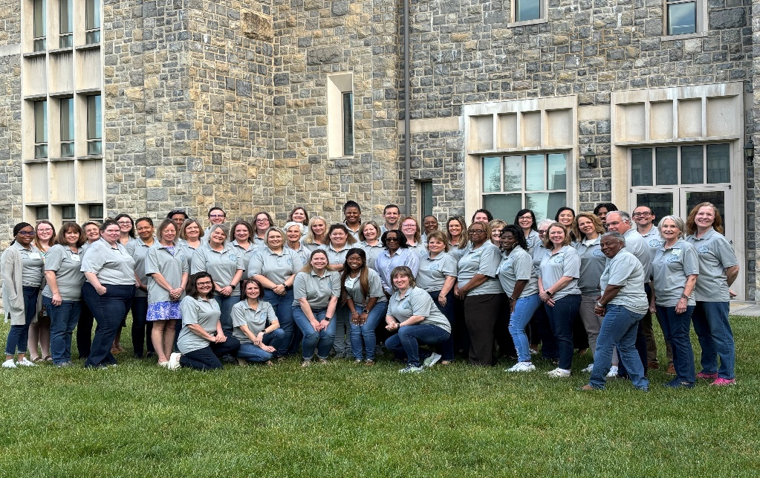

Attendee responses to a post-series survey:

* **100% agree** that participating in the academy improved their **understanding of implementation science**
* **100% agree** that participating in the improved their **ability to apply implementation science** to the work of school-based mental health.
* **95% agree** that participating in the improved their ability to **revise and refine critical grant activities** for evaluation and sustainable implementation of school-based mental health.

**Learn more about their experiences in this short promo video, click** [**here**](https://vimeo.com/1018083040/acb6bb481d?share=copy)**!!!**

Testimonials from Attendees

*“This [academy] has really been so helpful! I was overwhelmed at first but now I feel like I am prepared and can use it in several areas of my job.”*

*“Great information to move towards and improve evidenced based practices.”*

*“I learned a more effective way to discuss implementation practices”*

# Collaborators

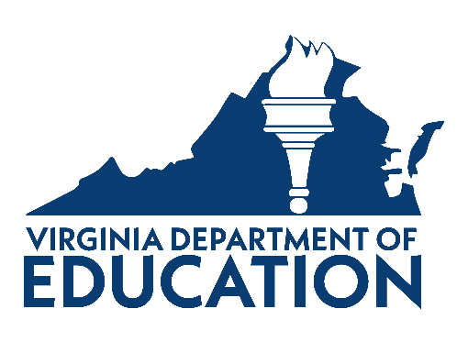**[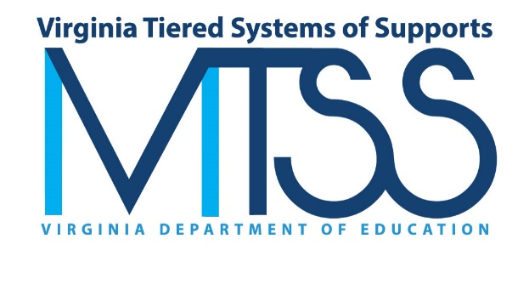](https://vtss-ric.vcu.edu/)We would like to thank all those who collaborate with VTSS to make this work possible. Click on a logo to learn more.**

**VTSS is supported by** [**grants**](https://www.doe.virginia.gov/) **from USED:**

* State Personnel Development Grant (H323A170018, H323A230002)
* School Climate Transformation Grant (S184F180014)
* Personnel Development Grant (H325P210003)
* School Based Mental Health Grant (S184H220101)

**VTSS Implementation Collaborators:**

* VTSS Research and Implementation Center (RIC) at Virginia Commonwealth University
* Virginia Regional Training and Technical Assistance Centers (TTACs)
* Old Dominion University, Center for Implementation and Evaluation of Education Systems (CIEES)
* Formed Families Forward (FFF)

[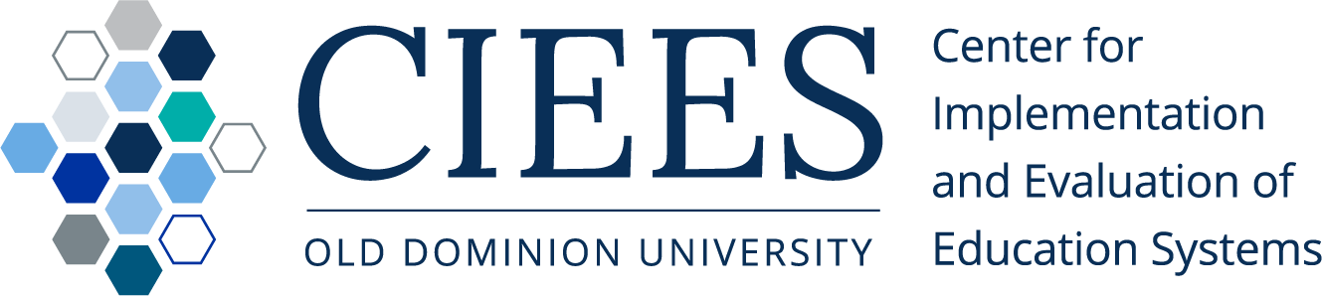](https://cieesodu.org/)[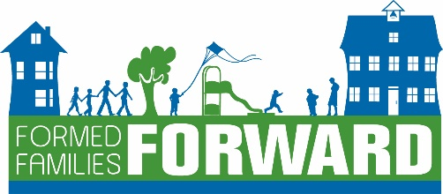](https://formedfamiliesforward.org/)

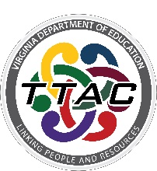[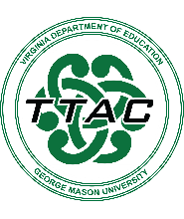](https://ttac.gmu.edu/) [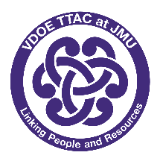](https://ttacjmu.org/) [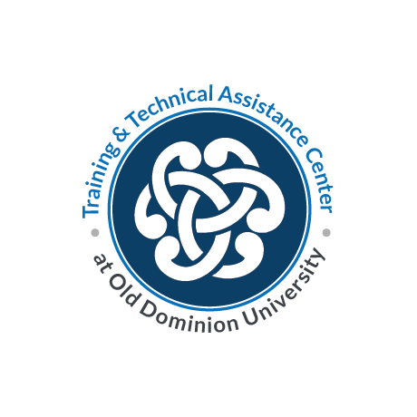](https://ttac.odu.edu/)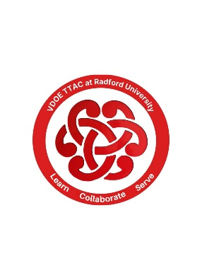[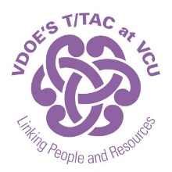](https://ttac.vcu.edu/) [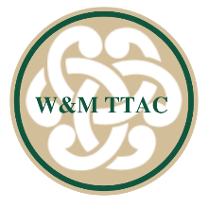](https://education.wm.edu/centers/ttac/)