**The Escalation Cycle**

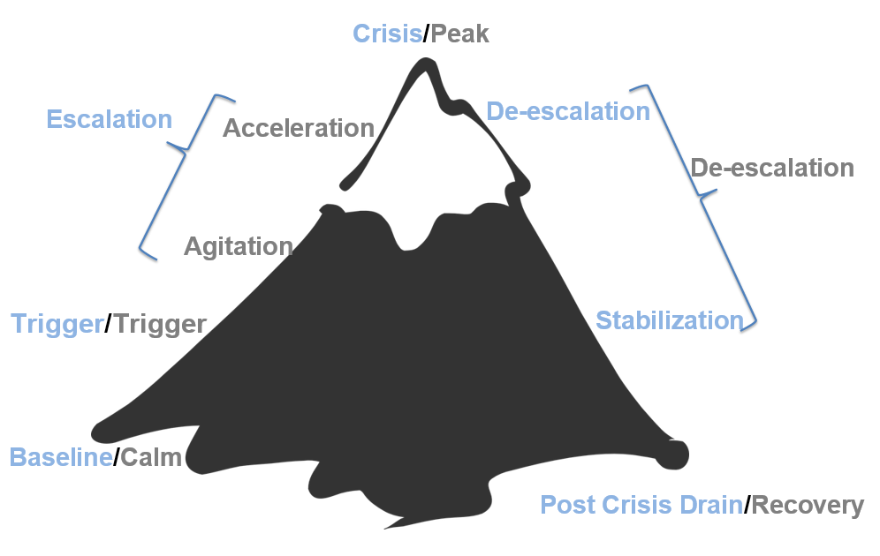

|  | Baseline/Calm | What is my role and/or what is my specific role in this phase? | Who can I contact for coaching and support? |
| --- | --- | --- | --- |
| What does it look like? | The student is feeling regulated, following directions, focused on work, and participating. | What role do I play in maintaining a calm environment?  What schoolwide/classroom expectations are proactively taught? If none, the steps needed:  What procedures are in place to recognize and reinforce positive behavior? If none, the steps needed:  How do I build relationships with students at this stage?  What systems exist to collect and analyze baseline behavior data? If none, the steps needed: |
| What can adults do? | * Notice and praise positive behaviors: “I see you’re working hard—great focus!” * Build connections and trust. * Teach skills for solving problems or handling emotions. |
| Key insights: | |
|  | Trigger | What is my role and/or what is my specific role in this phase? | Who can I contact for coaching and support? |
| What does it look like? | Small things start to bother a student—maybe someone took their pencil, the student didn’t get a turn, or they are hungry or tired. | What common triggers have been identified for specific students in my charge?  Which students have documented behavior support plans for frequent triggers?  What are the procedures for reporting emerging patterns or triggers? If none, the steps needed:  What are the environmental, academic, or social factors that could be potential triggers?  What is my role in adjusting instruction or environment when a trigger is suspected? |
| What can adults do? | * Gently check in: “Looks like something might be bothering you. Want to talk?” * Offer simple solutions or choices: “Would you like to take a quick break or get a drink of water?” * Stay calm and prevent further stress. |
| Key insights: | |
|  | Escalation Phase | What is my role and/or what is my specific role in this phase? | Who can I contact for coaching and support? |
| Agitation | | |
| What does it look like? | The student is feeling uncomfortable or frustrated. They may fidget, pace, tap a pencil, avoid eye contact, or stop following directions. | What early signs of agitation am I trained to recognize?  What are my go-to de-escalation strategies at this stage?  What classroom adjustments are allowed or encouraged (e.g., breaks, movement)?  How do I communicate with support staff (e.g., counselor, admin) when a student is agitated?  What documentation or reporting is required during agitation? If none, the steps needed: |
| What can adults do? | * Utilize calming Strategies * Redirection * Proximity–(for attention motivated behavior) * Provide space * Modify task-(Academic lesson is not a priority at this time; moving student back to calm phase is the primary goal) * Provide choice * Provide alternate/enriched sensory options * Give space or a break: “You can take 2 minutes to reset in the quiet area.” * Reduce demands: “Let’s skip the hardest question for now.” * Offer calming tools: stress ball, breathing strategies, drawing. |
| Acceleration | | |
| What does it look like? | The student becomes more upset now. They may raise their voice, argue, refuse to listen, slam things, or try to leave the room. | What are the procedures for calling for help or support? If none, the steps needed:  Are there clear guidelines on when to remove a class or a student? If none, the steps needed:  What de-escalation training have I received, and how do I apply it?  How is the student’s dignity preserved during behavioral acceleration? |
| What can adults do? | * Stay calm and avoid power struggles: “I’m here to help when you’re ready.” * Keep directions short and clear: “Please sit down. We’ll talk in a minute.” * Keep others safe and give the student physical and emotional space. |
| Key insights: | |
|  | Crisis/Peak | What is my role and/or what is my specific role in this phase? | Who can I contact for coaching and support? |
| What does it look like? | The student has lost control. They might scream, throw things, try to hurt themselves or others, or run away. | What are the school's crisis response procedures? If none, the steps needed:  Who is responsible for intervening directly during a peak event?  What documentation or reporting is required immediately after a crisis? If none, the steps needed:  What are the expectations for staff not directly involved (e.g., teachers nearby)?  How are physical interventions (if used) regulated and documented? |
| What can adults do? | * Prioritize safety for everyone. * Stay calm and non-threatening. * Interact as little as necessary to ensure safety. * Avoid talking too much—keep your voice low and body language open. * Use a crisis plan or call for help if needed. |
| Key insights: | |
|  | De-escalation | What is my role and/or what is my specific role in this phase? | Who can I contact for coaching and support? |
| What does it look like? | The student is calming down. They may seem quiet, tired, embarrassed, or avoid talking. | What behaviors signal that the student is de-escalating?  What should I *not* do during this stage?  Is there a protocol for supervision and support during de-escalation? If none, the steps needed:  How might I inadvertently re-trigger the student?  Who is responsible for maintaining safety and observing behavior at this stage? |
| What can adults do? | * Assign low-level independent task * Avoid blaming * Provide Structured Choice * Provide Differential Reinforcement * Allow silence and space to recover. * Reassure: “You’re safe now. We’ll figure this out together.” * Avoid consequences or big conversations right away. |
| Key insights: | |
|  | Recovery | What is my role and/or what is my specific role in this phase? | Who can I contact for coaching and support? |
| What does it look like? | The student is back to a calm state. They might feel confused, ashamed, or want to act like nothing happened. | What are the expectations for post-incident reflection (with the student and staff)?  How do I reestablish trust and connection with the student?  What procedures are in place for re-entry into class or routines? If none, the steps needed:  Who leads the recovery conversation, and what should be addressed?  How is the family member/caretaker communication handled?  How is the incident reviewed by the team (e.g., functional behavior analysis, plan update)? |
| What can adults do? | * Positively reinforce appropriate behavior * Focus on re-establishing routines * Debrief after the student has been calm for at least 20 minutes * Avoid aversive consequences * Keep the debrief short (3–5 minutes) * Gently reflect: “Let’s talk about what happened when you’re ready.” * Problem-solve together: “What can we do next time you feel that way?” * Rebuild connection and restore a sense of safety. |
| Key insights: | |
|  | After the Crisis | What is my role and/or what is my specific role in this phase? | Who can I contact for coaching and support? |
| Plan for support and skill-building | * Meet with teachers/staff and collaborate to identify * Triggers * Function * Proactively plan a response for future occurrences * Reach out to family | What is my responsibility immediately after a crisis situation?  If so, what behavior documentation is required (e.g., incident reports, behavior logs)? And by when?  How soon must the incident be reported, and to whom?  What are the procedures for notifying administrators, behavior specialists, or school psychologists? If none, the steps needed:  What is the process for documenting physical intervention (if used), including restraint or seclusion? If none, the steps needed:  Who is responsible for contacting the family member/caretaker after a behavioral incident? If none, the steps needed: |
| Key insights: | |

*Colvin, G. T. (2010). Defusing disruptive behavior in the classroom. Corwin Press.*

*\*ChatGPT (OpenAI) was used to assist in drafting parts of this resource*