Defusing Disruptive Behavior

Establishing Our Purpose
- Understand the foundational principles of behavior to design more effective interventions.
- Develop an understanding of the escalation cycle and contributing factors.
- Examine our responses throughout the phases of the escalation cycle to support student behavior.
- Explore evidenced based interventions to apply throughout the
escalation cycle.

When it comes to Defusing Disruptive Behavior, what strength(s) do you bring to the table?

2 | P a g e
Community Agreements |  | What do you need from us and yourself to honor the community agreement?
Practice Self-Compassion | - Extend patience, grace, and kindness  - Focus on solutions to make things easier
Practice Growth Mindset | - Be open to new thoughts and ideas  - Embrace learning opportunities
Practice Presence | - Focus on the here and  now  - Share your expertise, information and ideas.  - Assign a group recorder
Setting Intentions |  | What is your personal intention for our time together?



Personal Reflection

Think of a time when you were faced with behavior(s) that escalated. Let’s take time to do a brain dump of everything you remember about that event.

Behavior is Communication and has a
function
We change behavior through an instructional
approach
Behavior occurs as a sequence of
events





Why do they keep doing that?
GAIN | ESCAPE

4 | P a g e

Antecedent
Mr. Jones passes out a math worksheet
Behavior
Carson runs out of the classroom
Consequence
Carson followed and sent to the office

Notes:

Antecedent
Mr. Jones prompts students to take out notebooks
Behavior
Student says, ‘Mr. Jones, what is up with that ugly haircut?”

Consequence
The class laughs

Notes:

Antecedent
Mr. Jones prompts students to put phone away
Behavior
Student ignores Mr.
Jones, pulls up the hood, and stays on phone
Consequence
Mr. Jones stops his instruction and raises his voice, prompting the student to put up the phone

5 | P a g e

Notes:

Reflection



Using the scenario from your personal reflection, identify the antecedent, behavior, and consequence.


Behavior Consequence

Antecedent

6 | P a g e

… help explain why people respond differently at different times when
presented with the same set of triggers.
Fatigue
Transitions Time of Day
Hunger Sick/Allergies Medications Anxiety/Depression
Conflict Sleep Problems
Hardships
Setting Event
Antecedent
Behavior
Consequence
Setting Events
colleagues dealing with?
students dealing with?
What setting events are your…

7 | P a g e

What setting events impacted the scenario in your personal reflection? Based
on the ABC’s and setting events, what is your hypothesis of the function?



8 | P a g e


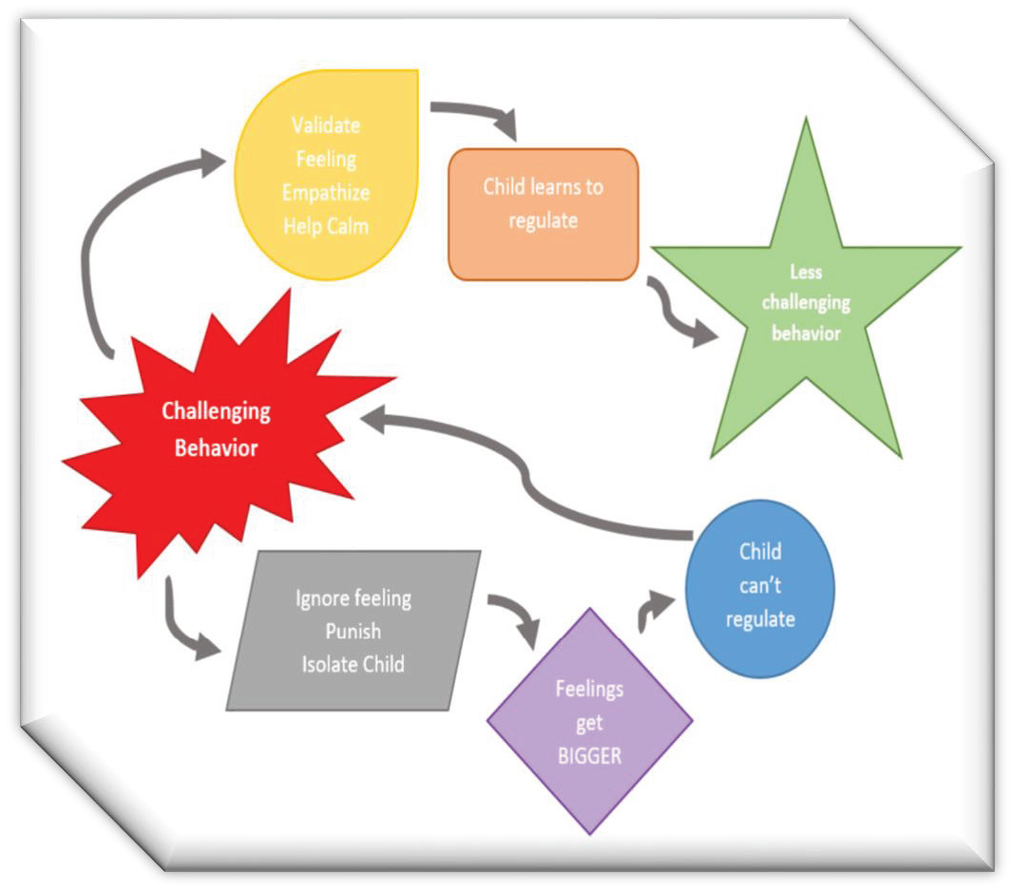

Behavior Chains
- Each ensuing behavior in a given behavior chain
becomes more serious than the one preceding it. (Walk-er et al., 1995)
- Prevent the behavior from becoming more serious by interrupting the behavioral chain at any time
- One way to change the student’s successive behaviors is to change the teacher’s responses.

Notes:

9 | P a g e

Teacher | Student
Mr. Jones greets Carson as he enters the classroom. | Carson nods and puts his head down.
Mr. Jones repeats himself, “I said good morning Carson.” | Carson looks up, sucks his teeth and looks away.
Mr. Jones says, “Fine, you can just start your work.” and passes out a math worksheet. | Carson runs out of the classroom.
Mr. Jones follows and sends Carson to the office. | …………..

Notes:



10 | P a g e
Using the scenario from your personal reflection, identify one or more behavior chains.


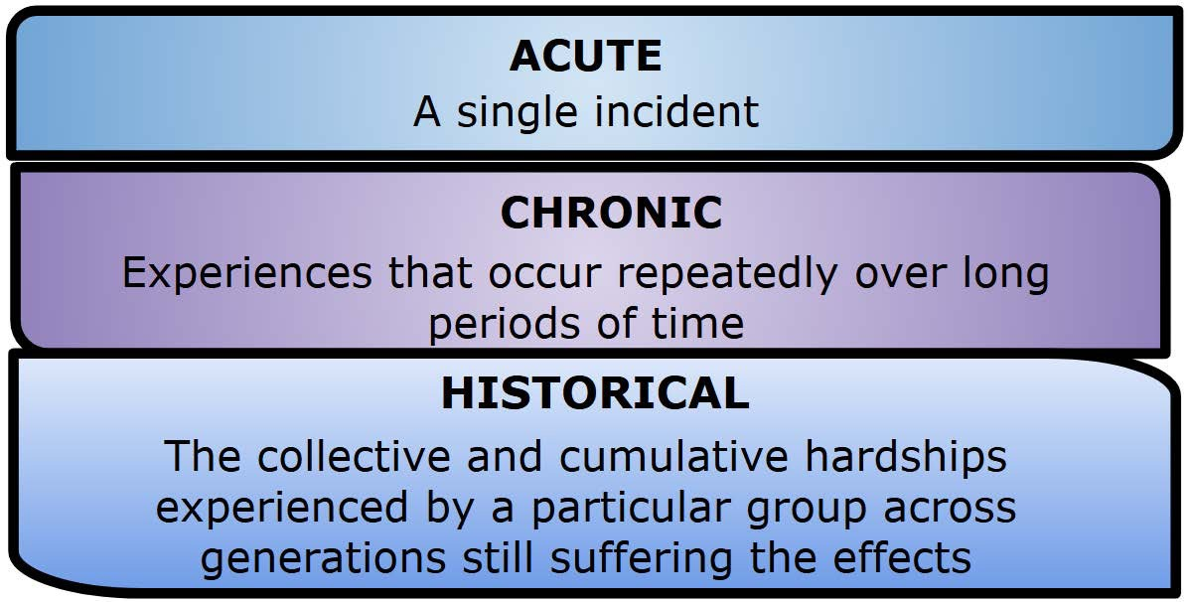
Types of Hardships

1
Results from an event, series of
events, or set of circumstances that is experienced by an individual as physically or emotionally harmful or life threatening and that has lasting adverse effects on the
2 individual's functioning and mental, physical, social, emotional, or spiritual wellbeing.

Notes:

What type of hardships have your students experienced? How did this impact you?

1 https://www.tandfonline.com/doi/abs/10.1080/15299732.2014.871666?journalCode=wjtd20
2 https://www.samhsa.gov/trauma violence
_

11 | P a g e

Impact of Hardships
Individuals who have experienced hardships may react differently as they go through the phases of the escalation cycle.

Notes:
CLASSROOM IMPACT
•
•
Executive Functioning
Language and
Communication Skills
•
•
Memory
Ability to see Cause and
Effect
•
•
Organizational Ability
Concentration and
Attention
_
What stood out to you in this video?
Why is it important to understand this information when responding to
disruptive behavior?

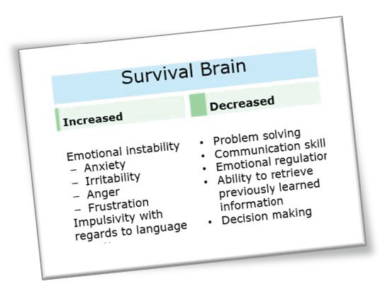
Fight, Flight, Freeze, Appease

Notes:

Fight  - Argumentative  - Aggressive  - Confrontational  - Alone  - Immature  - Glaring  - Hands in fists | Flight  - Hyperactive  - Aggressive  - Running away  - Disruptive  - Leg Movement  - Fidgety  - Immature | Freeze  - Bored  - Distracted  - Not listening  - Zoned out  - Wide-eyed  - Standing still | Appease  - Socially withdrawn  - Quiet  - Compliant  - Passive  - Resigned  - Low energy  - Neutral expression
How does this play out in your classroom?

13 | P a g e





When little people are overwhelmed with big emotions, it’s our job to share our calm, not join their chaos.
L. R. Knost

Does this information increase your understanding of what was happening in your personal scenario?

Escalation Cycle

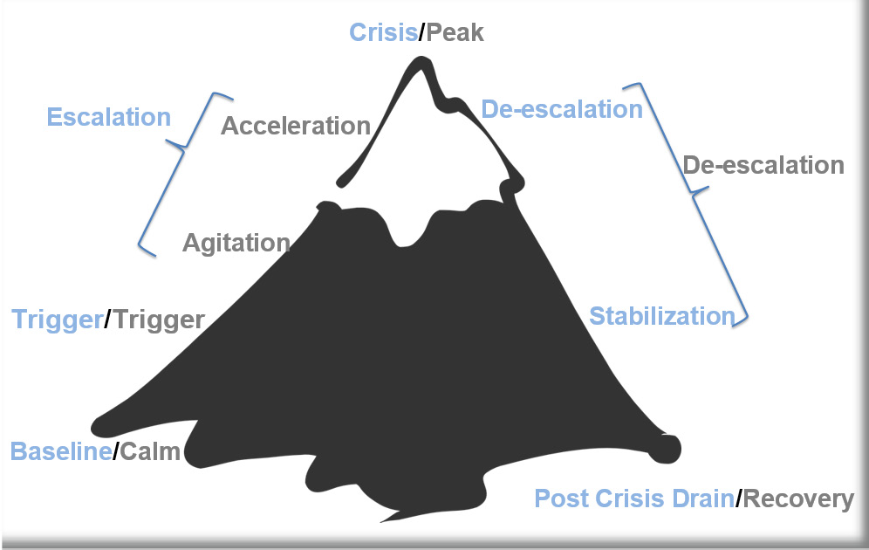

14 | P a g e


How full is your cup?
Take a few minutes to fill in your own cup with all the things you have on your plate right now.

Let’s Talk About Stress

Stressors | Stress
Notes:

15 | P a g e

__
How does ongoing stress impact you on a daily basis?

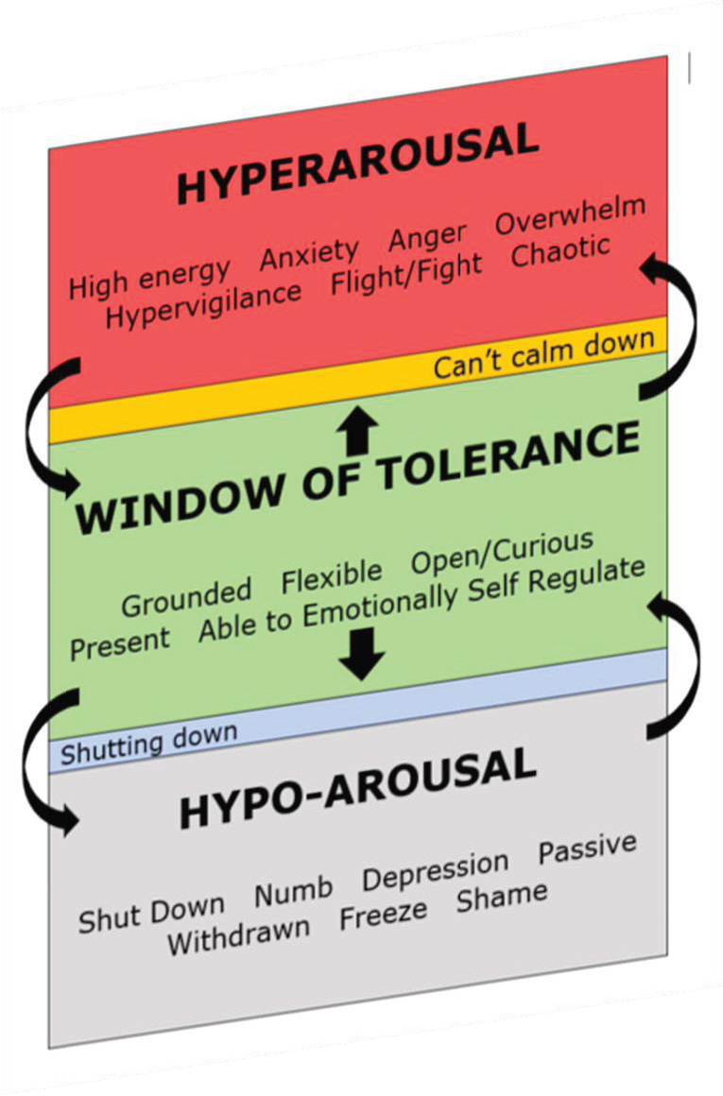
How does the window of tolerance apply to you? (Classroom/School wide)

16 | P a g e
_

Our Role…
First, we need to engage in practices that allow us to bring our best selves each day
We need a plan to maintain self control during a crisis/ power struggle. (Remember fight, flight, freeze, or appease response)
Take 10 minutes to complete the assessment in your workbook.

3
Our goal is to remain calm &
regain an “emotional balance”
(Northeast PBIS Network; Smith, et al.)

Notes:



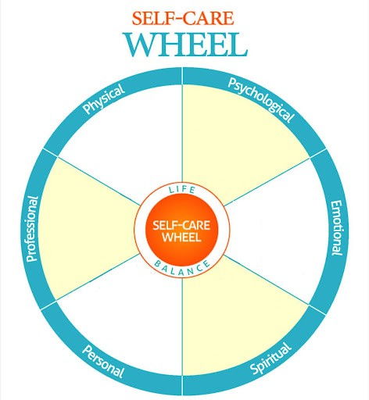
3 (Northeast PBIS Network; Smith, et al.)

17 | P a g e
_

What are your initial thoughts about the balance within your wheel?
_

Which steps can you take to create the balance you want?

18 | P a g e

What would it look like and sound like if we were to think about wellness, individual and collective, as a precursor to showing up as our best selves?

Individual | Collective



“To be “well” is not to live in a state of perpetual safety and calm, but to move fluidly from a state of adversity, risk, adventure, or excitement, back to safety and calm, and out again.”


Nagoski & Nagoski

Culture of Wellness Strategy Share

19 | P a g e

Vulnerable Decision Points (VDP) & Neutralizing Routines

What is VDP?

Notes:

Situations
- Subjective problem behavior
  - Defiance, Disrespect,
Disruption
  - Major vs. Minor
- Non-classroom areas
- – hallways, cafeterias
- Classrooms
- Afternoons

Decision States
Setting Events | Resource Depletion

What are some common VDP’s for adults in your school?

20 | P a g e

When you see an interfering behavior or the start a power struggle, stop and
ask yourself… ⁴
“Am I triggered or agitated?”
- by this student or situation
- or an outside factor
If yes, use an agreed upon alternative response (neutralizing routine)

Notes:

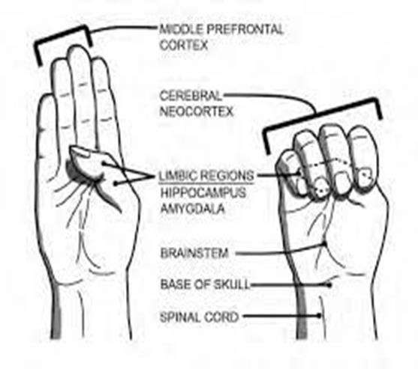

4 (Northeast PBIS Network)

21 | P a g e

“Emotional Agility….choosing how you’ll respond to your emotional warning system...between stimulus and response there is a space.
“In that space is our power to choose our response. In our response lies our growth and freedom.” (Frankl, 1946)

Components | Examples
Notes: | - Delay the decision until I can  think clearly  - Reframe the situation  - Take care of yourself
Notes: | Mindfulness Examples
Notes: | - Release your tongue from the top of your mouth  - Name 5 things you see  Push your feet through the floor  - Relax your jaw  - Count the things in the room that begin with the letter B  - Drop your shoulders away from your ears

22 | P a g e
_ _

What neutralizing routines are already in place? | What may be a routine(s) to add to your toolkit? | Could routines be extended out to class-room?
Was there an opportunity to utilize neutralizing routine in your personal scenario? Is there an opportunity for growth in this area?

23 | P a g e

Setting Our Classrooms Up for Success


Food
Rest/sleep
Safety (physical & emotional) Belonging through non

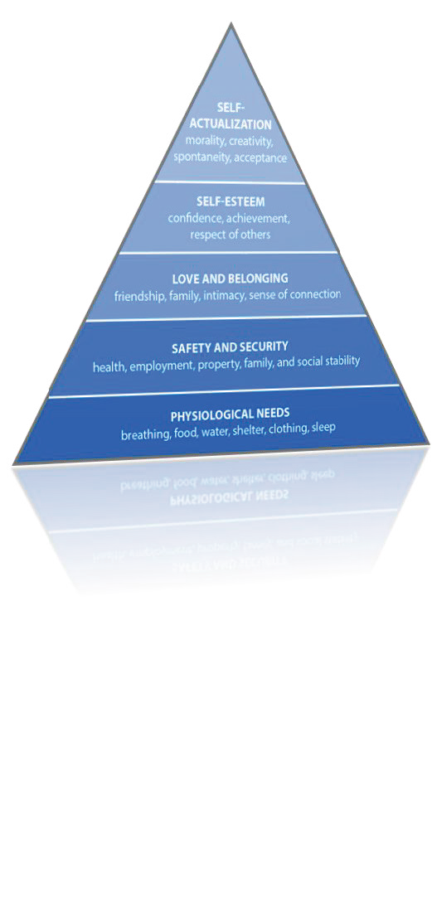
Notes:

What is one thing you do to establish a sense of emotional safety in your classroom?

24 | P a g e

What resonated with you about this video?


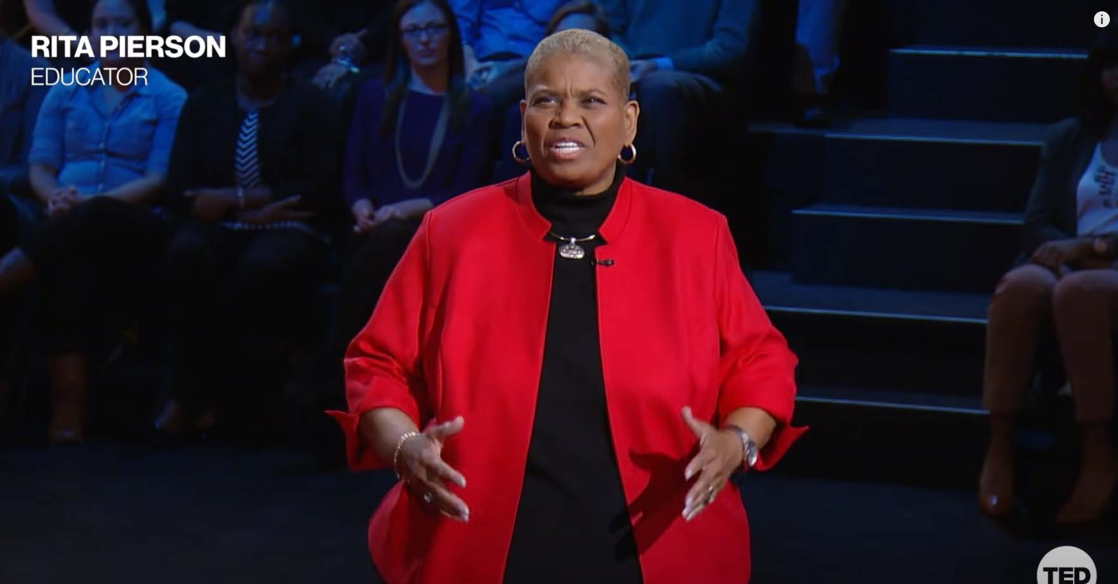

Reflecting upon today, what are some things you have learned that you can apply to access your own brilliance?

25 | P a g e

Ending Day 1!!!

Grab Bag Activity
Choose an item from the bag.
How is this item connected to what we have learned today? Share in your small group.
As a table, pick two people to share out with the larger group.

Use the following QR code to complete today’s exit ticket.


26 | P a g e

DAY TWO
What are some things that our students do well? How do they show up in ways that exhibit these skills?
Showcasing Student Strengths
Community Agreements |  | What do you need from us or yourself to honor the community agreement?
Practice Self-Compassion | - Extend patience, grace, and kindness  - Focus on solutions to make things easier
Practice Growth Mindset | - Be open to new thoughts and ideas  - Embrace learning opportunities
Practice Presence | - Focus on the here and  now  - Share your expertise, information and ideas.  - Assign a group recorder
Setting Intentions |  | What is your personal intention for our time together?

27 | P a g e



Question | Prediction
The most prevalent chronic illness affecting children is:
- Type 1 diabetes
- Asthma
- Internalizing disorders
How many youth suffer from a mental disorder?
How many youth suffer from depression?
How many youth with major depression do not receive any mental health services?
What percentage of youth ages 16-24 reported signiﬁcant loneliness in 2024?
What percentage of youth report high anxiety?
Anxiety is associated with what percentage of school avoidance cases?
Suicide is the leading cause of death for children aged 13-14. | True or False

Students spend an average of how many hours in a school building in their lifetime? | True or False
Youth are less likely to seek mental health services in schools rather than in the community. | True or False
When young people feel connected at school, they are better protected from mental health issues, suicidal thoughts, substance abuse, and violence. | True or False
Lacking social connection and isolation is as dangerous as…
How did your guesses hold up? Were you close?


Collective Brainstorming

30 | P a g e

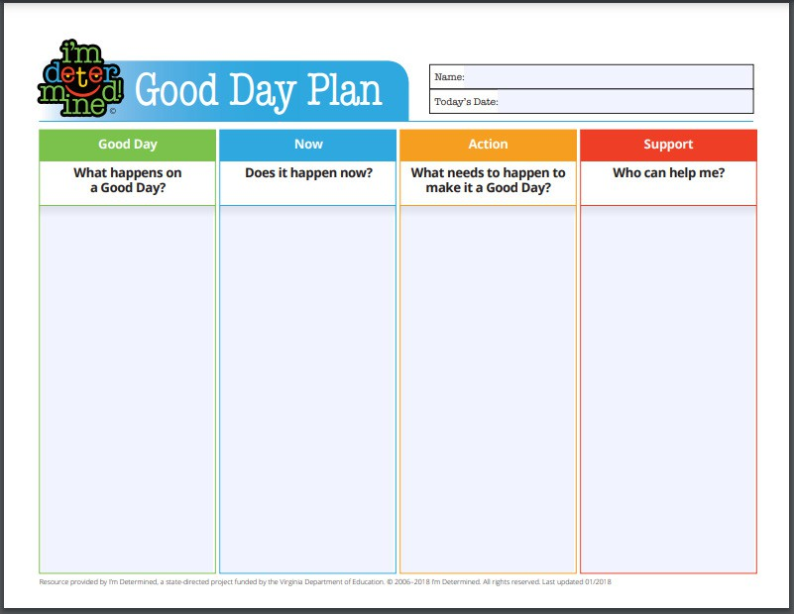
Complete your personal Good Day Plan or Take Care of Me List
Notes:

31 | P a g e

Complete your personal Good Day Plan or Take Care of Me List
The Take Care of Me List

- Ask students to fill a page with specific things you can do to take care of them as learners.
- Have them think back to a previous experience that made them happy to learn and
describe what the teacher did to support them
- Model this by giving having your own “Take Care of Me List” that highlights things you
need from them as students
- Read them all and write a short response
https://www.edutopia.org/article/takecaremelist
My Take Care of Me List
Notes:

32 | P a g e

__
VTSS Top 10

Notes:

PHYSICAL ENVIRONMENT ACTIVE SUPERVISION
DEFINE CLASSROOM EXPECTATIONS ROUTINES AND PROCEDURES OPPORTUNITIES TO RESPOND FORMATIVE ASSESSMENT SCAFFOLDING
ACKNOWLEDGEMENT/ BEHAVIOR SPECIFIC PRAISE ERROR CORRECTION
BUILDING COMMUNITY THROUGH FEEDBACK

These strategies are discussed in further detail in the Effective Classroom Systems (ECS) training provided through VTSS.

33 | P a g e

Classroom Management: Self Assessment Revised
Independent Reflection
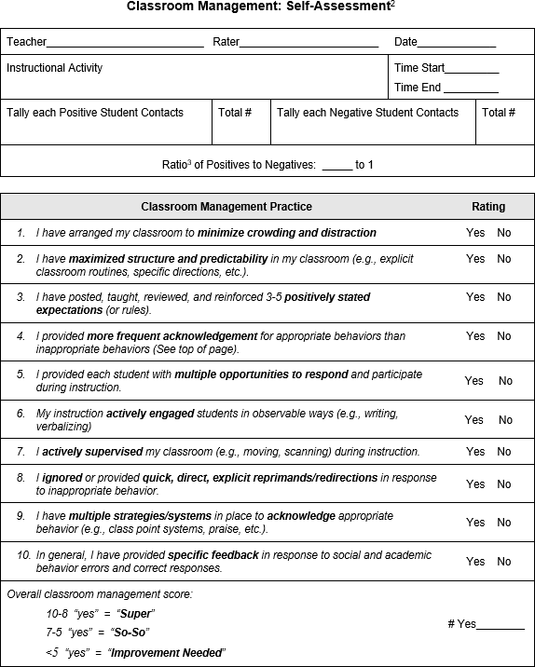
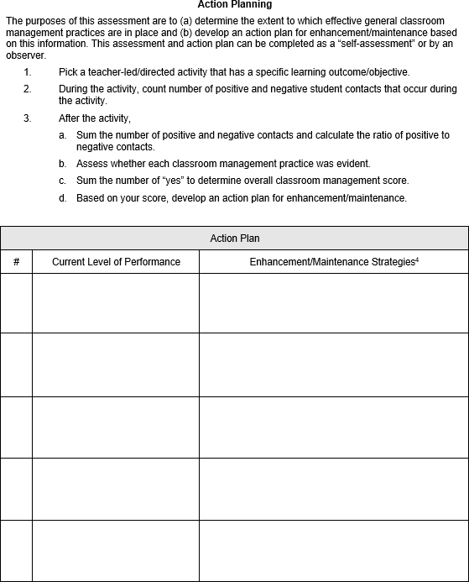

34 | P a g e

The Escalation Cycle

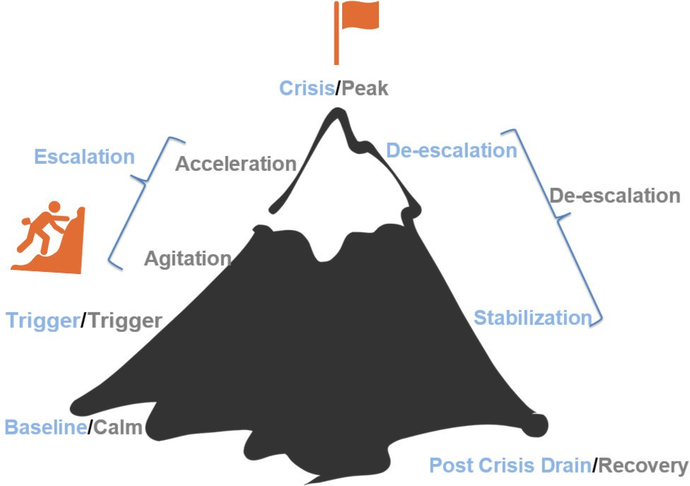

Notes:

35 | P a g e

Teaching Model

How can we shift to an instructional approach to address disruptive
behavior?

When to teach:
Teaching during Baseline
Where to teach:

How to teach:

36 | P a g e

Replacement Behaviors

A replacement behavior is an alternative behavior that allows a student to meet the same need or achieve a similar outcome as the undesired behavior they are currently using.
Notes:
- Must serve the same function as the challenging behavior
- Must be just as easy to perform as the challenging behavior
- Must be just as efficient (quick) as the challenging behavior
- Must be just as effective as the challenging behavior


Behavior Consequence
Antecedent
_
Mr. Jones handed an assignment to Mike

paper ripped up, thrown on floor

Mr. Jones redirected him





37 | P a g e


Important Considerations for Replacement Behaviors

Remember that students, like adults, are not wired to be onetime learners.
Teaching replacement behaviors allows you to encourage behavioral learning so that students’ needs are fulfilled, but it is done in a way that is more prosocial.

Go back to the ABC examples from Day 1. Identify replacement behaviors for each of the examples.

38 | P a g e

Prompting & Cueing

  - A hint meant to encourage
Reflect on your personal scenario. Identify a replacement behavior. What additional skills might your students need to engage in that replacement behavior?
  - a person to perform a desired behavior.
  - Paired with a desired behavior (i.e. social skill, coping skill, replacement behavior)
  - Subtle
  - Verbal, visual, gesture, etc.



39 | P a g e


How are you already incorporating
teaching these skills in your classroom?
40 | P a g e

Regulation strategies and activities | Building | Emotional check-ins | Connection begins at the door

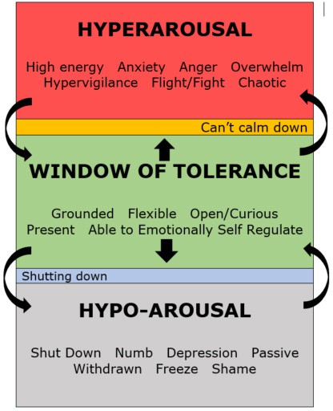
It’s not something you choose -
these reactions just take over.
You might feel stress or pressure, but it doesn’t bother you too much.
It’s not something you choose -
these reactions just take over.

- In your small groups discuss what new
ideas you learned about teaching these skills during our last walk-about
- Self-awareness
- Self-Management
- Social Awareness/Empathy
- Social skills

41 | P a g e

Vs.
Responding
Reacting Versus Responding

Our initial response determines what happens next.
    - Challenge ● Reprimand ● Argue ● Escalate Emotion ● Bigger Problem ●
Listen ● Paraphrase

BEHAVIOR

OUR
RESPONSE
    - Validate ● Show empathy ● Calm ● Support

Behaviors
Reacting

42 | P a g e

When Adults Respond


Notes:

- Move slowly and deliberately toward the problem situation
- Speak privately
- Speak calmly
- Minimize body language
- Keep reasonable distance
- Speak respectfully
- Establish eyelevel position
- Be brief
- Stay with the agenda – focus on the problem at hand

- Avoid power struggles – don’t get drawn into “I won’t, and you will” engagement
- Withdraw if the situation escalates

43 | P a g e

The Escalation Cycle

  - Changes in routine
  - Peer provocations
  - Pressure
  - Low preference activities
  - Facing correction procedures
  - High rate of failure on a task
  - Facing errors during instruction
  - Confusion about an assignment
  - Sensory overload
  - Being told no, or being denied some-
thing
  - Environment variables: lighting, noise level, seating arrangement
  - Feeling overwhelmed
  - Failing grades or worrying about an
assignment or project
  - Frightening news events
  - Being ignored/being criticized
  - Anniversary of a loss or hardships
  - Someone being unavailable to you
  - Lack of belonging
  - Spending too much time alone
  - End of relationship

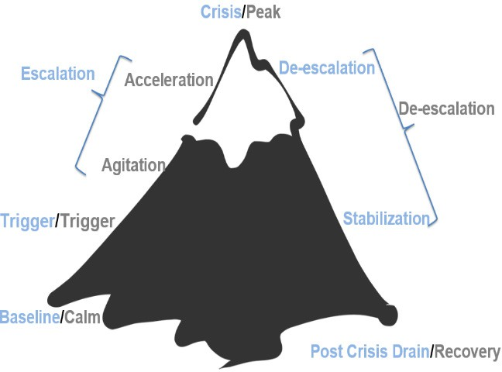
Notes:


44 | P a g e


Think “Function”
- First Step: Check Yourself
- Precorrection
- Limit setting
- Offering Choice
- Redirection / Prompting
- Behavior momentum
- Validation
- Active Listening
- Systematically Modifying Context
- Differential Reinforcement
- Reduce situation demands
- Teacher proximity
- Provide independent, passive, or movement activities
Trigger Phase: Strategies

Notes:

45 | P a g e

Limit Setting

Setting limits effectively requires a balance of firmness and respect.

Why Provide Choices?

46 | P a g e

Remind student of the task without commenting on the off task behavior.

Modifying Context Examples
- Sending student on an errand
- Taking a note to a colleague
- Returning material to the library
Redirection/Prompting
Examples:
- Calling on the student to answer a question.
- Assigning him or her a task to carry out
Providing student opportunity to temporarily remove themselves from setting/triggering event, which allows him/her to:
- calm down,
- move,
- avoid embarrassment,
- return and begin to work again.
Notes:

47 | P a g e

Behavior Momentum
Notes:

Make requests that are easy for the student before making requests that are more challenging or difficult.
By following a pattern of easyeasy-hardeasyeasyhard, student motivation to engage increases in response to increased opportunities for success.
Behavior Momentum Example
Michael does not like to read, so when he has to read, he puts his head on his desk and closes his eyes. His teacher, on this occasion, reads to him for a couple of minutes and engages his attention.
She then asks him to read with her, which he does, and he is then asked to read a little by himself. He continues to read and the teacher praises him.
(Colvin, 2009, p.46)

How could you use behavior momentum to address the following?

48 | P a g e

Active Listening Tips
Independent Reflection

49 | P a g e

Escalation Phase: Strategies
Goal: Interrupt/Intervene Connect
Notes:

Notes:
Connection before Correction
Goal: Interrupt/Intervene Connect

- Calming Strategies
- Redirection
- Proximity–(for attention motivated behavior
- Provide space
- Modify task (Academic lesson is not priority at this time; moving student back to calm phase is primary goal)
- Choice
- Provide alternative/enriched sensory options

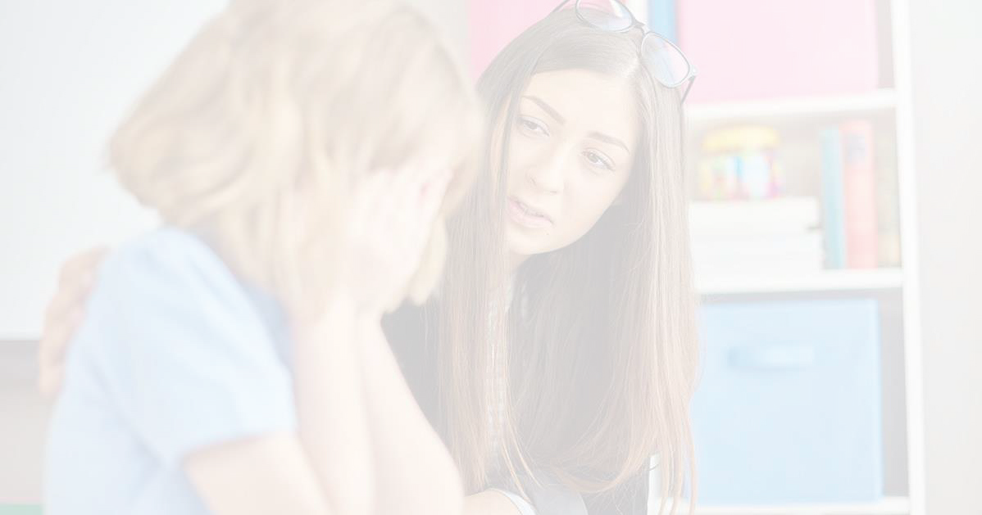

50 | P a g e

Validation In the moment,

Notes:
  - Don't try to fix it.
  - Don't give a life lesson or lecture.

Try using Validating Statements:
  - What can I help you with?
  - What do you need to feel safer?
  - I hear you, that sounds hard.
  - How did that make you feel?
  - It sounds like you are really struggling.



What are some sentence stems/phrases that work for you to
express validation?

51 | P a g e
_

Calming Strategies

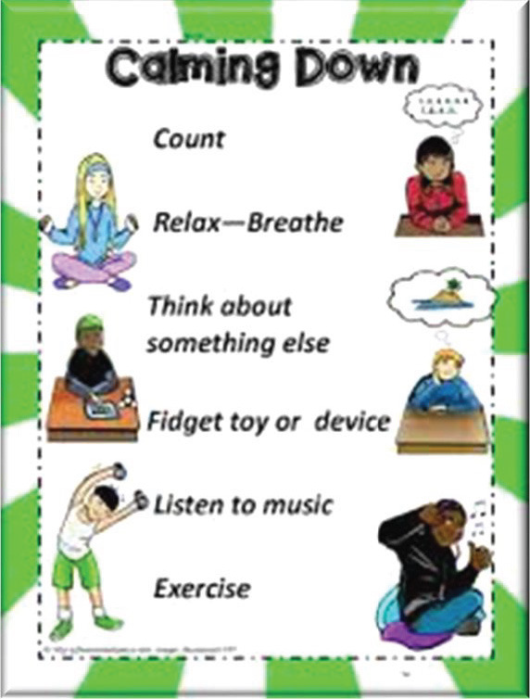
Notes:
Notes:

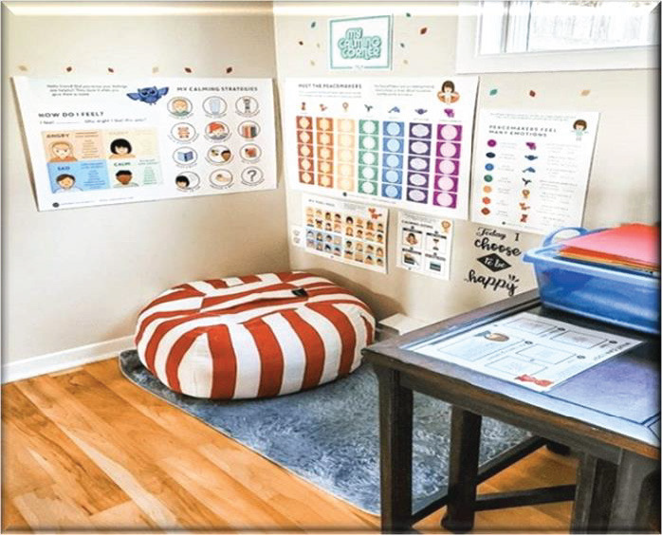

52 | P a g e

Peak Phase

This is the point where you let things run its course and keep everyone as safe as you can.
The risk of harm is the greatest at this phase.

Goal: Ensure Everyone's Safety
Notes:

- Interact as little as is necessary to ensure safety
- Provide physical space
- Limit talking (to student and other staff)
- Be aware and plan ahead

53 | P a g e

Scenario

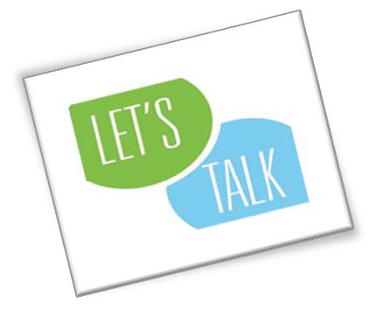
Tyler is a 7th grade boy. This morning, when he arrived at school, his teacher asked him for his
homework and Tyler did not have it. She expressed frustration and told him he had lunch detention consequently. Less than 5 minutes later, the student that sits behind Tyler accidentally bumped him. Tyler reacted by kicking the student. His teacher, shouted at Tyler to stop. He then began pushing his materials off his desk, yelling at his peers to leave him alone and then sat in the back of the room on the floor. After 10 minutes of trying to get Tyler to stand up and go back to his desk, the principal showed up, walked Tyler to the office and suspended him for
5 days for fighting and disruptive behavior.
Small Group Discussion
How did the teacher play a part in further escalating the situation? What could have been done at the very beginning to change how this situation played out?
What other changes could have been made?

How do you feel after a major emotional escalation?
How do your students act after a peak crisis situation?

_ 54 | P a g e

Deescalation & Stabilization

Physical and/or emotional discomfort is still present.
While muscle tension and breathing are decreasing, this phase is like the escalation phase.

55 | P a g e
Student behavior can look like…
Goal: Avoid Reescalation
▪
▪
▪
▪
▪
▪
▪
▪
▪
▪
▪
Reconciliation
Withdrawal Denial Blaming others
Increased responsiveness to directions Avoidance of discussion
Confusion
Preference for busy work Subdued
Avoidance of debriefing
May show signs of lethargy and fatigue
- Assign low level independent task
- Avoid blaming
- Provide Structured Choice
- Provide Differential Reinforcement

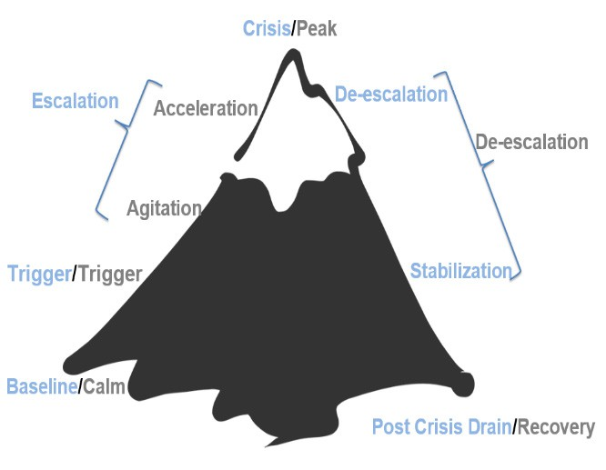
Post Crisis Drain/Recovery Phase

May experience a drop below baseline, appearing withdrawn or depressed.
May require rest due to emotional or physical drain.

Goal: Support and Observe
- Positively reinforce any display of appropriate behavior
- Focus intervention on reestablishing routine activities
- Debrief (after student has been calm at least 20 minutes)
- Not an aversive consequence
- No more than 35 minutes

56 | P a g e

Debriefing

Goal: Support and Observe
- Debrief with the student only after student has been calm at least 20 minutes
- Not an aversive consequence
- No more than 35 minutes
- Continue to positively reinforce any display of appropriate behavior
- Focus intervention on reestablishing routine activities
Components for Debriefing Plan

- Purpose of debrief is to facilitate transition back to instruction and to effectively problem solve, not further negative consequence
- Identify the sequence of events
- Pinpoint decision making moments during the sequence of events
- Evaluate the decisions

57 | P a g e

After the Incident

Goal: Plan for Support and Skill Building
  - Meet with teachers/staff and collaborate to identify
    - triggers
    - function
    - proactively plan response for future
occurrences

reach out to family
Staff Reflection

- What triggered the behavior?
- What was the function of the behavior?
- What strategies worked? Didn’t work?
- What skills/replacement behaviors does the student need to learn that align with the function?
- How can they be taught?
- Are there environmental chang-es we can make to set the student up for success?
- How can we involve the family?

What is your current process for supporting the student(s) and staff after the incident? Are there any adjustments that need to be made to that process?

58 | P a g e

Reflecting on your personal scenario, what have we covered over the past two days that would have
shifted the outcome? What might you try next time?
How can you use this information to adjust schoolwide practices and build capacity?

59 | P a g e

The Escalation Cycle

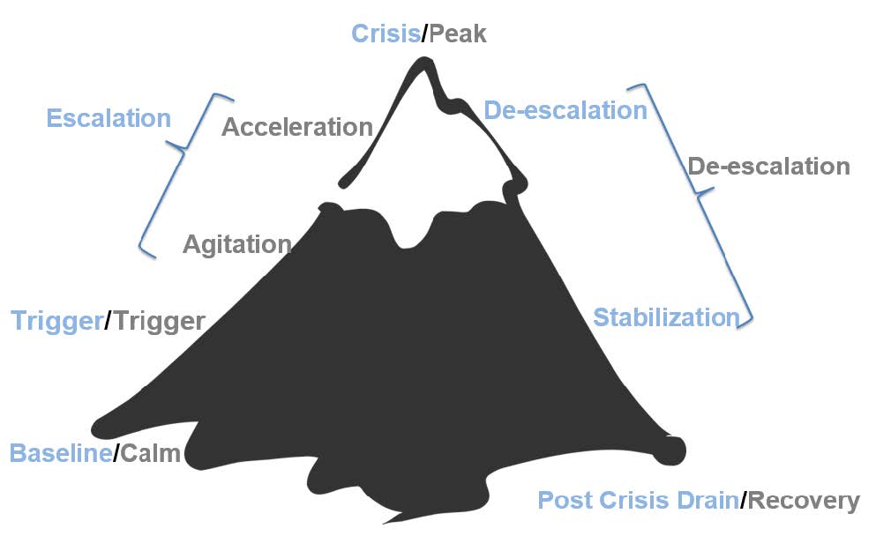

Phase: Baseline/ Calm | What is my role and/or what is my specific role in this phase? | Who can I contact for coaching and support?
What does it look like? | The student is feeling regulated, following directions, focused on work, and participating. | - What role do I play in maintaining a calm environment?  - What schoolwide/classroom expectations are proactively taught? If none, the steps needed:  - What procedures are in place to recognize and reinforce positive behavior? If none, the steps needed:  - How do I build relationships with students at this stage?  What systems exist to collect and analyze baseline behavior data? If none, the steps needed:

What can adults do?
- Notice and praise positive behaviors: “I see you’re working hard—great focus!”
- Build connections and trust.

Teach skills for solving problems or handling emotions.

Key insights:

Phase: Trigger | What is my role and/or what is my specific role in this phase? | Who can I contact for coaching and support?
What does it look like? | Small things start to bother a student—maybe someone took their pencil, the student didn’t get a turn, or they are hungry or tired. | - What common triggers have been identified for specific students in my charge?  - Which students have documented behavior support plans for frequent triggers?  - What are the procedures for reporting emerging patterns or triggers? If none, the steps needed:  - What are the environmental, academic, or social factors that could be potential triggers?  What is my role in adjusting instruction or environment when a trigger is suspected?

What can adults do?
- Gently check in: “Looks like something might be bothering you. Want to talk?”
- Offer simple solutions or choices: “Would you like to take a quick break or get a drink of water?”

Stay calm and prevent further stress.

Key insights:

The Escalation Phase Part 1
Phase: Agitation | What is my role and/or what is my specific role in this phase? | Who can I contact for coaching and support?
What does it look like? | The student is feeling uncomfortable or frustrated. They may fidget, pace, tap a pencil, avoid eye contact, or stop following directions. | - What early signs of agitation am I trained to recognize?  - What are my go-to de-escalation strategies at this stage?  - What classroom adjustments are allowed or encouraged (e.g., breaks, movement)?  - How do I communicate with support staff (e.g., counselor, admin) when a student is agitated?  What documentation or reporting is required during agitation? If none, the steps needed:

What can adults do?
- Utilize calming Strategies
- Redirection
- Proximity–(for attention motivated behavior)
- Provide space
Modify task-(Academic lesson is not a priority at this time; moving student back to calm phase is the primary goal)
- Provide choice
- Provide alternate/enriched sensory options
- Give space or a break: “You can take 2 minutes to reset in the quiet area.”
- Reduce demands: “Let’s skip the hardest question for now.”

Offer calming tools: stress ball, breathing strategies, drawing.

Key insights:

The Escalation Phase Part 2
Phase: Acceleration | What is my role and/or what is my specific role in this phase? | Who can I contact for coaching and support?
What does it look like? | The student becomes more upset now. They may raise their voice, argue, refuse to listen, slam things, or try to leave the room. | - What are the procedures for calling for help or support? If none, the steps needed:  - Are there clear guidelines on when to remove a class or a student? If none, the steps needed:  - What de-escalation training have I received, and how do I apply it?  How is the student’s dignity preserved during behavioral acceleration?

What can adults do?
- Stay calm and avoid power struggles: “I’m here to help when you’re ready.”
- Keep directions short and clear: “Please sit down. We’ll talk in a minute.”

Keep others safe and give the student physical and emotional space.

Key insights:

Phase: Crisis/Peak | What is my role and/or what is my specific role in this phase? | Who can I contact for coaching and support?
What does it look like? | The student has lost control. They might scream, throw things, try to hurt themselves or others, or run away. | - What are the school’s crisis response procedures? If none, the steps needed:  Who is responsible for intervening directly during a peak event?  - What documentation or reporting is required immediately after a crisis? If none, the steps needed:  - What are the expectations for staff not directly involved (e.g., teachers nearby)?  How are physical interventions (if used) regulated and documented?

What can adults do?
- Prioritize safety for everyone.
- Stay calm and non-threatening.
- Interact as little as necessary to ensure safety.
- Avoid talking too much—keep your voice low and body language open.

Use a crisis plan or call for help if needed.

Key insights:

Phase: De-escalation | What is my role and/or what is my specific role in this phase? | Who can I contact for coaching and support?
What does it look like? | The student is calming down. They may seem quiet, tired, embarrassed, or avoid talking. | - What behaviors signal that the student is de-escalating?  What should I not do during this stage?  - Is there a protocol for supervision and support during de-escalation? If none, the steps needed:  - How might I inadvertently re-trigger the student?  Who is responsible for maintaining safety and observing behavior at this stage?

What can adults do?
- Assign low-level independent task
- Avoid blaming
- Provide Structured Choice
- Provide Differential Reinforcement
- Allow silence and space to recover.
- Reassure: “You’re safe now. We’ll figure this out together.”

Avoid consequences or big conversations right away.

Key insights:

Phase: Recovery | What is my role and/or what is my specific role in this phase? | Who can I contact for coaching and support?
What does it look like? | The student is calming down. They may seem quiet, tired, embarrassed, or avoid talking. | - What are the expectations for post-incident reflection (with the student and staff)?  - How do I reestablish trust and connection with the student?  - What procedures are in place for re-entry into class or routines? If none, the steps needed:  - Who leads the recovery conversation, and what should be addressed?  - How is the family member/caretaker communication handled?  How is the incident reviewed by the team (e.g., functional behavior analysis, plan update)?

What can adults do?
- Assign low-level independent task
- Avoid blaming
- Provide Structured Choice
- Provide Differential Reinforcement
- Allow silence and space to recover.
- Reassure: “You’re safe now. We’ll figure this out together.”

Avoid consequences or big conversations right away.

Key insights:

Phase: After the Crisis | What is my role and/or what is my specific role in this phase? | Who can I contact for coaching and support?
What does it look like? | Meet with teachers/staff and collaborate to identify  Triggers  Function  Proactively plan a response for future occurrences  Reach out to family | - What is my responsibility immediately after a crisis situation?  - If so, what behavior documentation is required (e.g., incident reports, behavior logs)? And by when?  How soon must the incident be reported, and to whom?  - What are the procedures for notifying administrators, behavior specialists, or school psychologists? If none, the steps needed:  - What is the process for documenting physical intervention (if used), including restraint or seclusion? If none, the steps needed:  Who is responsible for contacting the family member/caretaker after a behavioral incident? If none, the steps needed:

Key insights:

Colvin, G. T. (2010). Defusing disruptive behavior in the classroom. Corwin Press.
*ChatGPT (OpenAI) was used to assist in drafting parts of this resource

