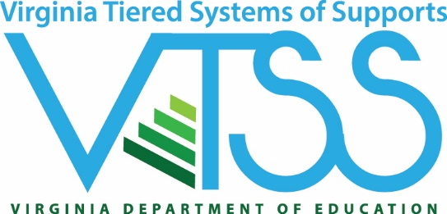

Statement of Commitment for
Exploration and Installation
Virginia Tiered Systems of Supports
Please return this form no later than February 3, 2020 to:
Michael Gregory
VTSS Specialist
Virginia Department of Education
Email: Michael.Gregory@doe.virginia.gov
Phone: 804-225-4543

Statement of Commitment
Exploration & Installation Checklist
Division:
Division Address, City, Zip:
Please check “yes” that you understand and agree: | YES
The division will establish and maintain a division exploration team, including a VTSS division coordinator and other key central office personnel. It is recommended that the team include individuals who can leverage resources, influence policy, and represent a range of stakeholders. Consider representation from executive level management, special education, student services, building level principals, family, and community representatives such as substance abuse and/or mental health community providers.

Identify division exploration team members:
Name | Position

Division exploration team will complete VTSS exploration activities as identified in E&I professional learning sessions and documented in a shared electronic folder.

School division personnel serving on the Division Exploration Team (including some building level personnel) will attend all three E&I professional learning sessions sponsored by the VDOE or complete the 4-part virtual series as documented by completion of activities embedded in the virtual series.

Statement of Commitment FY 2020
VTSS Signature Page
Division:
Division Address, City, Zip:
Division Coordinator
Name: |  |  | Position:
Phone: |  |  | E-mail:
Printed Name |  | Signature |  |  | Date

Division Superintendent
Printed Name | Signature | Date

Assistant Superintendent of Instruction
Printed Name | Signature | Date

Director of Special Education
Printed Name | Signature | Date

Director of Student Support Services
Printed Name | Signature | Date

