WHAT: A Division Initiative Map is an iterative activity completed as you implement VTSS. It allows the division an opportunity to identify existing initiatives used to address current needs. When completed as a part of the Exploration phase of implementation, certain outcomes can be achieved:

- A determination of the “fit” of VTSS with other priorities and existing initiatives
- A determination of VTSS as a “match” to the identified needs of community organizations, values, and diverse cultural groups within the division
- A foundation for building the data and systems around existing practices
- A structure for the gap analysis of current initiatives matched to school/division outcomes
- Identification of initiatives to match the goals of continuous improvement
- The initial conversation regarding the data collection that determines the efficacy of current practices and initiatives
- An opportunity to begin the discussion around outcomes of initiatives and consider decisions regarding continuance

HOW:
A | B | C | D | E | F | G | H | I | J | K | L
Continuum of Support for the Domain: Behavior, Academics, Social/Emotional Wellness | What initiatives do you support? | Community and/or Community Partners | What is the valued outcome (what brought this to your division)? | What strategic planning goal does this support? | Who receives support (e.g., ELL, SWD, Males, At Risk for Drop-out)? | How is school-based implementation supported from the division (e.g., funding, Division PD, External PD, Division Coaching, External Coaching)? | What is the funding source (e.g., specific grants)? | What department is responsible for oversight? Who is the contact person? | Is fidelity measured? If so, what is the instrument/measure? | What data is used to indicate impact? What reporting system is used? | What data is used to progress monitor? In what ways is this data collected and analyzed?
Tier 1: Universal instruction and support designed and differentiated for all students in all settings

- A – F describes the PRACTICES or INITIATIVES
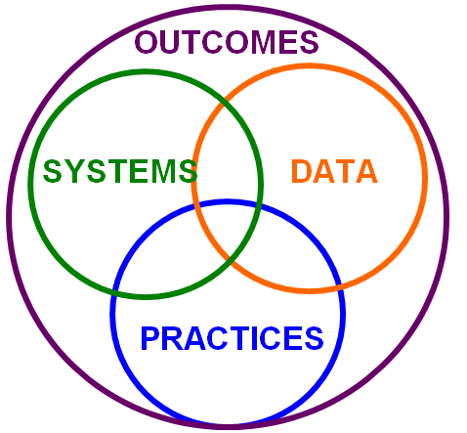
What are the practices or big initiatives that are taking the most time, resources, people, and funding? The goal is not to list them all, but to concentrate on the initiatives that are truly requiring a lot of attention. START HERE first. If you are unclear about what tier the initiative falls into, just put a question mark, and come back to it later.
- G-I describes the SYSTEMS components
How are we supporting implementation? How are we providing PD and coaching? Who is responsible for the support? Do we have a plan in place?
That specifies all these questions, and everyone is informed?
- J- L describes the DATA components
The data is about fidelity and progress monitoring. What is the impact? (K)
- A Division Initiative Map supports this work and alignment through all three Tiers. There is flexibility to add rows depending on each division’s needs.
- We revisit the map once a year along with our implementation planning. How can we leverage this initiative around the Implementation Matrix, so we align the work in our division with the framework of VTSS?
- How do we include our community partners?
- Who is the internal contact person to the agency, and is the communication aligned to our current work?
- Who needs to be at the division meetings because of their work with the division?

