Managing Complex Change
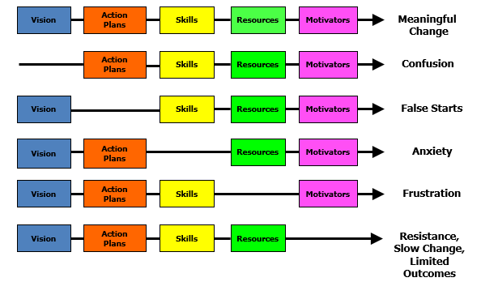Details on how to read this graphic are provided on the next page.
The previous graphic is a framework for thinking about systems change developed by Knoster, Villa and Thousand. This framework outlines the components of meaningful change: vision, action plans, skills, resources, and motivators. When components are missing, certain organizational behaviors will manifest: without vision, there is confusion; without action plans, there are false starts; without skill building, there is anxiety; without resources, there is frustration; without motivators; there is resistance and limited outcomes.

