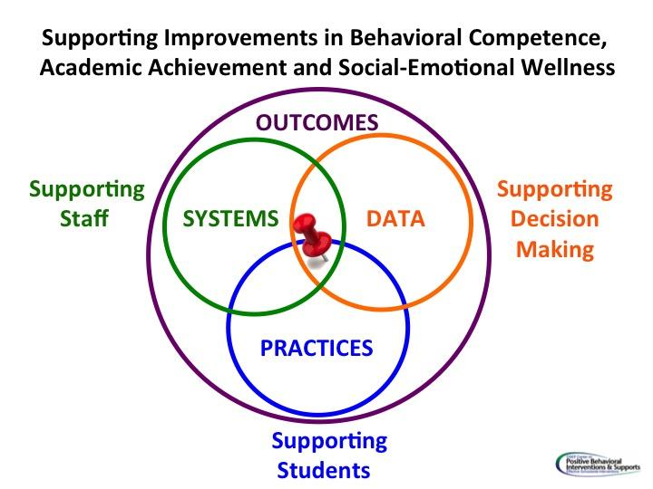
Data-Informed Decision Making: Division

DATA/Evidence of Need: Here we answer the question…Is there a problem? You can:
- Attach data analyst worksheet
- Attach charts, graphs, reports
- Electronically link to charts, graphs, reports in a shared folder for meeting minutes
Use the Data Audit Tool to ensure that the DLT and SLTs have access to this for EVERY meeting
Using the data, develop a precision statement. Who? What? When? Where? Why? Here we precisely define the problem or decision to be made. The definition should include:
- Who is having the problem? Are there certain schools and/or grade levels inclusive of priority groups that we want to be a focus for planning?
- What is the problem exactly? What do we need to prioritize? Working smarter, what aligns with school improvement plans, CAPs, MOUs, etc.?
- When is it happening? This is an easier question to answer at the school level. However, are there patterns or cycles to behavior? For example, are there periods that are worse or better for attendance?
- Where is it happening? At the school level, this could pertain to a location (bus, reading class, etc.). At the division level, this could mean a feeder pattern, a school or group of schools (with the who question above allowing us to be more specific).
- Why is it happening? At the division level, we want to consider things like, community factors, personnel considerations (new staff, provisional license, teacher attendance, etc.), capacity building needs (staff access to not just professional learning but coaching), etc. At the school level it also includes functions of behavior, prevalence of trauma, etc.
When answering these questions, in particular, the WHY, you should also consider the following (remember, the division role is to provide the support necessary for schools to make change):
- Are there/were there critical supports in place to make the change? Is there/was there adequate professional learning, coaching, administrative support, performance feedback, data for making ‘real time’ decisions?
- Were the right action steps and activities taken at the right time to ensure implementation fidelity?
- Were the right people taking responsibility for guiding the change process?
- Were the practices or innovations learnable, teachable, doable and readily assessable in practice?
- Was there sufficient support for barrier busting?
Equity Considerations:
- Have team members considered their own blind spots and the impact of implicit bias in defining the problem?
- Has your team discussed the potential impact of students’ feelings that their identities are not honored and valued in the school?
- Have students been asked about their feelings of belonging and connection to the school community?
- When looking at your precise problem, are certain groups over- or under- represented in the data?
- Has your team considered school and division policies that may contribute to the precise problem?
  - Examples: Dress code, student access to gifted/honors/AP courses, availability of resources for marginalized students, diverse representations in school curricula, etc.
Outcome (Set a goal): Set a goal that is achievable, time bound and has explicit criteria for success.
Click or tap here to enter text.
Key Practices: What key practices will the schools commit to implementing with fidelity? Name and define them.
Action Plan | Who? | When? | Fidelity Measures
- Be very specific here about what you want schools and teachers to do. By when? How will you know? If you don’t have a key practice you may have to utilize a formal selection process. (Refer to your initiative map and/or school resource maps to be sure.)
- Include actions for providing: a clear definition of what you want schools to do (action steps/by when); professional learning; coaching; administrative support; performance feedback; who should be monitoring progress at the school level (in charge of the innovation) and who should report progress to the division-level team; who should schools go to for support with barrier busting?
Key Systems: How will the division support the school in the implementation of new practices?
Action Plan | Who? | When? | Fidelity Measures
- Include communication plan – who is sharing the plan? By when? How?
- The level of detail may depend on the management structure of your division. Divisions that are more site- based managed may provide only guidelines or non- negotiables and the school provides more of the details as outlined above. The same details should be present regardless.
Data/Progress Monitoring: Did we do what we said we would do? With fidelity? Outcomes? Are we making progress?
Did it work?

