A Data Story: The Mad Libs Version
Best School Division

To understand and improve transportation for all students, Best School Division, (BSD)
(Topic Area of Concern/Interest) (Your Audience)

needs to know which barriers contribute to missed instructional time caused by misalignment
(Two Key Questions you have about this topic)

between bus arrivals and the start of instruction. To improve transportation for all students,
(Topic Area of Concern - Repeated)
BSD needs to identify barriers that contribute to missed instructional time due to the
(a way to find out the answer)

misalignment between bus arrivals and class start times. BSD transportation dept will want to

know how many routes there are, the average time, the frequency of rerouting due to
(possible variable for this answer)

changes, and how these vary. With those insights, the BSD transportation dept will be able to

find key trends and data points to support decision-making. Best of all, the BSD transportation
(Driver of this topic)

will be able to take actions such as hiring/training an appropriate number of drivers and/or
(One action that might help reach a goal)

engaging community partners, which will help the organization achieve the reallocation of
(A goal for your division/school)

resources and, equally important, equal access to instructional time.
(A particular skill or goal for the staff)

A Data Story: The Mad Libs Version
_______________________

To understand and improve ________________________ , ____________________ ,
(Topic Area of Concern/Interest) (Your Audience)

needs to know ____________________________________________________________
(Two Key Questions you have about this topic)

_________________________________. To improve _________________________________
(Topic Area of Concern - Repeated)
, _______, needs to _____________________________________________________________
(School) (a way to find out the answer)

_______________________________________________ . ______________ will want to know
(School)
_____________________________________________________________________________

____________________________________________________________________________ ,
(possible variables for this answer)

With those insights, the _________________ will be able __________________________
(School) (Driver of this topic or Key Insights)

______________________. Best of all, _____________________________will be able to
(School)

_____________________________________________________________________________
(One action that might help reach a goal)

which will ____________________________________________________________and,
(A goal for your division/school)

___________________________________________ .
(A particular skill or goal for the staff)

What is the story your data is telling about your students?
Be precise! Describe who, what, when, where and why! The more precise the story, the more efficient and effective we can be in our decision-making!
Again please tell the story through the lens of both division and pilot school data.

Your Data Story
Topic Area of Concern/Interest for your division/school
Audience that might be most interested/impacted
Two Key Questions you have about this topic
A way to find out the answer
A possible variable for this answer
What is a driver of this topic?
What gets in the way or is an outlier?
One action that might help reach a goal
A goal for your school
A particular skill or goal for the staff

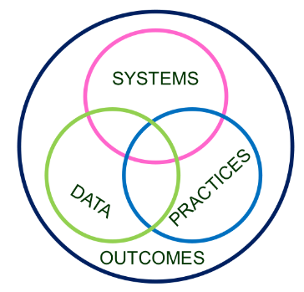
Data-Informed Decision Making

DATA/Evidence of Need:
Using the data, develop a precision statement. Who? What? When? Where? Why?
Outcome (Set a goal):
Key Practices: What key practices will the schools commit to implementing with fidelity? Name and define them.
Action Plan | Who? | When? | Fidelity Measures
Key Systems: How will the division support the school in the implementation of new practices?
Action Plan | Who? | When? | Fidelity Measures
Data/Progress Monitoring: Did we do what we said we would do? With fidelity? Outcomes? Are we making progress?

