Data Informed Decision Making: School
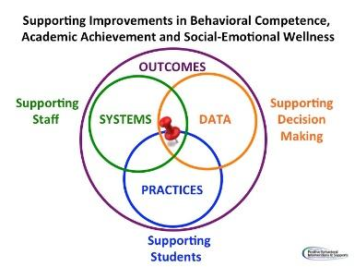

DATA/Evidence of Need:

Using the data, develop a precision statement. Who? What? When? Where? Why?

Outcome (Set a goal):

Key Practices: What key practices will the schools commit to implementing with fidelity? Name and define them.
Action Plan | Who? | When? | Fidelity Measures
Key Systems: How will the division support the school in the implementation of new practices?
Action Plan | Who? | When? | Fidelity Measures

Data/Progress Monitoring: Did we do what we said we would do? With fidelity? Outcomes? Are we making progress?

