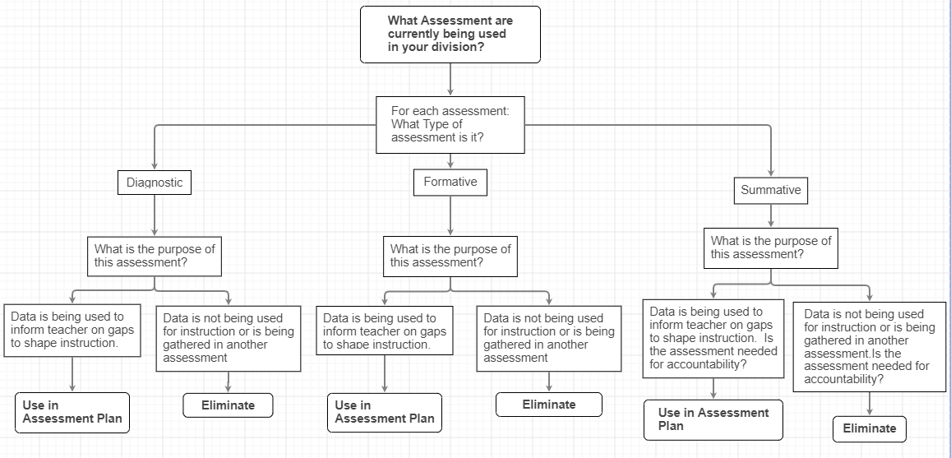
Items to consider:
1. Are there assessment currently in place in which the data are not currently informing instruction but could be?
2. Are we considering multiple ways to assess student mastery of content and science and engineering practices (addressing breadth and depth of student understanding)?
3. Are performance tasks (formative) and performance assessments (summative) in the plan?
4. Are current assessments in place that are assessing content and guiding instruction; however, another type of assessment would be more appropriate?

