Managing Complex Change

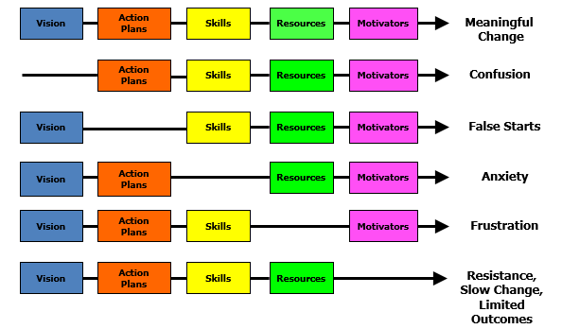
The Team’s Work is Managing Change
The graphic on the previous slide is a framework for thinking about systems change developed by Knoster, Villa and Thousand. This framework outlines the components of meaningful change: vision, action plans, skills, resources, and motivators. When components are missing, certain organizational behaviors will manifest: without vision, there is confusion; without action plans, there are false starts; without skill building, there is anxiety; without resources, there is frustration; without motivators, there is resistance and limited outcomes.

