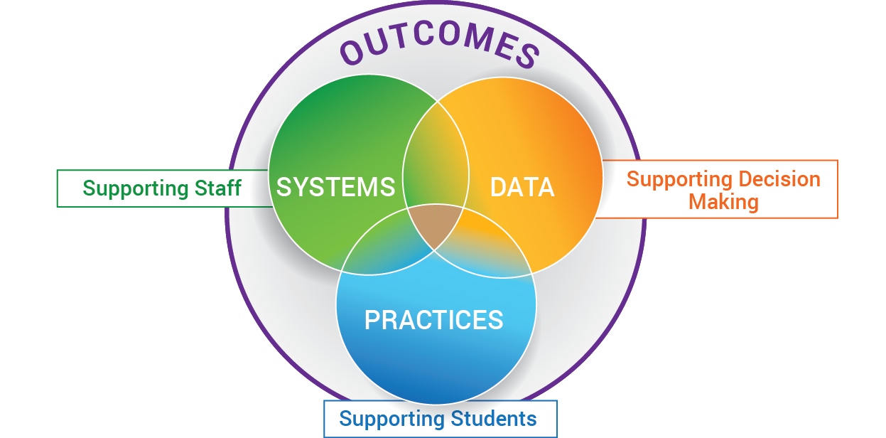
EXAMPLE: MULTI-TIERED SYSTEMS OF SUPPORT FOR IMPLEMENTING PBIS

PBIS DATA POSSIBILITIES:

Out of School Suspensions (OSS)
In School Suspensions (ISS)
Office Discipline Referrals (ODR)
% Students w/ 0-1 ODR; 2-5 ODR; 6+ ODR
TFI targets
School Climate targets
Academic targets
Attendance targets
Clinic Data
Classroom Walkthrough Data
Professional Learning Data
SYSTEMS
DIVISION:
Selects Evidence Based Practices
Provides Professional Learning
Develops Implementation Plan
Provides external coaching support
Designs Data /Problem Solving Protocol
Determines schedule for progress monitoring data
Defines Decision rules for support
Monitors implementation fidelity & data
Provides resources equitably
Communicates to Families/Community
Supports Staff Wellness
SCHOOL:
Builds Schoolwide Matrix and refines as needed, based on ongoing data
Determines structure for Tier 1 instruction: Morning Meetings, Advisory, Circles, etc.
Monitors data monthly (SLT; grade levels)
Identify students in need of further assessing and/or supports
Advanced Tiers bi-monthly meetings
Ongoing Professional Learning
Coaching as needed
Evaluation of all PD
Staff Wellness activities
IMPLEMENTING PBIS
PRACTICES / PROGRAMS:
Schoolwide Matrix
Schoolwide Lesson Plans
Flow Chart for consistency
Re-teaching opportunities
Classroom Matrices
Classroom Practices defined: Arranging the Physical Environment; Active Supervision; Classroom Expectations; Routines and Procedures; Opportunities to Respond; Ensuring Academic Success; Scaffolding; Acknowledgement and Behavior Specific Praise; Group Contingencies; Error Correction

Acknowledgement system (immediate; intermittent; schoolwide goals)
PBIS ADVANCED TIER SUPPORTS

Check-in Check-Out
Provide re-teaching opportunities based on data

Provide small group lessons for students identified as needing more support

Provide targeted lessons for students needing individualized support, as indicated by data
Using Data to Build a System of:
Prevention, Intervention
& Enrichment
to SUPPORT:
ALL Staff, Students
& Families
"If you're too busy to build good systems, then you'll always be too busy." - Brian Logue

