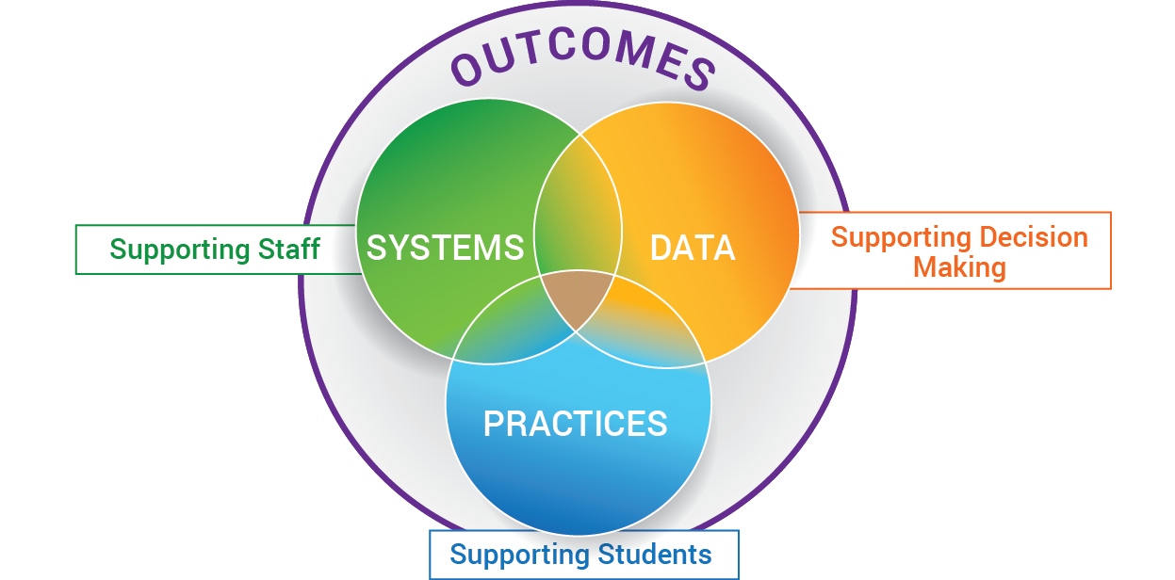
EXAMPLE: MULTI-TIERED SYSTEMS OF SUPPORT FOR IMPLEMENTING RESTORATIVE PRACTICES (as an enhancement to PBIS)

DATA POSSIBILITIES:

Out of School Suspensions (OSS)
In School Suspensions (ISS)
Office Discipline Referrals (ODR)
% Students w/ 0-1 ODR; 2-5 ODR; 6+ ODR
TFI targets
School Climate targets
Academic targets
Attendance targets
Clinic Data
Classroom Walkthrough Data
Professional Learning Data
SYSTEMS
DIVISION:

Selects Evidence Based Practices
Provides Professional Learning
Develops Implementation Plan
Provides external coaching support
Designs Data /Problem Solving Protocol
Determines schedule for progress monitoring data
Defines Decision rules for support
Monitors implementation fidelity & data
Provides resources equitably
Communicates to Families/Community
Supports Staff Wellness

SCHOOL:

Builds Schoolwide Matrix and refines as needed, based on ongoing data
Determines structure for Tier 1 instruction: Morning Meetings, Advisory, Circles, etc.
Monitors data monthly (SLT; grade levels)
Identify students in need of further assessing and/or supports
Advanced Tiers bi-monthly meetings
Ongoing Professional Learning
Coaching as needed
Evaluation of all PD
IMPLEMENTING RP
PRACTICES / PROGRAMS:
PBIS Practices PLUS

Proactive Circles

Responsive Circles

Affective Statements

Restorative Questions

Impromptu Chats

RP Advanced Tiers Practices
PBIS Adv. Tiers Practices PLUS:

Restorative Conferences

Restorative Re-entry
Using Data to Build a System of:
Prevention, Intervention
& Enrichment
to SUPPORT:
ALL Staff, Students
& Families
"If you're too busy to build good systems, then you'll always be too busy." - Brian Logue

