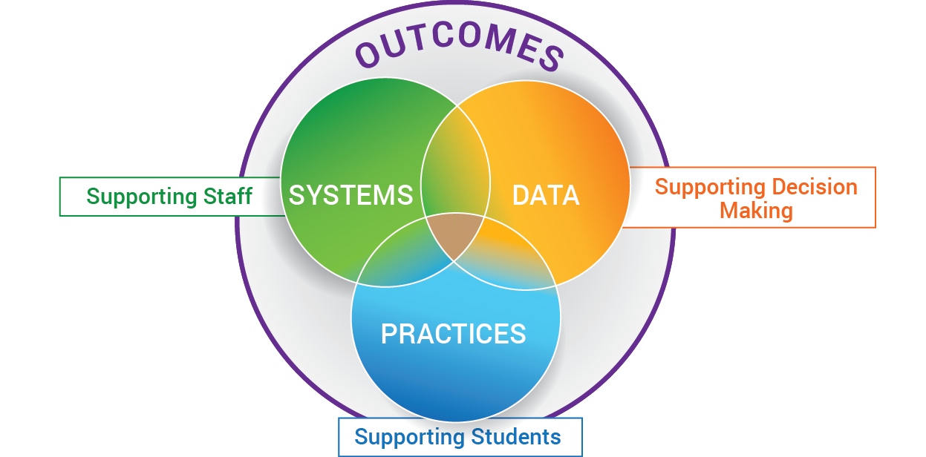
EXAMPLE: MULTI-TIERED SYSTEMS OF SUPPORT FOR IMPLEMENTING THE SCIENCE OF READING (S.O.R.)
SYSTEMS

DIVISION:

Selects Evidence Based Practices
Provides Professional Learning on S.O.R.
Develops Implementation Plan
Provides external coaching support
Designs Data /Problem Solving Protocol
Determines schedule for progress monitoring data
Defines Decision rules for support
Monitors implementation fidelity & data
Provides resources equitably
Communicates to Families/Community

SCHOOL:

Conduct quarterly screening
Identify students in need of further assessing and/or supports
SLT Monthly Data Meetings
Grade Level / Content Data Meetings
Advanced Tiers bi-monthly meetings
Ongoing Professional Learning
Coaching as needed
Evaluation of all PD
IMPLEMENTING S.O.R.
PRACTICES / PROGRAMS:
Division Curriculum
Phonemic Awareness
Phonics
Fluency
Vocabulary
Comprehension
Division Scope & Sequence

Core Reading Program(s) are clearly defined

Core Reading Practices are clearly defined

READING ADVANCED TIER SUPPORTS
Teacher (and/or as teams) provide additional skill specific small group instruction

Reading Specialist provides skill specific small group instruction

Reading Recovery

Wilson

Orton Gillingham
Using Data to Build a System of:
Prevention, Intervention
& Enrichment
to SUPPORT:
ALL Staff, Students
& Families
"If you're too busy to build good systems, then you'll always be too busy." - Brian Logue
READING DATA POSSIBILITIES:

PALS Data
SOL Outcome Data
Universal Screening Data
Benchmark Data
Oral Reading Fluency Data
Progress Monitoring Data
Classroom Walkthrough Data
Professional Learning Data
Attendance Data*
Discipline Data*

*Critical to account for missed instructional time

