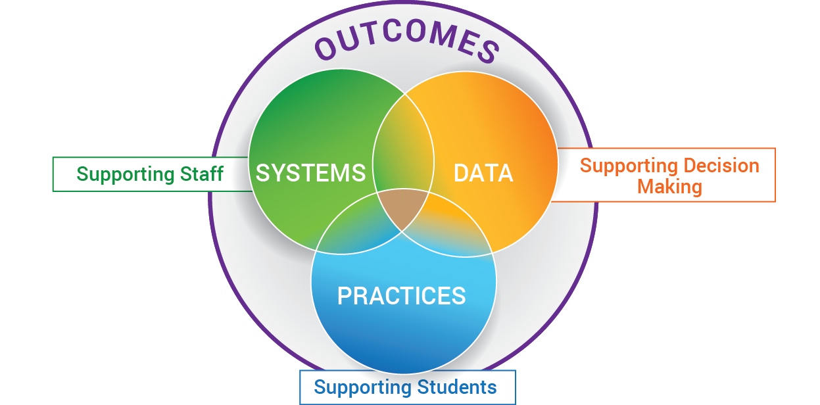
EXAMPLE: MULTI-TIERED SYSTEMS OF SUPPORT FOR IMPLEMENTING SOCIAL EMOTIONAL LEARNING

SEL DATA POSSIBILITIES:

Screening Data:
Climate Data
Discipline Data
Academic Data
Attendance Data
Clinic Data
PD evals
Morning meetings held
HS Advisory lessons
SYSTEMS
DIVISION:
Selects Evidence Based Practices
Provides Professional Learning
Develops Implementation Plan
Provides external coaching support
Designs Data /Problem Solving Protocol
Determines schedule for progress monitoring data
Defines Decision rules for support
Monitors implementation fidelity & data
Provides resources equitably
Communicates to Families/Community
Supports Staff Wellness
SCHOOL:
Conduct Semi-annual Screening
Identify students in need of further eval.
SLT holds Monthly Data Meetings
Advanced Tiers bi-monthly meetings
Professional Learning
Determine structure for Tier 1 instruction: Morning Meetings, Advisory, Circles, etc.
Coaching as needed
Evaluation of all PD
Staff Wellness activities
SAMPLE SEL
PRACTICES / PROGRAMS:

Screener (e.g., DESSA)
SEL Lessons (e.g., Second Step)
Morning Meetings
Circles
Advisory lessons
Targeted lessons for ALL students based on needs of class, grade, school, as determined by data

Evidence Based Programs (e.g., Hope Squad)

Secondary – Signs of Suicide
SAMPLE SEL
ADVANCED TIER SUPPORTS
Provide targeted lessons for small groups for students, as identified by data

Staff Mentors
Check-in Check-Out
Provide targeted lessons for students needing individualized support, as indicated by data

Secondary - Ripple Effect
Using Data to Build a System of:
Prevention, Intervention
& Enrichment
to SUPPORT:
ALL Staff, Students
& Families
"If you're too busy to build good systems, then you'll always be too busy." - Brian Logue

