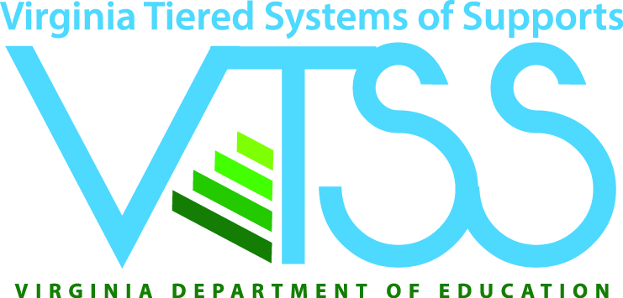
Academic Tiered Fidelity Inventory
July 21-23, 2020
Event Time: Daily 9:00 A.M – 12:00 P.M.
Event Location – Virtual Learning
Check-in at 8:50 A.M.

Materials, learning intentions, and information may be found on the VTSS-RIC website: https://vtss-ric.org/implementers/t1-resources/t1f-atfi/ Password: vtss

General Session Zoom Link: https://zoom.us/j/92162068231

Agenda
Day 1, July 21, 2020
8:50 a.m. – 9:00 a.m. Attendance and Welcome
9:00 a.m. – 9:30 a.m. Introduction to ATFI
9:30 a.m. – 10:50 a.m. Module: Instructional Planning
10:50 a.m. – 11:00 a.m. Preparation for Team Planning Break Out Sessions
11:00 a.m. – 11:15 p.m. Break
11:15- p.m. – 12:00 p.m. Team Planning

Day 2, July 22, 2020
8:50 a.m. – 9:00 a.m. Attendance and Welcome
9:00 a.m. – 9:30 a.m. Continue Module: Instructional Planning
9:30 a.m. – 12:00 p.m. Module: Instructional Delivery

Day 3, July 23, 2020
8:50 a.m. – 9:00 a.m. Attendance and Welcome
9:00 a.m. – 9:30 a.m. Continue Module: Instructional Delivery
9:30 a.m. – 10:45 a.m. Modules: Collective Teacher Efficacy, Professional
Learning, Coaching and Family Engagement
10:45 a.m. - 11:00 a.m. Wrap Up
11:00a.m. – 11:15 a.m. Break
11:15 a.m. – 12:00 p.m. Team Planning Time

@VTSS_RIC
#VTSScoaching
#VAis4Learners

