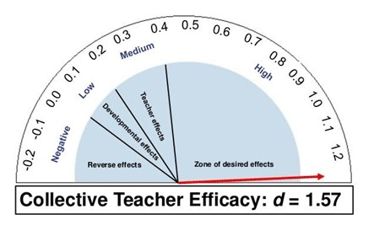
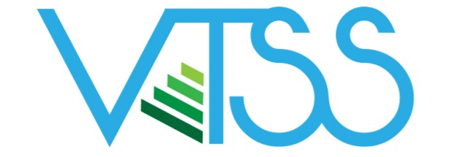
What can educational leaders (building based administrators and district office leadership) do to intentionally enhance the development and impact of effective teacher efficacy? We asked Virginia Administrators this question.
VTSS SYSTEMS BRIEF

BUILDING COLLECTIVE
TEACHER EFFICACY
John Hattie defines Collective Teacher Efficacy as the shared belief that through teachers’ collective action, they can positively influence student outcomes, including those who are disengaged and/or disadvantaged.
The VTSS Administrative Work group sponsored 3 networking sessions during the summer of 2019 designed to foster discussion among school administrators around these 6 factors that help build collective teacher efficacy.

Advance Teacher Influence

THE 6 CTE CONDITIONS
From an article by Jenni Donohoo: https://thelearningexchange.ca/collective-teacher-efficacy/ext

# 1. Advanced Teacher Influence
- Goal Consensus
- Teachers’ Knowledge about One Another’s Work
- Cohesive Staff
- Responsive Leadership
- Effective System of Intervention
The discussions focused on a variety of ways administrators gave teachers a voice in the school and allowed teachers to be a critical part in school leadership. For example, the VTSS/PBIS school level team is teacher led and administration provides support. It is critical to ensure teachers are part of the decision-making process. Examples of this included teacher led department meetings and always striving to seek teacher input on multiple topics and in multiple ways. Many schools have leadership teams comprised of teachers who help make important decisions.

# 2. Goal Consensus
Goal consensus begins with a clear-shared vision. The school needs to formulate consensus on the data driven goal to work toward the vision. Leaders need to include staff input and help everyone understand the “why” behind the goal to get buy in. Data driven updates, which are frequently communicated to staff, are essential so progress toward the goal can be assessed. When sharing this data, it is important that teachers are part of the reflection and problem-solving process to support adjustments in the strategies, as needed.

# 3. Teachers’ Knowledge About One Another’s Work
Varieties of strategies were shared to facilitate teachers’ knowledge of their colleagues’ work. Some suggestions included videotaping teachers and then use of social media to share videos of teachers providing classroom instruction. Peer observation is viewed as critical. Suggestions for peer observation included teachers doing walk-throughs with an administrator and opportunities to observe peers across grade levels. This is viewed as a necessary and helpful strategy for improving staff effectiveness. Finding ways for teachers to observe other teachers in the school is viewed as essential to build knowledge of others’ work therefore, scheduling time for collaboration and peer coaching is an important role for administration.

# 4. Cohesive Staff Many similar strategies were shared to build a cohesive staff. This often includes expanding teacher leadership opportunities and using teacher’s ideas. Utilizing teachers in leadership roles was viewed as imperative. This allows for input into formulating the school vision and goals. Finally, building positive relationships with all staff was believed to be essential. Leaders shared a variety of ideas such as positive blasts about people’s lives, changing rooms, and having mentors in other departments. Opportunities for building personal connections is considered vital. Staff bonding time is crucial as are celebrations on progress towards goals.
VTSS Systems Brief
BUILDING COLLECTIVE TEACHER EFFICACY

page 2

# 5. Responsiveness of Leadership
Schools need an inclusive leader that supports teachers and is approachable. Leaders need to be creative and try new approaches. For example, instead of weekly faculty meetings, use Google classroom or weekly emails. Responsive leaders are creative and think outside the box. The responsive leader is aware to the school’s climate and the emotional status of the staff. Ongoing efforts to raise teacher morale are critical. The bottom line is teachers want to know their principal has their back when carrying out a shared vision.

# 6. Effective Systems of Intervention
Given the fact that the participants were all from VTSS schools and divisions, it was not surprising that they all believe in the need for a highly effective MTSS approach to meet the needs of their students. This system necessitates trauma sensitivity and must address the needs of the whole student, not just their academics and behavior. The critical nature of creating a strong core in all areas (Academic, Behavior, Mental Wellness) was emphasized. The need to use evidence based practices was also underscored. Finally, leaders are constantly striving to find effective interventions to support their students.
Summary:
Administrators landed on the following core ideas. They felt VTSS and all other frameworks or initiatives must be presented in a way that promotes teacher buy-in and support, so teachers easily see the value and power of the work in which they are being asked to engage. They also shared this is most easily accomplished when it builds on the work teachers are already doing and everyone is involved. When teachers know their administrators support their role (good communication, supporting the mental health of teachers), and the message is not constantly changing, they are more likely to be supportive and effectively engaged.
Finally, teachers want their administrators to connect the dots between all of the work that they are asked to complete, and provide time for teachers to collaborate. Teachers want to see their work clearly supports school and district goals. These results are reinforced by the research and clearly indicate administrators should support the development of collective teacher efficacy.
Special thanks to Dr. Chuck Wagner who provided follow-up information on CTE during the administrative webinar.

Special thanks to the following Administrators for providing information captured in this brief during the CTE summer 2019 networking breakfast sessions.
Listed below are the CTE summer participants.
Rebecca Smith, Stephanie Williams, Michael Grim, Karin Castillo - Rose, Erin Phelps, Tianna Anthony, Regina Phillips, Lantz Martin, Kelly Holmes, Matt Giles, Mary Allison Fitzgerald, Mark Harrison, Charles Johnson,Tracey Rogers, Joan Hite, Stephane Neal, Ann Dalton, Marty Wood, Lauren Thompson, Carrie Wishon, Mandi Mellard, LaMeka Harrison, John Niles, Leigh Dunavant, Amy Gubler, Gregory Reto, Bernice Ford, Virginia Gills, Denise Elisa Boyle, Mary Crowder, Stacey Newton, Jalaika Hansan, Silvanus Thrower, Cynthia Grant

