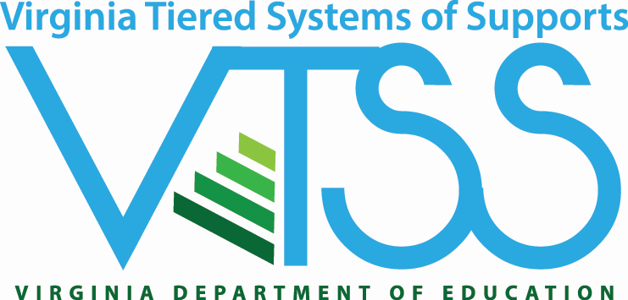

VTSS A-TFI Agenda
June 15 - June 17, 2021

Tuesday June 15, 2021, 9 AM-12:30 PM
- Welcome and Introductions
- VTSS A-TFI Overview
- Instructional Planning Module
  - Aligned Curricula
  - Collaborative Planning
  - Lesson Plans
  - Relevant Objectives
  - Performance Measures
  - Evidence-based Practices
- Daily Wrap-up

Wednesday June 16, 2021, 9 AM-12:30 PM
- Welcome
- Quick Review
- Instructional Delivery
  - Formative Assessment
  - Student Involvement
  - Instructional Practices
  - Team Composition
  - Team Alignment
  - Team Operating Procedures
  - Instructional Adjustment
- Daily Wrap-up

Thursday June 17, 2021, 9 AM-12:30 PM
- Welcome
- Quick Review
- Collective Teacher Efficacy
- Professional Learning and Coaching
- Family and Community Engagement
- Session Wrap-up

