**Teaching Appropriate Schoolwide and Classroom-wide Lesson Plans**

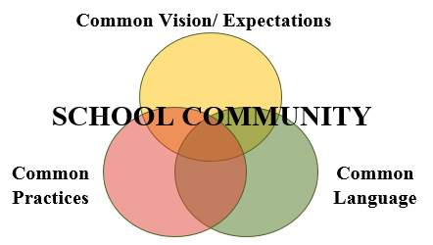

Because behaviors and emotions are embedded with cultural norms, we can’t assume the core values we’ve outlined are shared and understood by the diverse people in our buildings and communities.

We *can’t* assume:

* Students know the expectations/rules and appropriate ways to behavior in your school
* Students will learn appropriate behaviors quickly and effectively without consistent and ongoing modeling and practice

We *must* assume:

* We need to teach expectations and appropriate behaviors as effectively as we teach academic skills
* Students will require different curricula, instructional modalities, supports, etc. to learn appropriate behavior
* Children, especially those most stressed or traumatized, need to have repetition and consistency to establish safety

For students, knowing expectations, routines and procedures frees up cognitive space for new (academic) learning!

**The Science of Behavior**

*There is a science to behavior. Behaviors are learned and always about meeting some kind of need* ***(function)****…sometimes we learn behaviors that meet our individual/personal needs (and are* ***reinforced****) BUT interfere with the learning environment of the group. However, those behaviors can be* ***replaced*** *with time and plenty of deliberate practice.*

Behavior change requires ***interventions***. Interventions are changes in *staff* procedures and practices. In order to change student behavior, we have to change how the adults in the environment predict, prevent and respond to behavioral challenges.

**Creating Behavioral Lesson Plans**

What to teach: The MATRIX is the behavior curriculum. The specific behaviors for each expectation in each location must be taught to every student.

How to Teach:

*Direct instruction, feedback*, and *teacher clarity* are three instructional practice we know are highly effective and should be included in instructional design for both academics and behavior.

Teach and practice expected behaviors using direct instruction:

* **I do** (explain/show/model)
* **We do** (gradually release responsibility – may have several ‘we do’s)
* **You do** (practice with feedback)
* **You all do** (independent practice)