Infographic Module 3

What?
Trauma impacts students' performance in the classroom through challenges in learning, relationships, and behavior.
Learning | Relationship | Behavior
- Executive functioning deficits  - Difficulty with language and communication skills  - Challenges with memory  - Inability to see cause and effect  - Lack of organizational ability  - Trouble concentrating and maintaining attention | - Distrustful  - Distorted/absent attachment to others  - Impulsive/reactionary  - Unconsciously connect similarities between adults present during the traumatic experience and other adults  - Perceives the world as dangerous | - Emotional Dysregulation  - Reactivity/Impulsivity  - Aggression  - Defiance  - Withdrawal  - Perfectionism

Why?
When students are in the classroom they need to be able to access their learning brain and higher level thinking skills. Trauma adversely impacts brain functioning; therefore, students experiencing stress and trauma are more likely to be functioning in their survival brain rather than their learning brain. The survival brain, while helpful in responding to threats in the environment, is not conducive to learning. The inability to access the skills of the learning brain results in a variety of difficulties that can adversely impact their ability to to learn, build and sustain relationships, and behave in socially acceptable ways.

In survival brain we may see:
INCREASED: | Image of the Brain | DECREASED:
- Emotional instability  - Anxiety  - Irritability  - Anger  - Frustration  - Impulsivity  - Decision making | 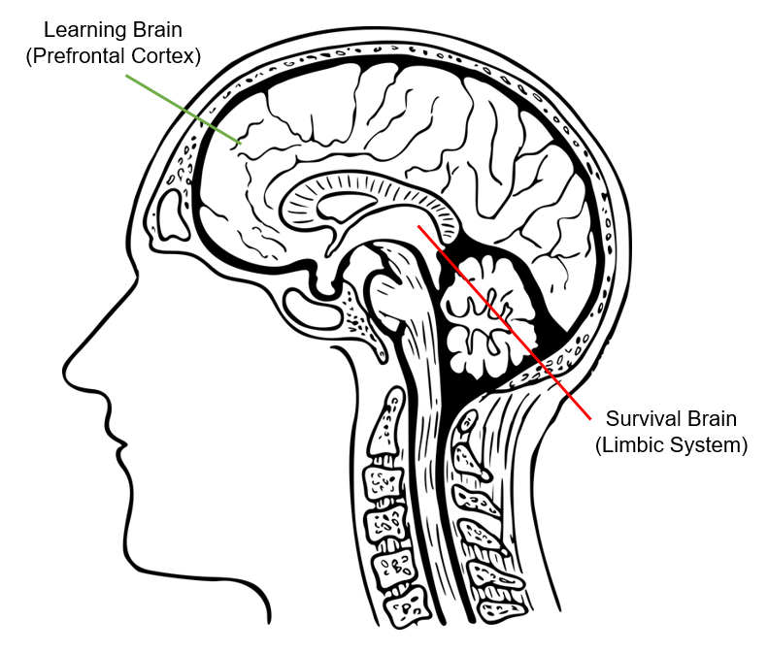 | - Problem solving  - Communication skills  - Emotional regulation  - Ability to retrieve previously learned information  - Decision making

How?
Dan Seigal’s Hand Model of the Brain can be used to explain how a person moves into functioning from their survival brain. As illustrated below, the four fingers represent the prefrontal cortex, or the learning brain, while the thumb represents the limbic system, or the survival brain. Ideally, in the classroom the learning brain is engaged enabling students to participate in learning. However, students who are experiencing stress or trauma are more likely to be triggered which cause them to flip their lid; therefore, limiting access to their learning brain.