
What: Request for Assistance

When a student discloses trauma in the classroom, educators play a pivotal role in supporting and directing students and families to the necessary resources and support they deserve.

Source: Photo by Brad Neathery on Unsplash


How:
- Review your school’s policies and procedures.

- Collaborate with your administrator and student support staff.
- Act immediately.
- Review and know best practices when responding to a student.
- Communicate with the child or youth's family to inform and connect regarding the disclosure and offer resources as appropriate.
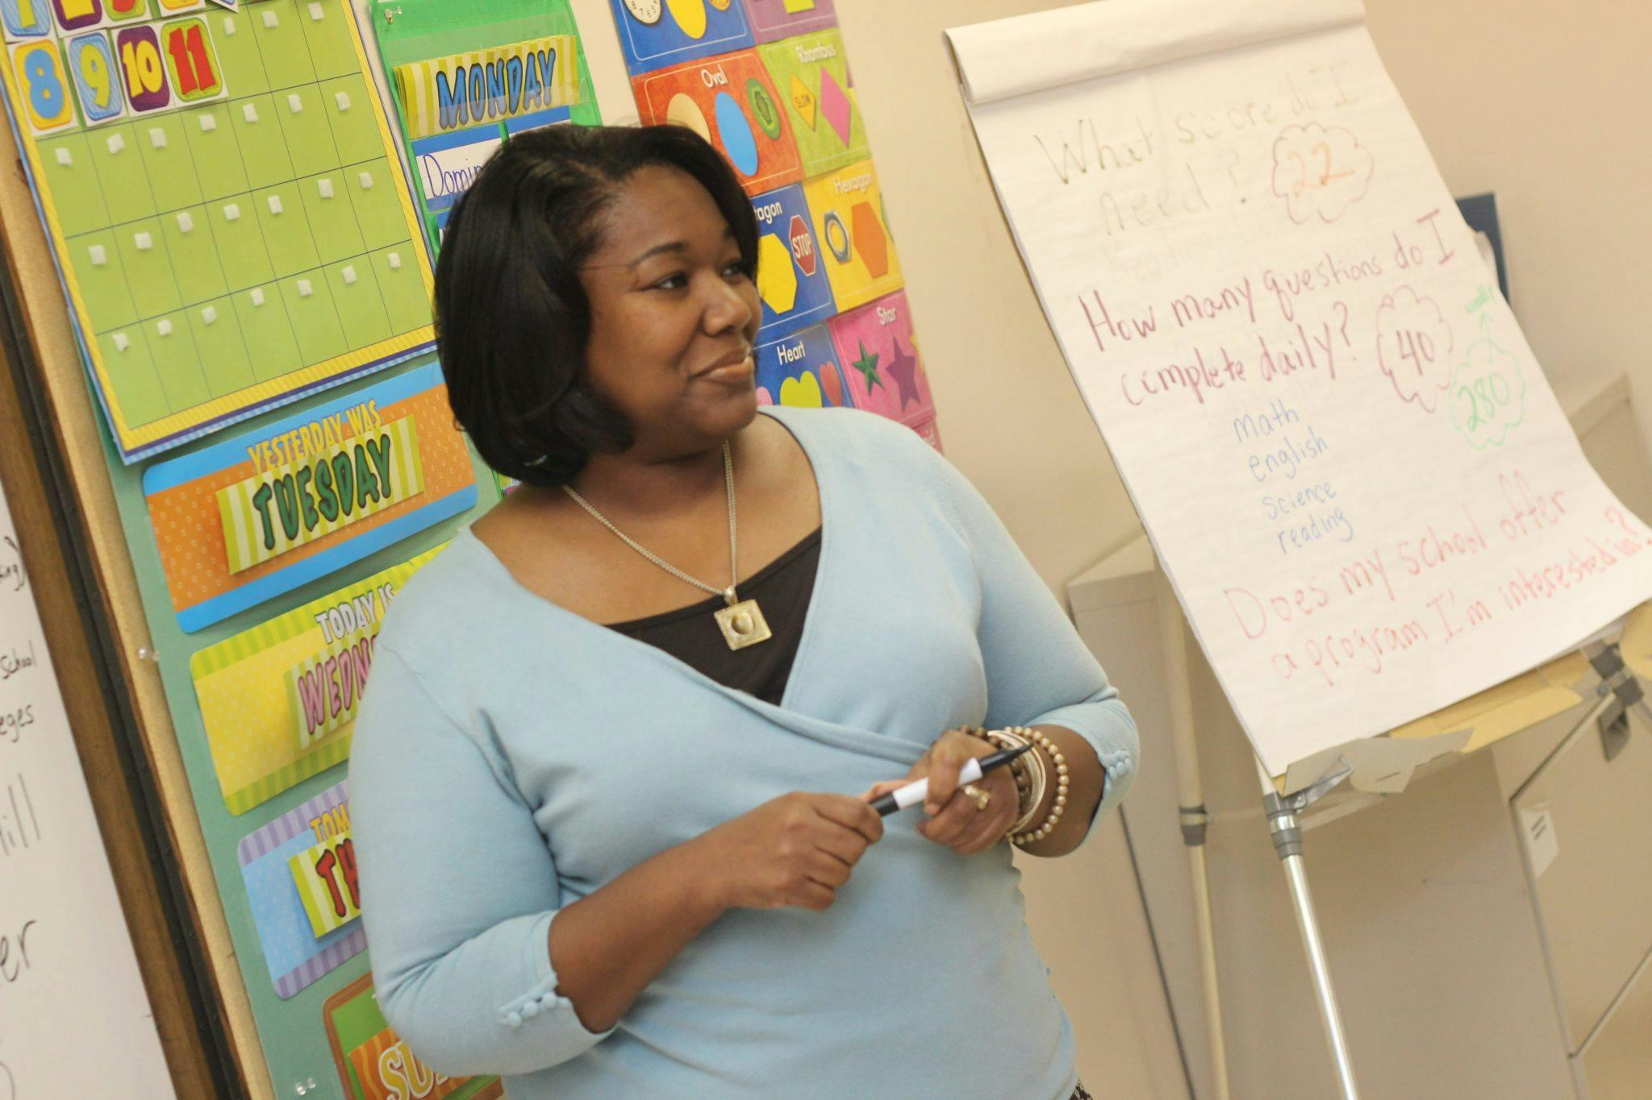
Why:
- Teachers foster a safe and nurturing space that contributes to the holistic development of each student, empowering them to overcome challenges and reach their full potential.
- Teachers are on the front line each day and, as mandated reporters, are positioned to interact in a compassionate and effective manner to support students and their families.
- Teachers are more effective in supporting students and families when they know they are not alone and understand their school’s policies, procedures, and student support services staff who can offer expertise and guidance.
Photo by nappy: https://www.pexels.com/photo/photo-of-woman-teaching-935943/

